INDIRA GANDHI NATIONAL OPEN UNIVERSITY

**PROJECT**

**OF**

**MCSP-060**



**SURAKSHA LIFE INSURANCE**

By

**SONALI GUGLANI**

**ENROLL NO. - 137882610**

** **

Submitted to the School of Computer and Information Sciences, IGNOU

In partial fulfilment of the requirements

For the award of the degree

INDEX

1. Certificate of originality 5
2. Acknowledgement 6
3. Synopsis 7
4. Introduction of the Suraksha Life Insurance 44-45
5. Objective of the Suraksha Life Insurance 46-47
6. Project Category 48-49
7. Tools and environment used 50-51
8. System analysis 52-53
9. Software requirement specifications 54-55
10. Functional requirements 55-56
11. Non-functional requirements 57-58
12. Life cycle model(water fall model) 59-61
13. COCOMO model 62-65
14. Fact Finding 66-67
15. Feasibility Study 68-69
16. Scheduling techniques 70
17. GANTT chart 70-71
18. PERT chart 72
19. Risk analysis and management 73-75
20. System design 76-77
21. Modular design 78
22. Modular description 79-81
23. Entity Relationship Diagram (ER-D) 82
24. Class Diagram 83
25. Use Case Diagram 84
26. Flow Chart 85
27. Data Flow Diagram (DFD) 86
28. Zero Level DFD 87
29. One Level DFD 88-89
30. Two Level DFD 90-91
31. Data Dictionary 92-96
32. Testing 97-98
33. Test plans 99-101
34. Testing types 102-105
35. Test cases design 106-123
36. Test reports | bug reports 124-127
37. Debugging 128
38. Code improvements 129-130
39. System and Security 131-132
40. Database security 133-136
41. Data security 137-140
42. User Access Rights 141-142
43. Limitations of the Suraksha Life Insurance 143
44. Future scope of the Suraksha Life Insurance 144
45. Conclusions 145
46. Bibliography 146
47. Input and output screens 147-179
48. Coding with comments and error handling 180-271

CERTIFICATE OF ORIGINALITY

This is to certify that the project report entitled Suraksha Life Insurance submitted to Indira Gandhi National Open University in partial fulfilment of the requirement for the award of the degree of MASTER OF COMPUTER APPLICATIONS (MCA), is an original work carried out by Ms. SONALI GUGLANI Enrolment No. 137882610 under the guidance of Mr. KAMAL TIWARI.

The matter embodied in this project is a genuine work done by the student and has not been submitted whether to this University or to any other University / Institute for the fulfilment of the requirement of any course of study.

**Signature of the Student Signature of the Guide**

Name and Address Name, Designation,Address

ACKNOWLEDGEMENT

I **SONALI GUGLANI** made this Project (**SURAKSHA LIFE INSURANCE)** under guidance of **MR. KAMAL TIWARI.**

I take great pride and privilege to express my gratitude to my guide, for expert planning, peerless guidance and untiring and bountiful help which inspired me to complete my desired Dissertatiwork. My indebtedness is reserved for his good will and patience during the project.

Last but not least, I would like to thank all those who have directly or indirectly contributed towards successful completion of this project.

ObservationsMade are Genuine and have not been manipulated in any way. Today I complete this Project and here to you.

SONALI GUGLANI

Enrollment No: 137882610

SYNOPSIS

**INDEX**

|  |  |  |
| --- | --- | --- |
| S. No. | Content | Page No. |
| 1 | **Introduction of the Project** | **2** |
| 2 | **Objectives of the Project** | **3** |
| 3 | **Project Category** | **4** |
| 4 | **Tools/Platform to be used** | **5** |
| 5 | **Complete description of the project** | **8** |
| 6 | * **System Analysis** | **9** |
|  | * **Fact Finding** | **9** |
|  | * **Feasibility Study** | **11** |
| 7 | * **Modular description** | **12** |
| 8 | * **Life Cycle Methodology** | **14** |
| 9 | * **Scheduling Techniques** | **16** |
|  | * **GANTT Chart** | **16** |
|  | * **PERT Chart** | **17** |
| 10 | * **Entity Relationship Diagram** | **18** |
| 11 | * **Data Flow Diagram** | **19** |
|  | * **Zero Level Diagram** | **19** |
|  | * **One Level Diagram** | **20** |
|  | * **Two Level Diagram** | **22** |
| 12 | * **Class Diagram** | **24** |
| 13 | * **Use Case Diagram** | **25** |
| 14 | * **Data Structure** | **26** |
| 15 | **Testing to be used** | **28** |
| 16 | **System security and validation** | **30** |
| 17 | **Future scope of the project** | **33** |
| 18 | **Bibliography** | **34** |

**Introduction of the project**

**Project Title : Suraksha Life Insurance**

**Application Type : Web Application**

**Description**

The main purpose of Life Insurance Management System project (ASP.net) is to estimate some important statistics of Micro insurance in the current market of India by gathering and analyzing data which is available. The statistics will be useful to prepare better insurance plans to boost up the Life Insurance industry in India.

Most of the micro insurance organizations are not having any existing fully computerized system and they are managing the information in the form of Excel spread sheets. Data of agents, insured persons, policy details, insurers list, TPS’s (third party Administrators) data, etc are maintained using Excel sheets.

The system has the following drawbacks.

* Every member organization has its own data structure.
* Due to lack of centralized data structure, it is very difficult to merge the data to analyze the statistics.
* Difficult to search for a data
* Possibility of duplicates, etc.

**Modules**

1. **Admin module:** This module allows only registered members to log in and manage the users and article.
2. **Registered users module:** This module allows to known the premium details of the users and product details.
3. **Public user’s module:** This module generates reports giving information about the insurance and statical information.

**Objectives**

This website is an online micro insurance Analysis and information management system that provides easy access of information regarding the people and resources of insurance. This site is not a static site but with wonderful dynamic facilities like search tool for insurance awareness articles, guidelines, illustrations through images for visitors. This site also provides several dynamic features.

The developed system should allow admin users to register insured persons with their name, date of birth, residence address, medical history and also policy details. After registering all the insured persons, website should provide management facilities like delete unwanted persons’ data. And also should provide awareness to the visitors about micro insurance through articles.

Proposed System

The proposed system (phase 1) provides easy solution for the above and some other problems by providing a common and centralized data structure for all members. The developed website provides the following facilities to admin users:

1. Common Database System with common Data structure.
2. Registration of insured person
3. Insured person search
4. Manage insured/Registered persons
5. Content Management (Articles)
6. Maintain insured person details
7. Easy availability of important information
8. Client can access policy details
9. Report generation and send to respective client by providing password protected

**Project Category**

**Web based application**

An application that is usable only with an active internet connection and that uses HTTP as its primary communications protocol, also called Web applications.

Web applications are computer programs allowing website visitors to submit and retrieve data to/from a database over the Internet using their preferred web browser. The data is then presented to the user within their browser as information is generated dynamically (in a specific format, e.g. in HTML using CSS) by the web application through a web server.

**ASP.NET using C#**

ASP.NET is a web development platform, which provides a programming model, a comprehensive software infrastructure and various services required to build up robust web applications for PC as well as mobile devices. It is used to produce interactive, data-driven web applications over the internet. It consists of a large number of controls such as text boxes, buttons, and labels for assembling, configuring, and manipulating code to create HTML pages.

C# is a modern, general-purpose, object-oriented programming language. C# is designed for Common Language Infrastructure (CLI), which consists of the executable code and runtime environment that allows use of various high-level languages on different computer platforms and architectures. C# is part of .Net framework and is used for writing .Net applications.

**SQL Server**

MS SQL Server is a relational database management system (RDBMS) developed by Microsoft. This product is built for the basic function of storing retrieving data as required by other applications. It can be run either on the same computer or on another across a network.

Features of SQL Server

* License cost is very lower than any RDBMS Systems
* Runs under Windows all windows servers (NT/2000/2003)
* Runs under client versions Windows 95/98/XP … (to install server service, we need to install MSDE – Microsoft SQL Desktop Engine)
* Scalable to meet Enterprise level databases
* Supports data replication
* Supports Data Marts and Data Warehouses
* Provide OLAP service
* English Query tool makes data move available to casual users
* Data transmission services enable easy exchange of data
* Supports distributed transaction
* Centralized management
* Availability of Visual administration tools and wizards
* Generation and transmission of data in XML format

**Tools/Platform to be used**

**Software requirement**

This web site requires the following software in Server (computer), clients (computers)

**Server-side requirement**

Operating System : Windows 2007

Web Server : IIS 6.0 (Internet Information System)

Framework : ASP.NET 2.x frame work enabled

Database : SQL Server 2000/2005

Minimum Space : 1GB (including Database space) and may grow depends on the Customer information

Front End : ASP.net using C#

Back End : SQL Server

**Client-side Requirements**

Browser : Any HTML 4.0 or prior version compliant browser with a Minimum Screen resolution of 800X600 pixels (best ewed in 1024 x 768 resolution).

JavaScript : JavaScript should be enabled in the browser

**Hardware requirements**

System type : 32 bit Operating System

Motherboard : Intel DH61BF Intel H61 Express Chipset Socket LGA-1155

Monitor : Generic PNC Monitor

RAM : 4.00 GB

Processor : Intel ® Core™ i3 CPU 540@ 3.07 GHz

Hard Disk : 40GB Hard disk with minimum 4GB free space

Interface : Keyboard, Mouse

**Functional Requirements**

**Product Requirements**

This web site is an online Micro Insurance Management System that provides the following features in this phase-1.

* Micro Insurance Awareness
* Login to admin members
* Insured persons’ registrations and management
* Awareness Articles management

Visitor Services

* Articles
* About Website
* Contact Information

Member Services

* Login
* Change-password (to remind the forgotten password)
* Insured Registrations & management
* Search for insured persons
* Article Management

**Non-Functional Requirements**

**Accessibility -** Software accessibility can be defined as a trait of software or other electronic information sources whereby it is usable by people with physical, cognitive or emotional disabilities. A software, website or other electronic information source is accessible if someone with a disability is able to use the source’s data, information, or services as effectively as someone without a disability.

**Robustness –** Robustness is the ability of a system to prevent, detect, adapt to and recover from operational problems. Software is robust if it can tolerate such problems as unanticipated events, invalid inputs, corrupted internally stored data, improper uses by system operators, unavailable databases, stress overload.

**Portability –** Portability is a measure of how easily an application can be transferred from one computer environment to another. A computer software application is considered portable to a new environment.

**Usability –** Usability is the degree of ease with which web applications can be achieved required goals effectively and efficiently. Usability assesses the level of difficulty involved in using a user interface.

**Scalability –** Scalability is an attribute that describes the ability of a process, network, software or organization to grow and manage the increased demand. A system, business or software that is described as scalable has an advantage because it is more adaptable to the changing needs or demands of its users or clients.

**Reliability -** Requirements about how often the software fails. The measurement is often expressed in MTBF (mean time between failures). The definition of a failure must be clear. Also, don't confuse reliability with availability which is quite a different kind of requirement.  Be sure to specify the consequences of software failure, how to protect from failure, a strategy for error detection, and a strategy for correction.

**Security -**One or more requirements about protection of your system and its data. The measurement can be expressed in a variety of ways (effort, skill level, time, ...) to break into the system.  Do not discuss solutions (e.g. passwords) in a requirements document.

**Efficiency -** Efficiency refers to the level at which a software system uses scarce computational resources, such as CPU cycles, memory, disk space, buffers and communication channels.

**Testability–**Software testability is a set of attributes that bear on the effort needed for validating the modified software. It is one of the important concepts in design and testing of software program and components.

**Complete description of the project**

**System Analysis**

System analysis and design deal with planning the development of information systems through understanding and specifying in detail what a system should do and how the components of the system should be implemented and work together.

**The expanding role of software in the information world forced attentions to software & development needs:**

* + Acceptable speed & cost for development
  + Traceable time schedule for development process

**Software products need to be developed with assurances:**

* + High Quality
  + Longevity—used/maintained over a long period of time
  + Accommodate the changing requirements of the user
  + Compliance

**Fact Finding**

Fact finding is process of collection of data and information based on techniques which contain sampling of existing documents, research, observation, questionnaires, interviews, prototyping and joint requirements planning. Collecting required facts are very important to apply tools in System Development Life Cycle because tools cannot be used efficiently and effectively without proper extracting from facts. Fact-finding techniques are used in the early stage of System Development Life Cycle including system analysis phase, design and post implementation review. Facts included in any information system can be tested based on three steps: data- facts used to create useful information, process- functions to perform the objectives and interface- designs to interact with users.

**Fact Finding Techniques**

1. **Onsite observation –**I met to an agent office to analyze their workand to understand the flow of documents, working of the existing system, the users of the system etc. I observedthat which unwanted things as well and simply cause delay in the development of the new system.
2. **Questionnaire**– When I met with an agent so I asked some questions regarding his work that how they keep record of client’s policies, how the client can access easily important notice or articles regarding insurance, how do they know about their claims and how they keep follow up of their client’s record.
3. **Interview -**I took an interview of an agent regarding their work to find, verify, clarify facts, motivate end-users involved, identify his requirements and gatheredsome ideas and opinions for new system.
4. **Sampling –**I took some samples of their documents, forms and records through which he is keeping records of his clients and maintain the information of client’s claims.

**Feasibility Study**

Feasibility is defined as the practical extent to which a project can be performed successfully. To evaluate feasibility, a feasibility study is performed, which determines whether the solution considered to accomplish the requirements is practical and workable in the software. The objective of the feasibility study is to establish the reasons for developing the software that is acceptable to users, adaptable to change and conformable to established standards.

1. **Technical Feasibility -**Technical feasibility assesses the current resources (such as hardware and software) and technology, which are required to accomplish user requirements in the software within the allocated time and budget. My software is based on ASP.net and SQL Server 2012, it’s a web application can be open on any web browser like Chrome, Mozilla Firefox etc.. So, the user doesn’t need to have any specific software to run it. Any user either client side or server side can access the information.
2. **Operational Feasibility -**Operational feasibility assesses the extent to which the required software performs a series of steps to solve business problems and user requirements. This web application will be user friendly by giving hyperlinks, to make important articles highlighted, by provide site map through which navigation will become simple and easy to follow and by providing important documents pdf formats.
3. **Economical Feasibility -**Economic feasibility determines whether the required software is capable of generating financial gains for an organization. It involves the cost incurred on the software development team, estimated cost of hardware and software, cost of performing feasibility study, and so on. As it is a web application, developer has to pay only hosting charges to web hosting company. And at the client side or user no need to install any specific software and there is no need to implement high configuration hardware. Every user who will use this website obviously he/she use any operating system and every operating system has pre-installed web browser and they can also other web browser from internet.

Only the cost that the developer should bare is cost of development. They make estimates cost of development depends on the features to be included in the website. In future, if client want any new feature to be added, so the cost of new features submitted to the client and after getting the confirmation from the client the newfeatures will be added by the developer.

**Modular Description**

1. Admin – This module is managed by admin to generate policies, approve claims, agent management and update information. Admin has authority to approve and generate policy after approving the documents, the policy will be issued to the customer. Same with claim, whenever a customer claim against his/her policy so firstly admin will approve the claim and forward the status to the agent or directly to the customer through their account. Only admin has authority to update and manage all the information of agents. Admin can only edit, delete and insert the details of an agent.
2. Agent – This module is used to provide policy information for agents, check agent details and profiles. Agent can also check maturity level of his customer’s policy and status of claim, if he is already informed by admin regarding claim status so he is responsible to inform or update his customer. This is agent’s responsibility that he should give reminder to customer before the date of premium so the customer will not face any inconvenience to pay any extra charges.
3. Customer – By using this module customer can login to account and know details about policy maturity, claim, about premium, to buy policy. Registered customer has its own login ID and password so they can login their account and can check the details of policy, which will get mature and when they have to pay next premium. In case, if customer made any claim so he/she can check the status of claim. When an agent met with customer and explain the policy and aware them about its profits now customer have to decide that which policy he/she should take. After choosing the policy customer give details and got registration. Then he/she buy policy by make payment of initial amount of premium. Then admin generate that policy by his name and provide him full details.
4. Policy – This module provide whole information about different policies. This module can be accessed by registered customers and by general user. When a general user will visit this module, he/she can check the plan. But when a registered user access policy, he/she can check his/her policy details by providing the policy no. and policy name. He/she can check the duration of policy, can calculate the amount and can check the start date and end date.
5. Claim – This module contain the information of claims like request no., reason, status, made by customer. When a customer will make claim against his/her policy, they can check their claim’s status by providing request no. whether it got approval or not. Admin and agent can also access this module to update the status of claim.
6. Maturity – This module contain the maturity amount of the policy which can be checked by an agent and registered customer. Agents and customers both can access this module. Agents can check their own customer’s policy maturity level by their customer ID and policy ID and registered customers can also check the same after login their account. So that customer can follow up their policy maturity level when it will become mature and how much more time is left.
7. Premium – This module contains the payment details done previously, remaining and its receipts in printable format. Registered users can check the payment details that they made previous payment by cash or cheque and date. Agents can also access this module to check their own customer payment details by providing customer ID and policy no.

**Life Cycle Methodology**

A methodology should provide a framework or procedure within which the analyst can systematically and comprehensively investigate a business or business area, document the findings developed from that investigation, draw conclusions from those findings, and develop recommendations based upon those conclusions. In many organizations this framework has been formalized into a standardized set of steps or phases which defines both the sequence of the phases and the documentation deliverables which the firm deems necessary to the accomplishment of the desired tasks in the most efficient and practical manner.

**Spiral Model**

The spiral model is similar to the incremental model, with more emphasis placed on risk analysis. The spiral model has four phases: Planning, Risk Analysis, Engineering and Evaluation. A software project repeatedly passes through these phases in iterations (called Spirals in this model). The baseline spiral, starting in the planning phase, requirements are gathered and risk is assessed. Each subsequent spirals builds on the baseline spiral.

**Spiral Model**

**Planning Phase:**Requirements are gathered during the planning phase. Requirements like ‘BRS’ that is ‘Business Requirement Specifications’ and ‘SRS’ that is ‘System Requirement specifications’.

**Risk Analysis:** In the**risk analysis phase**, a process is undertaken to identify risk and alternate solutions.  A prototype is produced at the end of the risk analysis phase. If any risk is found during the risk analysis then alternate solutions are suggested and implemented.

**Engineering Phase:** In this phase software is **developed**, along with testing at the end of the phase. Hence in this phase the development and testing is done.

**Evaluation phase:**This phase allows the customer to evaluate the output of the project to date before the project continues to the next spiral.

**Scheduling Techniques**

**Scheduling Tools**

1. **GANTT CHART –** There are various tools that help you create a schedule. One of the simplest project management tools used to represent the timeline of activities is the Gantt chart. The Gantt chart shows almost all of the information contained in the schedule activity list, but in a much more digestible way. The schedule information is more easily grasped and understood, and the activities can be easily compared. The Gantt chart enables us to see at any given time, which activities should be occurring in the project.

A Gantt chart has horizontal bars plotted on a chart to represent a schedule. In a Gantt chart, you plot time on the horizontal axis and activities on the vertical axis. You represent an activity by a horizontal bar on the Gantt chart. The position of a horizontal bar shows the start and end time of an activity and the length of the bar show its duration.

|  |  |  |  |  |  |  |  |
| --- | --- | --- | --- | --- | --- | --- | --- |
| **Tasks/Period** | **Sep’17** | **Oct’17** | **Nov’17** | **Dec’17** | **Jan’18** | **Feb’18** | **Mar’18** |
| **Study of the topic** |  |  |  |  |  |  |  |
| **Write Proposal** |  |  | |  |  |  |  |
| **Requirement** |  |  |  |  |  |  |  |
| **High Level Design**  **(Interface, Data Design)** |  |  |  |  |  |  |  |
| **Procedural Design** |  |  |  |  |  |  |
| **Coding** |  |  |  |  |  |  |  |
| **Testing(Module and Integrated)** |  |  |  |  |  |  |  |
| **Implementation** |  |  |  |  |  |  |

1. **PERT CHART –** The Program Evaluation Review Technique (PERT) Chart helps you diagram workflows, milestones, schedules, timetables, critical paths, and other planning requirements for a project. PERT is a method to analyze the involved tasks in completing a given project, especially the time needed to complete each task, and identifying the minimum time needed to complete the total project.

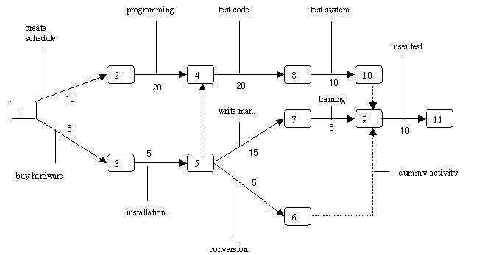

**­Entity Relationship Diagram**

**CUSTOMER**

**POLICY**

**Buys**

**1**

**M**

**has**

**makes**

**CLAIM**

**M**

**1**

**1**

**NOMINEE**

**sell**

**1**

**AGENT**

**1**

**M**

**Data Flow Diagram**

**Zero Level DFD**

**CUSTOMER**

**PREMIUM**

**MATURITY**

**REPORT**

**CLAIM**

customerID

policy

Customer details

Payment details

Receipt

Maturity

Amount

Request

Status

settlement

**First Level DFD for Admin**

**ADMIN**

**CLAIM STATUS**

**POLICY**

**AGENT**

**First Level DFD for Customer**

**POLICY**

**CUSTOMER**

**CUSTOMER**

**PREMIUM**

**MATURITY**

**CLAIM**

**Second Level DFD**

**Customer   
details**

**CUSTOMER**

**Policy**

**AGENT**

**CUSTOMER**

**Policy**

**Premium**

**Customer**

**Policy   
details**

**Payment  
details**

**Second Level DFD**

**CUSTOMER**

**AGENT**

**PREMIUM**

**CUSTOMER**

**POLICY**

**PREMIUM**

**Class Diagram**

**CUSTOMER**

**custID : int**

**custnum : char**

**caddr : char**

**DOB : date**

**Sex : char**

**mobilenum : char**

**cust_reg()**

**search_cust()**

**POLICY**

**policynum : char**

**policyname : char**

**duration : char**

**purchasedate: date**

**expirydate : date**

**startdate : date**

**premiumamt: char**

**sumassured : char**

**buypolicy()**

**searchpolicy()**

**maturity()**

**AGENT**

**agentID : int**

**agentname : char**

**address : char**

**mobilenum : char**

**sex : char**

**DOB : date**

**agentregister()**

**deleteagent()**

**searchagent()**

**CLAIM**

**requestnum : char**

**requestdate : date**

**reason : char**

**status : char**

**doclaim()**

**changestatus()**

**searchstatus()**

**1**

**1.\***

**1.\***

**Use Case Diagram**

**Admin**

**Customer**

**Company officials**

**Data Dictionary**

**Customer**

|  |  |  |
| --- | --- | --- |
| **Field name** | **Data type** | **Constraint** |
| custid  custname  caddr  dob  sex  mobilenum  policyno | int  char  char  date  char  char  int | Primary key  Not null  Not null  Not null  Not null  Not null  Foreign key |

**Policy**

|  |  |  |
| --- | --- | --- |
| **Field name** | **Data type** | **Constraint** |
| policyno  policyname  duration  purchasedate  expirydate  startdate  premiumamt  sumassured | int  char  char  date  date  date  char  char | Primary key  Not null  Not null  Not null  Not null  Not null  Not null  Not null |

**Agent**

|  |  |  |
| --- | --- | --- |
| **Field name** | **Data type** | **Constraint** |
| Agented  agentname  address  mobilenum  sex  dob | int  char  char  char  char  date | Primary key  Not null  Not null  Not null  Not null  Not null |

**Claim**

|  |  |  |
| --- | --- | --- |
| **Field name** | **Data type** | **Constraint** |
| Requestnum  requestdate  reason  status | int  date  char  char | Not null  Not null  Not null  Not null |

**Testing**

Software Testing is evaluation of the software against requirements gathered from users and system specifications. Testing is conducted at the phase level in software development life cycle or at module level in program code. Software testing comprises of Validation and Verification.

**Black-box testing**

It is carried out to test functionality of the program. It is also called ‘Behavioral’ testing. The tester in this case, has a set of input values and respective desired results. On providing input, if the output matches with the desired results, the program is tested ‘ok’, and problematic otherwise.

In this testing method, the design and structure of the code are not known to the tester, and testing engineers and end users conduct this test on the software.

### White-box testing

It is conducted to test program and its implementation, in order to improve code efficiency or structure. It is also known as ‘Structural’ testing.

In this testing method, the design and structure of the code are known to the tester. Programmers of the code conduct this test on the code.

### Testing Levels

Testing itself may be defined at various levels of SDLC. The testing process runs parallel to software development. Before jumping on the next stage, a stage is tested, validated and verified.

Testing separately is done just to make sure that there are no hidden bugs or issues left in the software. Software is tested on various levels -

### Integration Testing

Even if the units of software are working fine individually, there is a need to find out if the units if integrated together would also work without errors. For example, argument passing and data updation etc.

### System Testing

The software is compiled as product and then it is tested as a whole. This can be accomplished using one or more of the following tests:

* **Functionality testing** - Tests all functionalities of the software against the requirement.
* **Performance testing** - This test proves how efficient the software is. It tests the effectiveness and average time taken by the software to do desired task. Performance testing is done by means of load testing and stress testing where the software is put under high user and data load under various environment conditions.
* **Security & Portability** - These tests are done when the software is meant to work on various platforms and accessed by number of persons.

### Acceptance Testing

When the software is ready to hand over to the customer it has to go through last phase of testing where it is tested for user-interaction and response. This is important because even if the software matches all user requirements and if user does not like the way it appears or works, it may be rejected.

* **Alpha testing** - The team of developer themselves perform alpha testing by using the system as if it is being used in work environment. They try to find out how user would react to some action in software and how the system should respond to inputs.
* **Beta testing** - After the software is tested internally, it is handed over to the users to use it under their production environment only for testing purpose. This is not as yet the delivered product. Developers expect that users at this stage will bring minute problems, which were skipped to attend.

**System Security & Validation**

**Authentication**

Authentication is the process of validating the identity of a user to allow or deny the user request. It involves accepting user credentials from the user and validating against the user. The system checks for the verification the user is legal for the system.

**Authorization**

Authorization is the process of ensuring users with valid identity are allowed to access the specific resources in the system. Depending on the roles assign to the user the authorization is provided. If the user has Administrator authorization, access throughout the application is possible. It can create or delete users depending on the requirement.

**ASP.NET Validations**

ASP.NET validation controls validate the user input data to ensure that useless, unauthenticated, or contradictory data don't get stored.

## RequiredFieldValidator Control

The RequiredFieldValidator control ensures that the required field is not empty. It is generally tied to a text box to force input into the text box.

## RangeValidator Control

The RangeValidator control verifies that the input value falls within a predetermined range.

It has three specific properties:

|  |  |
| --- | --- |
| Properties | Description |
| Type | It defines the type of the data. The available values are: Currency, Date, Double, Integer, and String. |
| MinimumValue | It specifies the minimum value of the range. |
| MaximumValue | It specifies the maximum value of the range. |

## CompareValidator Control

The CompareValidator control compares a value in one control with a fixed value or a value in another control.

It has the following specific properties:

|  |  |
| --- | --- |
| Properties | Description |
| Type | It specifies the data type. |
| ControlToCompare | It specifies the value of the input control to compare with. |
| ValueToCompare | It specifies the constant value to compare with. |
| Operator | It specifies the comparison operator, the available values are: Equal, NotEqual, GreaterThan, GreaterThanEqual, LessThan, LessThanEqual, and DataTypeCheck. |

## RegularExpressionValidator

The RegularExpressionValidator allows validating the input text by matching against a pattern of a regular expression. The regular expression is set in the ValidationExpression property.

**Future scope of the project**

After finishing the requirements for phase-1 of the development the remaining estimated modules will be developed. The following enhancements may be added to the existing modules.

* Add new Administrators
* Enhancement of search options after completion of the pahse-2

These features are estimated depends upon the requirements of the client in phase-2. So, these modifications require completion of the pahse-2 development of the project.

The developed project fulfills the website facilities estimated for pahse-1 development and as per all the currently addressed requirements of the client (stakeholder).

Developer will provide

* Uploading and trail running of the website.
* Plan to avoid/handle unexpected damages
* Probable list of modifications that will guide the pahse-2 development of the project.

**Bibliography**

1. **http://www.homeandlearn.co.uk/csharp/csharp.html**
2. **https://www.tutorialspoint.com/asp.net/index.htm**
3. **http://www.referenceforbusiness.com/management/Str-Ti/  
   Systems-Analysis.html**
4. **.Net Tutorials for Beginners by Akila Manian (MVP)**
5. **C# Programming object oriented programming by tutorialspoint.com**
6. **An Integrated Approach to Software Engineering: PANKAJ JALOTE**
7. **SQL Server 2008; Database Design Study Guide: Kevin Hough**

PROJECT REPORT

**Introduction of the project**

**Project Title : Suraksha Life Insurance**

**Application Type : Web Application**

**Description**

The main purpose of Life Insurance Management System project (ASP.net) is to estimate some important statistics of Micro insurance in the current market of India by gathering and analyzing data which is available. The statistics will be useful to prepare better insurance plans to boost up the Life Insurance industry in India.

Most of the micro insurance organizations are not having any existing fully computerized system and they are managing the information in the form of Excel spread sheets. Data of agents, insured persons, policy details, insurers list, TPS’s (third party Administrators) data, etc are maintained using Excel sheets.

The system has the following drawbacks.

* Every member organization has its own data structure.
* Due to lack of centralized data structure, it is very difficult to merge the data to analyze the statistics.
* Difficult to search for a data
* Possibility of duplicates, etc.

**Modules**

1. **Admin module:** This module allows only registered members to log in and manage the users and article.
2. **Registered users module:** This module allows to known the premium details of the users and product details.
3. **Public user’s module:** This module generates reports giving information about the insurance and statical information.

**Objectives**

This website is an online micro insurance Analysis and information management system that provide easy access of information regarding the people and resources of insurance. This site is not a static site but with wonderful dynamic facilities like search tool for insurance awareness articles, guidelines, illustrations through images for visitors. This site also provide several dynamic features.

The developed system should allow admin users to register insured persons with their name, date of birth, residence address, medical history and also policy details. After registering all the insured persons, website should provide management facilities like delete unwanted persons’ data. And also should provide awareness to the visitors about micro insurance through articles.

Proposed System

The proposed system (phase 1) provides easy solution for the above and some other problems by providing a common and centralized data structure for all members. The developed website provides the following facilities to admin users:

1. Common Database System with common Data structure.
2. Registration of insured person
3. Insured person search
4. Manage insured/Registered persons
5. Content Management (Articles)
6. Maintain insured person details
7. Easy availability of important information
8. Client can access policy details
9. Report generation and send to respective client by providing password protected

**Project Category**

**Web based application**

An application that is usable only with an active internet connection and that uses HTTP as its primary communications protocol, also called Web applications.

Web applications are computer programs allowing website visitors to submit and retrieve data to/from a database over the Internet using their preferred web browser. The data is then presented to the user within their browser as information is generated dynamically (in a specific format, e.g. in HTML using CSS) by the web application through a web server.

**ASP.NET using C#**

ASP.NET is a web development platform, which provides a programming model, a comprehensive software infrastructure and various services required to build up robust web applications for PC as well as mobile devices. It is used to produce interactive, data-driven web applications over the internet. It consists of a large number of controls such as text boxes, buttons, and labels for assembling, configuring, and manipulating code to create HTML pages.

C# is a modern, general-purpose, object-oriented programming language. C# is designed for Common Language Infrastructure (CLI), which consists of the executable code and runtime environment that allows use of various high-level languages on different computer platforms and architectures. C# is part of .Net framework and is used for writing .Net applications.

**SQL Server**

MS SQL Server is a relational database management system (RDBMS) developed by Microsoft. This product is built for the basic function of storing retrieving data as required by other applications. It can be run either on the same computer or on another across a network.

Features of SQL Server

* License cost is very lower than any RDBMS Systems
* Runs under Windows all windows servers (NT/2000/2003)
* Runs under client versions Windows 95/98/XP … (to install server service, we need to install MSDE – Microsoft SQL Desktop Engine)
* Scalable to meet Enterprise level databases
* Supports data replication
* Supports Data Marts and Data Warehouses
* Provide OLAP service
* English Query tool makes data move available to casual users
* Data transmission services enable easy exchange of data
* Supports distributed transaction
* Centralized management
* Availability of Visual administration tools and wizards
* **Tools/Platform to be used**
* **Software requirement**
* This web site requires the following software in Server (computer), clients (computers)
* **Server-side requirement**
* Operating System : Windows 2007
* Web Server : IIS 6.0 (Internet Information System)
* Framework : ASP.NET 2.x frame work enabled
* Database : SQL Server 2000/2005
* Minimum Space : 1GB (including Database space) and may grow depends on the Customer information
* Front End : ASP.net using C#
* Back End : SQL Server
* **Client-side Requirements**
* Browser : Any HTML 4.0 or prior version compliant browser with a Minimum Screen resolution of 800X600 pixels (best ewed in 1024 x 768 resolution).
* JavaScript : JavaScript should be enabled in the browser
* **Hardware requirements**
* System type : 32 bit Operating System
* Motherboard : Intel DH61BF Intel H61 Express Chipset Socket LGA-1155
* Monitor : Generic PNC Monitor
* RAM : 4.00 GB
* Processor : Intel ® Core™ i3 CPU 540@ 3.07 GHz
* Hard Disk : 40GB Hard disk with minimum 4GB free space
* Interface : Keyboard, Mouse

**System Analysis**

System analysis and design deal with planning the development of information systems through understanding and specifying in detail what a system should do and how the components of the system should be implemented and work together.

**The expanding role of software in the information world forced attentions to software & development needs:**

* + Acceptable speed & cost for development
  + Traceable time schedule for development process

**Software products need to be developed with assurances:**

* + High Quality
  + Longevity—used/maintained over a long period of time
  + Accommodate the changing requirements of the user
  + Compliance

**Fact Finding**

Fact finding is process of collection of data and information based on techniques which contain sampling of existing documents, research, observation, questionnaires, interviews, prototyping and joint requirements planning. Collecting required facts are very important to apply tools in System Development Life Cycle because tools cannot be used efficiently and effectively without proper extracting from facts. Fact-finding techniques are used in the early stage of System Development Life Cycle including system analysis phase, design and post implementation review. Facts included in any information system can be tested based on three steps: data- facts used to create useful information, process- functions to perform the objectives and interface- designs to interact with users.

**Fact Finding Techniques**

1. **Onsite observation –**I met to an agent office to analyze their workand to understand the flow of documents, working of the existing system, the users of the system etc. I observedthat which unwanted things as well and simply cause delay in the development of the new system.
2. **Questionnaire**– When I met with an agent so I asked some questions regarding his work that how they keep record of client’s policies, how the client can access easily important notice or articles regarding insurance, how do they know about their claims and how they keep follow up of their client’s record.
3. **Interview -**I took an interview of an agent regarding their work to find, verify, clarify facts, motivate end-users involved, identify his requirements and gatheredsome ideas and opinions for new system.
4. **Sampling –**I took some samples of their documents, forms and records through which he is keeping records of his clients and maintain the information of client’s claims.

**SOFTWARE REQUIREMENT SPECIFICATIONS**

**NON FUNCTIONAL REQUIREMENTS**

**Software Requirements**

This web site requires the following software in Server (computer), clients (computers)

**Server-side Requirements**

Operation System : Windows 2003

Web Server : IIS 6.0(Internet Information Server)

Framework : ASP.NET 2.x frame work enabled

Database : SQL Server 2000/2005

Minimum Space : 1GB (including Database space) and may grow depends on the Customer information

**Client-side Requirements**

Browser : Any HTML 4.0 or prior version compliant browser with a Minimum Screen resolution of 800X600 pixels (best ewed in 1024 x 768 resolution

JavaScript : JavaScript should be enabled in the browser

**Hardware Requirements**

The following is a list of minimum requirements on server side

Processor : Pentium III

Speed : 1.0 GHz

Memory : 256MB RAM

Hard Disk : 40GB Hard disk with minimum 4GB free space

Interface : Mouse, Keyboard

On client side any hardware that can run a web browser.

**FUNCTIONAL REQUIREMENTS**

**Product Requirements**

This web site is an online Suraksha Life Insurance Management System that provides the following features in this phase-1.

* Micro Insurance Awareness
* Login to admin members
* Insured persons’ registrations and management
* Awareness Articles management

Visitor Services

* Articles
* About Website
* Contact Information

Member Services

* Login
* Change-password (to remind the forgotten password)
* Insured Registrations & management
* Search for insured persons
* Article Management

**Non-Functional Requirements**

**User Requirements**

The web site provides easy links for easy navigation (browse) in the site. A visitor with minimum knowledge of web browsing/surfing can access the site very easily. Due to dynamic nature of features, the members, Admin members should be able to understand the provided facilities. An online help documentation will be provided to help the users and visitors in using the facilities.

**Performance Requirements**

The following performance requirements should be maintained in the project.

* Each page in the site needs to load in a reasonable amount of time.
* Latest web techniques like Caching should be implemented to speed up the loading of dynamic pages. This will also improve on the number of simultaneous users, as connections are freed faster.

**Quality Attributes**

The following quality attributes should be maintained in the project.

**Maintainabilit**

The site's maintainability will depend on clean, easy-to-read pages. Being a Dynamic Site we need to generate the dynamic output clean and well formatted

**Availability**

The site should be accessible to as many browsers as possible; including text browsers.

**Reliability**

The reliability of the website depends on the web server it will be hosted on, and also on LOGIN mechanisms.

**Security**

All the necessary steps has been taken to provide security to the site by following the latest technology because all the data of all members is proprietary data of the Client’s Organization and its members (Visitors and members)

**Life Cycle Methodology**

A methodology should provide a framework or procedure within which the analyst can systematically and comprehensively investigate a business or business area, document the findings developed from that investigation, draw conclusions from those findings, and develop recommendations based upon those conclusions. In many organizations this framework has been formalized into a standardized set of steps or phases which defines both the sequence of the phases and the documentation deliverables which the firm deems necessary to the accomplishment of the desired tasks in the most efficient and practical manner.

**Spiral Model**

The spiral model is similar to the incremental model, with more emphasis placed on risk analysis. The spiral model has four phases: Planning, Risk Analysis, Engineering and Evaluation. A software project repeatedly passes through these phases in iterations (called Spirals in this model). The baseline spiral, starting in the planning phase, requirements are gathered and risk is assessed. Each subsequent spirals builds on the baseline spiral.

**Spiral Model**

**Planning Phase:**Requirements are gathered during the planning phase. Requirements like ‘BRS’ that is ‘Business Requirement Specifications’ and ‘SRS’ that is ‘System Requirement specifications’.

**Risk Analysis:** In the**risk analysis phase**, a process is undertaken to identify risk and alternate solutions.  A prototype is produced at the end of the risk analysis phase. If any risk is found during the risk analysis then alternate solutions are suggested and implemented.

**Engineering Phase:** In this phase software is **developed**, along with testing at the end of the phase. Hence in this phase the development and testing is done.

**Evaluation phase:**This phase allows the customer to evaluate the output of the project to date before the project continues to the next spiral.

**COCOMO MODEL**

The **Constructive Cost Model** (**COCOMO**) is an algorithmic software cost estimation model developed by Barry Boehm. The model uses a basic regression formula, with parameters that are derived from historical project data and current project characteristics.

COCOMO was first published in 1981 Barry W. Boehm's Book *Software engineering economics* as a model for estimating effort, cost, and schedule for software projects. It drew on a study of 63 projects at TRW Aerospace where Barry Boehm was Director of Software Research and Technology in 1981. The study examined projects ranging in size from 2,000 to 100,000 lines of code, and programming languages ranging from assembly to PL/I. These projects were based on the waterfall model of software development which was the prevalent software development process in 1981.

References to this model typically call it *COCOMO 81*. In 1997 *COCOMO II* was developed and finally published in 2000 in the book *Software Cost Estimation with COCOMO II*. COCOMO II is the successor of COCOMO 81 and is better suited for estimating modern software development projects. It provides more support for modern software development processes and an updated project database. The need for the new model came as software development technology moved from mainframe and overnight batch processing to desktop development, code reusability and the use of off-the-shelf software components. This article refers to *COCOMO 81*.

COCOMO consists of a hierarchy of three increasingly detailed and accurate forms. The first level, *Basic COCOMO* is good for quick, early, rough order of magnitude estimates of software costs, but its accuracy is limited due to its lack of factors to account for difference in project attributes (*Cost Drivers*). *Intermediate COCOMO* takes these Cost Drivers into account and *Detailed COCOMO* additionally accounts for the influence of individual project phases.

**Basic COCOMO**

Basic COCOMO computes software development effort (and cost) as a function of program size. Program size is expressed in estimated thousands of lines of code (KLOC).

COCOMO applies to three classes of software projects:

* Organic projects - "small" teams with "good" experience working with "less than rigid" requirements
* Semi-detached projects - "medium" teams with mixed experience working with a mix of rigid and less than rigid requirements
* Embedded projects - developed within a set of "tight" constraints (hardware, software, operational ...)

The basic COCOMO equations take the form

**Effort Applied** = ab(KLOC)bb**[ man-months ]**

**Development Time** = cb(Effort Applied)db**[months]**

**People required** = Effort Applied / Development Time **[count]**

**Intermediate COCOMOs**

Intermediate COCOMO computes software development effort as function of program size and a set of "cost drivers" that include subjective assessment of product, hardware, personnel and project attributes. This extension considers a set of four "cost drivers”, each with a number of subsidiary attributes:-

* Product attributes
  + Required software reliability
  + Size of application database
  + Complexity of the product
* Hardware attributes
  + Run-time performance constraints
  + Memory constraints
  + Volatility of the virtual machine environment
  + Required turnabout time
* Personnel attributes
  + Analyst capability
  + Software engineering capability
  + Applications experience
  + Virtual machine experience
  + Programming language experience
* Project attributes
  + Use of software tools
  + Application of software engineering methods
  + Required development schedule

**Detailed COCOMO**

* Detailed COCOMO - incorporates all characteristics of the intermediate version with an assessment of the cost driver's impact on each step (analysis, design, etc.) of the software engineering process 1. the detailed model uses different efforts multipliers for each cost drivers attribute these **Phase Sensitive** effort multipliers are each to determine the amount of effort required to complete each phase

**Fact Finding**

Fact finding is process of collection of data and information based on techniques which contain sampling of existing documents, research, observation, questionnaires, interviews, prototyping and joint requirements planning. Collecting required facts are very important to apply tools in System Development Life Cycle because tools cannot be used efficiently and effectively without proper extracting from facts. Fact-finding techniques are used in the early stage of System Development Life Cycle including system analysis phase, design and post implementation review. Facts included in any information system can be tested based on three steps: data- facts used to create useful information, process- functions to perform the objectives and interface- designs to interact with users.

**Fact Finding Techniques**

1. **Onsite observation –**I met to an agent office to analyze their workand to understand the flow of documents, working of the existing system, the users of the system etc. I observedthat which unwanted things as well and simply cause delay in the development of the new system.
2. **Questionnaire**– When I met with an agent so I asked some questions regarding his work that how they keep record of client’s policies, how the client can access easily important notice or articles regarding insurance, how do they know about their claims and how they keep follow up of their client’s record
3. **Interview -** I took an interview of an agent regarding their work to find, verify, clarify facts, motivate end-users involved, identify his requirements and gathered some ideas and opinions for new system.
4. **Sampling –**I took some samples of their documents, forms and records through which he is keeping records of his clients and maintain the information of client’s claims.

**Feasibility Study**

Feasibility is defined as the practical extent to which a project can be performed successfully. To evaluate feasibility, a feasibility study is performed, which determines whether the solution considered to accomplish the requirements is practical and workable in the software. The objective of the feasibility study is to establish the reasons for developing the software that is acceptable to users, adaptable to change and conformable to established standards.

1. **Technical Feasibility -**Technical feasibility assesses the current resources (such as hardware and software) and technology, which are required to accomplish user requirements in the software within the allocated time and budget. My software is based on ASP.net and SQL Server 2012, it’s a web application can be open on any web browser like Chrome, Mozilla Firefox etc.. So, the user doesn’t need to have any specific software to run it. Any user either client side or server side can access the information.
2. **Operational Feasibility -**Operational feasibility assesses the extent to which the required software performs a series of steps to solve business problems and user requirements. This web application will be user friendly by giving hyperlinks, to make important articles highlighted, by provide site map through which navigation will become simple and easy to follow and by providing important documents pdf formats.
3. **Economical Feasibility -**Economic feasibility determines whether the required software is capable of generating financial gains for an organization. It involves the cost incurred on the software development team, estimated cost of hardware and software, cost of performing feasibility study, and so on. As it is a web application, developer has to pay only hosting charges to web hosting company. And at the client side or user no need to install any specific software and there is no need to implement high configuration hardware. Every user who will use this website obviously he/she use any operating system and every operating system has pre-installed web browser and they can also other web browser from internet.

Only the cost that the developer should bare is cost of development. They make estimates cost of development depends on the features to be included in the website. In future, if client want any new feature to be added, so the cost of new features submitted to the client and after getting the confirmation from the client the newfeatures will be added by the developer.

**Scheduling Techniques**

**Scheduling Tools**

1. **GANTT CHART –** There are various tools that help you create a schedule. One of the simplest project management tools used to represent the timeline of activities is the Gantt chart. The Gantt chart shows almost all of the information contained in the schedule activity list, but in a much more digestible way. The schedule information is more easily grasped and understood, and the activities can be easily compared. The Gantt chart enables us to see at any given time, which activities should be occurring in the project.

A Gantt chart has horizontal bars plotted on a chart to represent a schedule. In a Gantt chart, you plot time on the horizontal axis and activities on the vertical axis. You represent an activity by a horizontal bar on the Gantt chart. The position of a horizontal bar shows the start and end time of an activity and the length of the bar show its duration.

|  |  |  |  |  |  |  |  |
| --- | --- | --- | --- | --- | --- | --- | --- |
| **Tasks/Period** | **Sep’17** | **Oct’17** | **Nov’17** | **Dec’17** | **Jan’18** | **Feb’18** | **Mar’18** |
| **Study of the topic** |  |  |  |  |  |  |  |
| **Write Proposal** |  |  | |  |  |  |  |
| **Requirement** |  |  |  |  |  |  |  |
| **High Level Design**  **(Interface, Data Design)** |  |  |  |  |  |  |  |
| **Procedural Design** |  |  |  |  |  |  |
| **Coding** |  |  |  |  |  |  |  |
| **Testing(Module and Integrated)** |  |  |  |  |  |  |  |
| **Implementation** |  |  |  |  |  |  |

1. **PERT CHART –** The Program Evaluation Review Technique (PERT) Chart helps you diagram workflows, milestones, schedules, timetables, critical paths, and other planning requirements for a project. PERT is a method to analyze the involved tasks in completing a given project, especially the time needed to complete each task, and identifying the minimum time needed to complete the total project.



**RISK ANALYSIS & MANAGEMENT**

## Whatis Risk?

Risk is defined as "The possibility of suffering harm or loss; danger." Even if we're not familiar with the formal definition, most of us have an innate sense of risk. We are aware of the potential dangers that permeate even simple daily activities, from getting injured when crossing the street to having a heart attack because our cholesterol level is too high. Although we prefer not to dwell on the myriad of hazards that surround us, these risks shape many of our behaviors. Experience (or a parent) has taught us to look both ways before stepping off the curb and most of us at least think twice before ordering a steak. Indeed, we manage personal risks every day.

## Risks in Software Project Management: -

Unlike the hazards of daily living, the dangers in the young and emerging field of software engineering must often be learned without the benefit of lifelong exposure. A more deliberate approach is required. Such an approach involves studying the experiences of successful project managers as well as keeping up with the leading writers and thinkers in the field. One such writer in the area of risk is Dr. Barry W. Boehm. In his article "Software Risk Management: Principles and Practices" he lists the following top 10 software risk items:

1. Personnel Shortfalls
2. Unrealistic schedules and budgets
3. Developing the wrong functions and properties
4. Developing the wrong user interface
5. Gold-plating
6. Continuing stream of requirements changes
7. Shortfalls in externally furnished components
8. Shortfalls in externally performed tasks
9. Real-time performance shortfalls

10. Straining computer-science capabilities

Risk is the net negative impact of the exercise of vulnerability, considering both the probability and the impact of occurrence. Risk management is the process of identifying risk, assessing risk, and taking steps to reduce risk to an acceptable level. This guide provides a foundation for the development of an effective risk management program, containing both the definitions and the practical guidance necessary for assessing and mitigating risks identified within projects. The ultimate goal is to help organizations to better manage project-related mission risks.

The objective of performing risk management is to enable the organization to accomplish its mission(s) (1) by better securing the systems that store, process, or transmit organizational information; (2) by enabling management to make well-informed risk management decisions to justify the expenditures that are part of an project budget; and (3) by assisting management in authorizing (or accrediting) the systems on the basis of the supporting documentation resulting from the performance of risk management.

**How to Manage: -**

In the same article, Dr. Boehm describes risk management as being comprised of the following activities:

* **Risk Assessment** (figuring out what the risks are and what to focus on)
  + - making a list of all of the potential dangers that will affect the project
  + - assessing the probability of occurence and potential loss of each item listed
  + - ranking the items (from most to least dangerous)
* **Risk Control** (doing something about them)
  + coming up with techniques and strategies to mitigate the highest ordered risks
  + implementing the strategies to resolve the high order risks factors
  + monitoring the effectiveness of the strategies and the changing levels of risk throughout the project

**SYSTEM DESIGN**

Systems design is the process of defining the architecture, components, modules, interfaces, and data for a system to satisfy specified requirements. One could see it as the application of systems theory to product development. There is some overlap with the disciplines of systems analysis, systems architecture and systems engineering. If the broader topic of product development "blends the perspective of marketing, design, and manufacturing into a single approach to product development, then design is the act of taking the marketing information and creating the design of the product to be manufactured. Systems design is therefore the process of defining and developing systems to satisfy specified requirements of the user. Until the 1990s systems design had a crucial and respected role in the data processing industry. In the 1990s standardization of hardware and software resulted in the ability to build modular systems. The increasing importance of software running on generic platforms has enhanced the discipline of software engineering.

Object-oriented analysis and design methods are becoming the most widely used methods for computer systems design. The UML has become the standard language in object-oriented analysis and design. It is widely used for modeling

**software systems** and is increasingly used for high designing non-software systems and organizations.

The purpose of System Design is to create a technical solution that satisfies the functional requirements for the system. At this point in the project lifecycle there should be a Functional Specification, written primarily in business terminology, containing a complete description of the operational needs of the various organizational entities that will use the new system. The challenge is to translate all of this information into Technical Specifications that accurately describe the design of the system, and that can be used as input to System Construction.

The Functional Specification produced during System Requirements Analysis is transformed into a physical architecture. System components are distributed across the physical architecture, usable interfaces are designed and prototyped, and Technical Specifications are created for the Application Developers, enabling them to build and test the system.

Many organizations look at System Design primarily as the preparation of the system component specifications; however, constructing the various system components is only one of a set of major steps in successfully building a system. The preparation of the environment needed to build the system, the testing of the system, and the migration and preparation of the data that will ultimately be used by the system are equally important. In addition to designing the technical solution, System Design is the time to initiate focused planning efforts for both the testing and data preparation activities.

**MODULAR DESIGN**

**Customer MANAGEMENT**

**Claim & Maturity Mangement**

**Premium**

**PAYMENT**

**Agent Mangement**

**Administrator**

**Modular Description**

1. Admin – This module is managed by admin to generate policies, approve claims, agent management and update information. Admin has authority to approve and generate policy after approving the documents, the policy will be issued to the customer. Same with claim, whenever a customer claim against his/her policy so firstly admin will approve the claim and forward the status to the agent or directly to the customer through their account. Only admin has authority to update and manage all the information of agents. Admin can only edit, delete and insert the details of an agent.
2. Agent – This module is used to provide policy information for agents, check agent details and profiles. Agent can also check maturity level of his customer’s policy and status of claim, if he is already informed by admin regarding claim status so he is responsible to inform or update his customer. This is agent’s responsibility that he should give reminder to customer before the date of premium so the customer will not face any inconvenience to pay any extra charges.
3. Customer – By using this module customer can login to account and know details about policy maturity, claim, about premium, to buy policy. Registered customer has its own login ID and password so they can login their account and can check the details of policy, which will get mature and when they have to pay next premium. In case, if customer made any claim so he/she can check the status of claim. When an agent met with customer and explain the policy and aware them about its profits now customer have to decide that which policy he/she should take. After choosing the policy customer give details and got registration. Then he/she buy policy by make payment of initial amount of premium. Then admin generate that policy by his name and provide him full details.
4. Policy – This module provide whole information about different policies. This module can be accessed by registered customers and by general user. When a general user will visit this module, he/she can check the plan. But when a registered user access policy, he/she can check his/her policy details by providing the policy no. and policy name. He/she can check the duration of policy, can calculate the amount and can check the start date and end date.
5. Claim – This module contain the information of claims like request no., reason, status, made by customer. When a customer will make claim against his/her policy, they can check their claim’s status by providing request no. whether it got approval or not. Admin and agent can also access this module to update the status of claim.
6. Maturity – This module contain the maturity amount of the policy which can be checked by an agent and registered customer. Agents and customers both can access this module. Agents can check their own customer’s policy maturity level by their customer ID and policy ID and registered customers can also check the same after login their account. So that customer can follow up their policy maturity level when it will become mature and how much more time is left.
7. Premium – This module contains the payment details done previously, remaining and its receipts in printable format. Registered users can check the payment details that they made previous payment by cash or cheque and date. Agents can also access this module to check their own customer payment details by providing customer ID and policy no.

**Entity Relationship Diagram**

**CUSTOMER**

**POLICY**

**Buys**

**1**

**M**

**has**

**makes**

**CLAIM**

**M**

**1**

**1**

**NOMINEE**

**sell**

**1**

**AGENT**

**1**

**M**

**Class Diagram**

**CUSTOMER**

**custID : int**

**custname : char**

**caddr : char**

**DOB : date**

**Sex : char**

**mobilenum : char**

**cust_reg()**

**search_cust()**

**POLICY**

**Policyno : int**

**policyname : char**

**duration : int**

**purchasedate: date**

**expirydate : date**

**startdate : date**

**premiumamt: int**

**sumassured : char**

**buypolicy()**

**searchpolicy()**

**maturity()**

**AGENT**

**agentID : int**

**agentname : char**

**address : char**

**mobileno : char**

**sex : char**

**DOB : date**

**agentregister()**

**deleteagent()**

**searchagent()**

**CLAIM**

**Requestno : char**

**requestdate : date**

**reason : char**

**status : char**

**doclaim()**

**changestatus()**

**searchstatus()**

**1**

**1.\***

**1.\***

**Use Case Diagram**

**Admin**

**Customer**

**Company officials**

* + - 1. **FLOW CHART**

Admin logs in

Registers insured persons’ data

Search and Manages insured persons’ data

Manages Agent

Persons’ data

Login is **Success**

Login is not succeeded

Can browse only articles and public pages

Log out

Cusotmer logs in

Pay Policy Premium and Calculate Premium amount

Buy Policy and Policy status seach Agent

Register Calim &

Check Status

Login is **Success**

Login is not succeeded

Can browse only insurance plans and Calculate Premium

Log out

Search Agent and Branch

**Data Flow Diagram**

**Zero Level DFD**

**CUSTOMER**

**PREMIUM**

**MATURITY**

**REPORT**

**CLAIM**

customerID

policy

Customer details

Payment details

Receipt

Maturity

Amount

Request

Status

settlement

**First Level DFD for Admin**

**ADMIN**

**CLAIM STATUS**

**POLICY**

**AGENT**

**First Level DFD for Customer**

**POLICY**

**CUSTOMER**

**CUSTOMER**

**PREMIUM**

**MATURITY**

**CLAIM**

**Second Level DFD**

**Customer   
details**

**CUSTOMER**

**Policy**

**AGENT**

**CUSTOMER**

**Policy**

**Premium**

**Customer**

**Policy   
details**

**Payment  
details**

**Second Level DFD**

**CUSTOMER**

**AGENT**

**PREMIUM**

**CUSTOMER**

**POLICY**

**PREMIUM**

**Data Dictionary**

**Customer**

|  |  |  |
| --- | --- | --- |
| **Field name** | **Data type** | **Constraint** |
| custId  name  address  state  city  pincode  dob  sex  MobileNo  Policyno  usernm  emailed  passwd | Int  nchar(10)  varchar(50)  nchar(10)  nchar(10)  int  varchar(50)  nchar(10)  int  int  varchar(50)  varchar(50)  nchar(10) | Primary key  Not null  Not null  Not null  Not null  Not null  Not null  Not null  Not null  Foreign key  Not null  Not null  Not null |

**Policy**

|  |  |  |
| --- | --- | --- |
| **Field name** | **Data type** | **Constraint** |
| policyno  policynm  duration  purchdate  expirydate  startdate  premium  assured | Int  Nchar(30)  int  varchar(50)  varchar(50)  varchar(50)  int  int | Primary key  Not null  Not null  Not null  Not null  Not null  Not null  Not null |

**Payment**

|  |  |  |
| --- | --- | --- |
| **Field name** | **Data type** | **Constraint** |
| TransId  PolicyNo  plan  premium  date  bank  cardtype  cardno  cardholder | Int  int  nchar(10)  nchar(10)  nchar(10)  nchar(10)  nchar(10)  int  nchar(10) | Primary key  Foreign key  Not null  Not null  Not null  Not null  Not null  Not null  Not null |

**Agent**

|  |  |  |
| --- | --- | --- |
| **Field name** | **Data type** | **Constraint** |
| AgentId  name  dob  sex  address  state  city  pincode  MobilNo  usernm  email  passwd | int  nchar(10)  varchar(50)  nchar(10)  varchar(50)  nchar(10)  nchar(10)  numeric(18,0)  numeric(18,0)  varchar(50)  varchar(50)  nchar(10) | Primary key  Not null  Not null  Not null  Not null  Not null  Not null  Not null  Not null  Not null  Not null  Not null |

**Claim**

|  |  |  |
| --- | --- | --- |
| **Field name** | **Data type** | **Constraint** |
| requestnum  requestdate  reason  status | int  nchar(10)  nchar(10)  nchar(10) | Primary Key  Not null  Not null  Not null |

**Admin**

|  |  |  |
| --- | --- | --- |
| **Field name** | **Data type** | **Constraint** |
| AdminId  name  dob  sex  address  state  city  pincode  MobilNo  usernm  email  passwd | int  nchar(10)  nchar(10)  nchar(10)  nchar(10)  nchar(10)  numeric(18,0)  numeric(18,0)  numeric(18,0)  nchar(10)  varchar(50)  nchar(10) | Primary key  Not null  Not null  Not null  Not null  Not null  Not null  Not null  Not null  Not null  Not null |

**BankPayment**

|  |  |  |
| --- | --- | --- |
| **Field name** | **Data type** | **Constraint** |
| cardno  cardtype  validupto  cvv  cardholder  cardlimit | Int  Nchar(10)  nchar(10)  int  nchar(10)  int | Primary Key  Not null  Not null  Not null  Not null  Not null |

**Office**

|  |  |  |
| --- | --- | --- |
| **Field name** | **Data type** | **Constraint** |
| OfficeId  name  address  state  city  pincode  PhoneNo  email | int  nchar(10)  nchar(10)  nchar(10)  nchar(10)  numerice(18,0)  numerice(18,0)  varchar(50) | Primary Key  Not null  Not null  Not null  Not null  Not null  Not null  Not null |

**TESTING**

Software Testing is the process of executing a program or system with the intent of finding errors. Or, it involves any activity aimed at evaluating an attribute or capability of a program or system and determining that it meets its required results. Software is not unlike other physical processes where inputs are received and outputs are produced. Where software differs is in the manner in which it fails. Most physical systems fail in a fixed (and reasonably small) set of ways. By contrast, software can fail in many bizarre ways. Detecting all of the different failure modes for software is generally infeasible.

Unlike most physical systems, most of the defects in software are design errors, not manufacturing defects. Software does not suffer from corrosion, wear-and-tear -- generally it will not change until upgrades, or until obsolescence. So once the software is shipped, the design defects -- or bugs -- will be buried in and remain latent until activation.

Software bugs will almost always exist in any software module with moderate size: not because programmers are careless or irresponsible, but because the complexity of software is generally intractable -- and humans have only limited ability to manage complexity. It is also true that for any complex systems, design defects can never be completely ruled out. Discovering the design defects in software, is equally difficult, for the same reason of complexity. Because software and any digital systems are not continuous, testing boundary values are not sufficient to guarantee correctness. All the possible values need to be tested and verified, but complete testing is infeasible. Exhaustively testing a simple program to add only two integer inputs of 32-bits (yielding 2^64 distinct test cases) would take hundreds of years, even if tests were performed at a rate of thousands per second. Obviously, for a realistic software module, the complexity can be far beyond the example mentioned here. If inputs from the real world are involved, the problem will get worse, because timing and unpredictable environmental effects and human interactions are all possible input parameters under consideration.

A further complication has to do with the dynamic nature of programs. If a failure occurs during preliminary testing and the code is changed, the software may now work for a test case that it didn't work for previously. But its behavior on pre-error test cases that it passed before can no longer be guaranteed. To account for this possibility, testing should be restarted. The expense of doing this is often prohibitive.

An interesting analogy parallels the difficulty in software testing with the pesticide, known as the Pesticide Paradox: Every method you use to prevent or find bugsleaves a residue of subtler bugs against which those methods are ineffectual. But this alone will not guarantee to make the software better, because the Complexity Barrier principle states: Software complexity(and therefore that of bugs) grows to the limits of our ability to manage that complexity. By eliminating the (previous) easy bugs you allowed another escalation of features and complexity, but his time you have subtler bugs to face, just to retain the reliability you had before. Society seems to be unwilling to limit complexity because we all want that extra bell, whistle, and feature interaction

**TEST PLAN**

A test plan documents the strategy that will be used to verify and ensure that a product or system meets its design specifications and other requirements. A test plan is usually prepared by or with significant input from Test Engineers.

Depending on the product and the responsibility of the organization to which the test plan applies, a test plan may include one or more of the following:

* Design Verification or Compliance test - to be performed during the development or approval stages of the product, typically on a small sample of units.
* Manufacturing or Production test - to be performed during preparation or assembly of the product in an ongoing manner for purposes of performance verification and quality control.
* Acceptance or Commissioning test - to be performed at the time of delivery or installation of the product.
* Service and Repair test - to be performed as required over the service life of the product.
* Regression test - to be performed on an existing operational product, to verify that existing functionality didn't get broken when other aspects of the environment are changed (e.g., upgrading the platform on which an existing application runs).

A complex system may have a high level test plan to address the overall requirements and supporting test plans to address the design details of subsystems and components.

Test plan document formats can be as varied as the products and organizations to which they apply. There are three major elements that should be described in the test plan: Test Coverage, Test Methods, and Test Responsibilities. These are also used in a formal test strategy.

Test coverage in the test plan states what requirements will be verified during what stages of the product life. Test Coverage is derived from design specifications and other requirements, such as safety standards or regulatory codes, where each requirement or specification of the design ideally will have one or more corresponding means of verification. Test coverage for different product life stages may overlap, but will not necessarily be exactly the same for all stages. For example, some requirements may be verified during Design Verification test, but not repeated during Acceptance test. Test coverage also feeds back into the design process, since the product may have to be designed to allow test access.

Test methods in the test plan state how test coverage will be implemented. Test methods may be determined by standards, regulatory agencies, or contractual agreement, or may have to be created new. Test methods also specify test equipment to be used in the performance of the tests and establish pass/fail criteria. Test methods used to verify hardware design requirements can range from very simple steps, such as visual inspection, to elaborate test procedures that are documented separately.

Test responsibilities include what organizations will perform the test methods and at each stage of the product life. This allows test organizations to plan, acquire or develop test equipment and other resources necessary to implement the test methods for which they are responsible. Test responsibilities also includes, what data will be collected, and how that data will be stored and reported (often referred to as "deliverables"). One outcome of a successful test plan should be a record or report of the verification of all design specifications and requirements as agreed upon by all parties.

**TESTING TYPES**

**Unit testing** refers to tests that verify the functionality of a specific section of code, usually at the function level. In an object-oriented environment, this is usually at the class level, and the minimal unit tests include the constructors and destructors.

These type of tests are usually written by developers as they work on code (white-box style), to ensure that the specific function is working as expected. One function might have multiple tests, to catch corner cases or other branches in the code. Unit testing alone cannot verify the functionality of a piece of software, but rather is used to assure that the building blocks the software uses work independently of each other.

Unit testing is also called *component testing*.

**Integration testing** is any type of software testing that seeks to verify the interfaces between components against a software design. Software components may be integrated in an iterative way or all together ("big bang"). Normally the former is considered a better practice since it allows interface issues to be localized more quickly and fixed.

Integration testing works to expose defects in the interfaces and interaction between integrated components (modules). Progressively larger groups of tested software components corresponding to elements of the architectural design are integrated and tested until the software works as a system.

**System testing** of software or hardware is testing conducted on a complete, integrated system to evaluate the system's compliance with its specified requirements. System testing falls within the scope of black box testing, and as such, should require no knowledge of the inner design of the code or logic.

As a rule, system testing takes, as its input, all of the "integrated" software components that have successfully passed integration testing and also the software system itself integrated with any applicable hardware system(s). The purpose of integration testing is to detect any inconsistencies between the software units that are integrated together (called *assemblages*) or between any of the *assemblages* and the hardware. System testing is a more limited type of testing; it seeks to detect defects both within the "inter-assemblages" and also within the system as a whole.

**Regression testing** focuses on finding defects after a major code change has occurred. Specifically, it seeks to uncover software regressions, or old bugs that have come back. Such regressions occur whenever software functionality that was previously working correctly stops working as intended. Typically, regressions occur as an unintended consequence of program changes, when the newly developed part of the software collides with the previously existing code. Common methods of regression testing include re-running previously run tests and checking whether previously fixed faults have re-emerged. The depth of testing depends on the phase in the release process and the risk of the added features. They can either be complete, for changes added late in the release or deemed to be risky, to very shallow, consisting of positive tests on each feature, if the changes are early in the release or deemed to be of low risk.

**Acceptance testing** is black-box testing performed on a system prior to its delivery. It is also known as functional testing, black-box testing, QA testing, application testing, confidence testing, final testing, validation testing, or factory acceptance testing.

Software developers often distinguish acceptance testing by the system provider from acceptance testing by the customer (the user or client) prior to accepting transfer of ownership. In the case of software, acceptance testing performed by the customer is known as user acceptance testing (UAT), end-user testing, site (acceptance) testing, or field (acceptance) testing.

**Performance Testing** covers a broad range of engineering or functional evaluations where a material, product, system, or person is not specified by detailed material or component specifications: rather, emphasis is on the final measurable performance characteristics. Testing can be a qualitative or quantitative procedure.

Performance testing can refer to the assessment of the performance of a human examinee. For example, a behind-the-wheel driving test is a performance test of whether a person is able to perform the functions of a competent driver of an automobile.

In the computer industry, software performance testing is used to determine the speed or effectiveness of a computer, network, software program or device. This process can involve quantitative tests done in a lab, such as measuring the response time or the number of MIPS (millions of instructions per second) at which a system functions. Qualitative attributes such as reliability, scalability and interoperability may also be evaluated. Performance testing is often done in conjunction with stress testing.

**Recovery Testing**:- In software testing, recovery testing is the activity of testing how well an application is able to recover from crashes, hardware failures and other similar problems.

Recovery testing is the forced failure of the software in a variety of ways to verify that recovery is properly performed. Recovery testing should not be confused with reliability testing, which tries to discover the specific point at which failure occurs. Recovery testing is basically done in order to check how fast and better the application can recover against any type of crash or hardware failure etc. Type or extent of recovery is specified in the requirement specifications. It is basically testing how well a system recovers from crashes, hardware failures, or other catastrophic problems.

**Stress Testing:-** It is a form of testing that is used to determine the stability of a given system or entity. It involves testing beyond normal operational capacity, often to a breaking point, in order to observe the results. Stress testing may have a more specific meaning in certain industries, such as fatigue testing for materials.

**TEST CASES DESIGN**

A test case is a detailed procedure that fully tests a feature or an aspect of a feature. Test case description includes preconditions, generic or specific test inputs, expected results, and steps to perform to execute the test. There are many definitions and formats for test case description. In general, the intent of the test case is to capture what the particular test is designed to accomplish. Risk analysis, test strategy, and the test plan should guide test case development.

A test case describes how to perform a particular test. We need to develop a test case for each test listed in the test plan. Figure illustrates the point at which test case design occurs in the lab development and testing process.

A test case includes:

* The purpose of the test.
* Special hardware requirements, such as a modem.
* Special software requirements, such as a tool.
* Specific setup or configuration requirements.
* A description of how to perform the test.
* The expected results or success criteria for the test.

“A test case has components that describe an input, action or event and an expected response, to determine if a feature of an application is working correctly”.

Test cases should be written by a team member who understands the function or technology being tested, and each test case should be submitted for peer review.

Organizations take a variety of approaches to documenting test cases; these range from developing detailed, recipe-like steps to writing general descriptions. In detailed test cases, the steps describe exactly how to perform the test. In descriptive test cases, the tester decides at the time of the test how to perform the test and what data to use.

Most organizations prefer detailed test cases because determining pass or fail criteria are usually easier with this type of case. In addition, detailed test cases are reproducible and are easier to automate than descriptive test cases. This is particularly important if you plan to compare the results of tests over time, such as when you are optimizing configurations. Detailed test cases are more time-consuming to develop and maintain. On the other hand, test cases that are open to interpretation are not repeatable and can require debugging, consuming time that would be better spent on testing.

It includes two techniques to design test cases:-

**White Box Testing:-**

White box testing is a security testing method that can be used to validate whether code implementation follows intended design, to validate implemented security functionality, and to uncover exploitable vulnerabilities. It is also called as **Structural or Glass box testing**.

The purpose of any security testing method is to ensure the robustness of a system in the face of malicious attacks or regular software failures. White box testing is performed based on the knowledge of how the system is implemented. White box testing includes analyzing data flow, control flow, information flow, coding practices, and exception and error handling within the system, to test the intended and unintended software behavior. White box testing can be performed to validate whether code implementation follows intended design, to validate implemented security functionality, and to uncover exploitable vulnerabilities

**White Box Testing is coverage of the specification in the code:**

White box testing involves looking at the structure of the code. White box testing requires access to the source code. Though white box testing can be performed any time in the life cycle after the code is developed, it is a good practice to perform white box testing during the unit testing phase.

White box testing requires knowing what makes software secure or insecure, how to think like an attacker, and how to use different testing tools and techniques.

* The first step in white box testing is to comprehend and analyze source code, so knowing what makes software secure is a fundamental requirement.
* Second, to create tests that exploit software, a tester must think like an attacker.
* Third, to perform testing effectively, testers need to know the different tools and techniques available for white box testing.

**Benefits:-**

There are many benefits to white box testing, including the following:

* Analyzing source code and developing tests based on the implementation details enables testers to find programming errors quickly. For example, a white box tester looking at the implementation can quickly uncover a way, say, through an error handling mechanism, to expose secret data processed by a component.
* Executing some (hard to set up) black box tests as white box tests reduces complexity in test setup and execution. For example, to drive a specific input into a component, buried inside the software, may require elaborate setup for black box testing but may be done more directly through white box testing by isolating the component and testing it on its own. This reduces the overall cost (in terms of time and effort) required to perform such tests.
* Validating design decisions and assumptions quickly through white box testing increases effectiveness. The design specification may outline a secure design, but the implementation may not exactly capture the design intent. For example, a design might outline the use of protected channels for data transfer between two components, but the implementation may be using an unprotected method for temporary storage before the data transfer. This increases the productivity of testing effort.
* Finding “unintended” features can be quicker during white box testing. Security testing is not just about finding vulnerabilities in the intended functionality of the software but also about examining unintended functionality introduced during implementation. Having access to the source code improves understanding and uncovering the additional unintended behavior of the software. For example, a component may have additional functions exposed to support interactions with some other component, but the same functions may be used to expose protected data from a third component. Depending on the nature of the “unintended” functionality, it may require a lot more effort to uncover such problems through black box testing alone.

For a complete software examination, both [white box](http://www.webopedia.com/TERM/B/White_Box_Testing.html) and black box tests are required.

**Black Box Testing:-**

Black Box Testing is testing technique having no knowledge of the internal functionality/structure of the system. This testing technique treats the system as black box or closed box. Tester will only know the formal inputs and projected results. Tester does not know how the program actually arrives at those results.  Hence tester tests the system based on the functional specifications given to him. That is the reason black box testing is also considered as functional testing.  This testing technique is also called as behavioral testing or opaque box testing or simply closed box testing. Although black box testing is a behavioral testing, Behavioral test design is slightly different from black-box test design because the use of internal knowledge is not illegal in behavioral testing.

Black box testing is also known as *functional testing* which is a software testing technique whereby the internal workings of the item being tested are not known by the tester. For example, in a black box test on software design the tester only knows the inputs and what the expected outcomes should be and not how the program arrives at those outputs. The tester does not ever examine the programming [code](http://www.webopedia.com/TERM/B/code.html) and does not need any further knowledge of the program other than its specifications.

The advantages of this type of testing include:

* Efficient when used on Larger systems
* As the tester and developer are independent of each other, test is balanced and unprejudiced
* Tester can be non-technical.
* There is no need of having detailed functional knowledge of system to the tester.
* Tests will be done from an end user's point of view. Because end user should accept the system. (This is reason, sometimes this testing technique is also called as Acceptance testing)
* Testing helps to identify the vagueness and contradiction in functional specifications.
* Test cases can be designed as soon as the functional specifications are complete
* The test is unbiased because the designer and the tester are independent of each other.
* The tester does not need knowledge of any specific programming languages.
* The test is done from the point of view of the user, not the designer.
* Test cases can be designed as soon as the specifications are complete.

The disadvantages of this type of testing include:

* Test cases are tough and challenging to design, without having clear functional specifications
* It is difficult to identify tricky inputs, if the test cases are not developed based on specifications.
* It is difficult to identify all possible inputs in limited testing time. So writing test cases is slow and difficult
* Chances of having unidentified paths during this testing
* Chances of having repetition of tests that are already done by programmer.
* The test can be redundant if the software designer has already run a test case.
* The test cases are difficult to design.
* Testing every possible input stream is unrealistic because it would take an inordinate amount of time; therefore, many program paths will go untested.

**Test Cases**

Login.aspx page Test:-

|  |  |  |  |  |  |
| --- | --- | --- | --- | --- | --- |
| Test ID | Objective | Description | Expected Result | Actual Result | Status |
| Tc_001  **Tc_002** | Textbox accept only valid username and password  Test whether Textbox2 showing  is (.) | 1. Invalid username and valid password.  2. Valid username and invalid password.  3. Invalid username and valid password.  4. valid username and valid password  1.Login Page  2.Type password | Error massage  Error massage  Error massage  Accepted  (.) | Same  Same  Same  Same  Same | Pass  Pass  Pass  Pass  Pass |

CustomerRegistration.aspx page test:-

|  |  |  |  |  |  |
| --- | --- | --- | --- | --- | --- |
| Test ID | Objective | Description | Expected Result | Actual Result | Status |
| **Tc_003** | To verify same textbox must not leave blank | 1. leave the textbox blank 2. fill the textbox with required value 3. fill different value of both textbox of password 4. fill our choice username in username textbox 5. fill character and integer values in mobile no textbox 6. fill correct integer mobile no in mobile no textbox | Error massage  Error massage  Error massage  Username all ready exist.  Incorrect mobile number  Accept | Same  Same  Same  Same  Same  Same | Pass  pass  pass  Pass  Pass  pass |

Changepassword.aspx :-

|  |  |  |  |  |  |
| --- | --- | --- | --- | --- | --- |
| Test ID | Objective | Description | Expected Result | Actual Result | Status |
| Tc_004 | To verify Textbox must be black | 1. current password is fill but new password and re-enter password are fill wrong 2. current password and new password are fill and re-enter password are blank 3. current password, new password and re-enter password are fill same password | Error  Massage  Error  Massage  Error massage | Same  Same  same | Pass  Pass  pass |

Forget Password.aspx:-

|  |  |  |  |  |  |
| --- | --- | --- | --- | --- | --- |
| Test ID | Objective | Description | Expected Result | Actual Result | Status |
| TC_005 | To check txtusername it accept char & numeric both | Type both char & numeric in txtusername | Accepted | Same | Pass |
| TC_006 | To check Txtemail id should accept email address | Type Invalid email id | Error Message | Same | Pass |
| TC_006 | To Check the functionality of “SEND” button | Type valid Username & Password | Accepted & send password | Same | Pass |
| TC_007 | To check the functionality of “Google” link button & image button | Run the home page and click on “Google” Link button or image button | Redirect to the “Google mail(Gmail signin)” page | Same | Pass |
| TC_008 | To check the functionality of “Yahoo” link button & image button | Run the home page and click on “Yahoo” Link button or image button | Redirect to the “Yahoo signin)” page | Same | Pass |
| TC_009 | To check the functionality of “Facebook” link button & image button | Run the home page and click on “Facebook” Link button or image button | Redirect to the “Facebook signin)” page | Same | Pass |

Contact us.aspx

|  |  |  |  |  |  |
| --- | --- | --- | --- | --- | --- |
| Test ID | Objective | Description | Expected Result | Actual Result | Status |
| TC_010 | To check txt TO it accept char & numeric both | Type both char & numeric in txt TO | Accepted | Same | Pass |
| TC_011 | To check Txt TO it should accept email address | Type valid email id | Accepted | Same | Pass |
| TC_012 | To check Txt FROM it should accept email address | Type invalid email id | Error message | Same | Pass |
| TC_013 | To check txt Message it accept char & numeric both | Type both char & numeric in txt Message body | Accepted | Same | Pass |
| TC_014 | To Check the functionality of “SEND” button | Type valid Data | Accepted & send message | Same | Pass |
| TC_015 | To check the working of Discard button of new user page | Click on “DISCARD” button | blank all fields | Same | Pass |

AgentRegistration.aspx

|  |  |  |  |  |  |
| --- | --- | --- | --- | --- | --- |
| Test ID | Objective | Description | Expected Result | Actual Result | Status |
| TC_016 | To check txtname it accept only char | Type char in Txtname | Accepted | Same | Pass |
| TC_017 | To check txtaddress it accept both char & numeric | Type both char & numeric | Accepted | Same | Pass |
| TC_018 | To check the txtcontact number it should accept numeric | Type Both char & numeric in txtcontact number | Error message | Same | Pass |
| TC_019 | To check Length of txtcontact number it should accept 10 digits number | Type 6 Digits number | Error message | Same | Pass |
| TC_019 | To check txtemail id it accept email address | Type Valid email id | Accepted | Same | Pass |
| TC_020 | To check txtusername &txtpassword it should not be null | Left blank field or null value of username and password | Error Message | Same | Pass |
| TC_021 | To check the functionality of txtconfirm password | Type same or valid password | Accepted | Same | Pass |
| TC_022 | To Check the functionality of “SUBMIT” button of new user page | Type Valid data in all field of new user page | Accepted | Same | Pass |
| TC_023 | To check the working of Cancel button of new user page | Click on “CANCEL” button | Cancel & blank all fields | Same | Pass |

BUG REPORT

[Document](http://www.businessdictionary.com/definition/document.html) that [records](http://www.businessdictionary.com/definition/record.html)[data](http://www.businessdictionary.com/definition/data.html) obtained from an [experiment](http://www.businessdictionary.com/definition/experiment.html) of [evaluation](http://www.businessdictionary.com/definition/evaluation.html) in an [organized](http://www.businessdictionary.com/definition/organized.html) manner, describes the environmental or [operating](http://www.investorwords.com/3455/operating.html)[conditions](http://www.businessdictionary.com/definition/condition.html), and shows the [comparison](http://www.investorwords.com/994/comparison.html) of [test](http://www.businessdictionary.com/definition/test.html)[results](http://www.businessdictionary.com/definition/result.html) with test [objectives](http://www.businessdictionary.com/definition/objective.html).

|  |
| --- |
| BUG REPORT |
| Tester Name : SONALI GUGLANI Module: Login.aspx  Test Date : 25/03/2018 Tc_ID: Tc_001 |
| Objective : To check the functionality of “LOGIN” button |
| Description:   1. Run the Login.aspx page 2. Type valid username 3. Type invalid password |
| Expected Result : Error message |
| Actual Result : Redirect to Home page |
|  |
| BUG REPORT | |
| Tester Name : SONALI GUGLANI Module: ChangePassword.aspx  Test Date : 25/03/2018 TC­_ID : Tc_004 | |
| Objective : To check the functionality of “Change” button | |
| Description:   1. Run the Change Password.aspx 2. Type valid username & password 3. Click on “GO” button 4. Type Valid new password & confirm password 5. Click on “CHANGE” button | |
| Expected Result : Change Password | |
| Actual Result : Error message | |
| BUG REPORT | |
| Tester Name : SONALI GUGLANI Module: Forgetpassword.aspx  Test Date :25/03/2018 TC_ID : Tc_009 | |
| Objective : To check the functionality of “SEND” button | |
| Description:   1. Run forgetpassword.aspx 2. Type valid user name 3. Type valid Email id | |
| Expected Result : Send password to email inbox | |
| Actual Result : Error message | |
| BUG REPORT | |
| Tester Name : SONALI GUGLANI Module: AgentRegistration.aspx  Test Date : 25/03/2018 TC_ID: Tc_015 | |
| Objective : To Check the working of “SUBMIT” button of new user page | |
| Description:   1. Run New user.aspx 2. Type Invalid data 3. Click on “Submit” button | |
| Expected Result : Error message | |
| Actual Result : Create a new user | |

**DEBUGGING**

In computers, debugging is the process of locating and fixing or bypassing bugs (errors) in computer program code or the engineering of a hardware device. To *debug* a program or hardware device is to start with a problem, isolate the source of the problem, and then fix it. A user of a program that does not know how to fix the problem may learn enough about the problem to be able to avoid it until it is permanently fixed. When someone says they've debugged a program or "worked the bugs out" of a program, they imply that they fixed it so that the bugs no longer exist.

Debugging is a necessary process in almost any new software or hardware development process, whether a commercial product or an enterprise or personal application program. For complex products, debugging is done as the result of the unit test for the smallest unit of a system, again at component test when parts are brought together, again at system test when the product is used with other existing products, and again during customer beta test, when users try the product out in a real world situation. Because most computer programs and many programmed hardware devices contain thousands of lines of code, almost any new product is likely to contain a few bugs. Invariably, the bugs in the functions that get most use are found and fixed first. An early version of a program that has lots of bugs is referred to as "buggy."

Debugging tools (called *debugger*s) help identify coding errors at various development stages. Some programming language packages include a facility for checking the code for errors as it is being written.

**CODE IMPROVEMENTS**

Code improvements include various steps:-

1. **Gather complete requirements:**- Take the time to write down what the end product needs to achieve. Clarity of thought at this stage will save a lot of time down the line.
2. **Write an implementation plan (or model):-**

* For something small and self-contained, this might just be a basic flowchart or an equation.
* For larger projects, it helps to break it into modules and consider what job each module must do, how data gets passed between modules, and within each module how it will function.
* Although it is fun to dive straight into code, it is equally tedious to spend hours debugging. By taking the time to design the structure on paper, we will drastically reduce our debugging time (and we may also spot more efficient ways of doing things even before you write the first line of code).

1. **Add Comments to your code:-**

Whenever we feel our code needs some explanation, drop some comments in. Each function should be preceded by 1-2 lines describing the arguments and what it returns. (Comments should tell us why more often than what. Remember to update the comments when we update our code!)

1. **Use naming conventions for variables:-**

It will help us to keep track of what type the variable is and also what its purpose is. Although this means more typing than x = a + b * c, it will make our code easier to debug and maintain. It doesn't matter what our naming convention is, but be sure that it is consistent and that our variable names are descriptive.

1. **Organize our code:-**

Use visual structure to indicate code structure. i.e. indent a code block that sits within a conditional (if, else,...) or a loop (for, while,...) Also try putting spaces between a variable name and an operator such as addition, subtraction, multiplication, division, and even the equal sign. As well as making the code more visually elegant, it makes it much easier to see the program flow at a glance.

**SYSTEM SECURITY**

**Validation Controls**

An important aspect of creating ASP.NET Web pages for user input is to be able to check that the information users enter is valid. ASP.NET provides a set of validation controls that provide an easy-to-use but powerful way to check for errors and, if necessary, display messages to the user. The topics in this section describe the validation controls a how to use them.

These controls come with the .NET framework. They perform validation on the client and server, meaning that in the remote case if the browser has no JavaScript support then the validation can only be performed on the server **Authentication**

Authentication is the process of obtaining identification credentials such as name and password from a user and validating those credentials against some authority. If the credentials are valid, the entity that submitted the credentials is considered an authenticated identity. Once an identity has been authenticated, the authorization process determines whether that identity has access to a given resource.

**Authorization**

Authorization determines whether an identity should be granted access to a specific resource. In ASP.NET, there are two ways to authorize access to a given resource:

* **File authorization**   File authorization is performed by the [File Authorization Module](http://msdn.microsoft.com/en-us/library/system.web.security.fileauthorizationmodule.aspx). It checks the access control list (ACL) of the .asps or .asmx handler file to determine whether a user should have access to the file. ACL permissions are verified for the user's Windows identity (if Windows authentication is enabled) or for the Windows identity of the ASP.NET process. For more information, see [ASP.NET Impersonation](http://msdn.microsoft.com/en-us/library/xh507fc5.aspx).
* **URL authorization**   URL authorization is performed by the [Url Authorization Module](http://msdn.microsoft.com/en-us/library/system.web.security.urlauthorizationmodule.aspx), which maps users and roles to URLs in ASP.NET applications. This module can be used to selectively allow or deny access to arbitrary parts of an application (typically directories) for specific users or roles

**DATABASE SECURITY**

**Database security** is the system, processes, and procedures that protect a database from unintended activity. Unintended activity can be categorized as authenticated misuse, malicious attacks or inadvertent mistakes made by authorized individuals or processes. *Database security* is also a specialty within the broader discipline of computer security.

Traditionally databases have been protected from external connections by firewalls or routers on the network perimeter with the database environment existing on the internal network opposed to being located within a demilitarized zone. Additional network security devices that detect and alert on malicious database protocol traffic include network intrusion detection systems along with host-based intrusion detection systems.

Database security is more critical as networks have become more open.

Databases provide many layers and types of information security, typically

Specified in the data dictionary, including:

* Access control
* Auditing
* Authentication
* Encryption
* Integrity controls

**Triggers:-**A trigger is a special kind of stored procedure that is invoked whenever an attempt is made to modify the data in the table it protects. Modifications to the table are made using INSERT, UPDATE, OR DELETE statements. Triggers are used to enforce data integrity and business rules such as automatically updating summary data. It allows to perform cascading, delete or update operations. If constraints exist on the trigger table, they are checked prior to the trigger execution. If constraints are violated statement will not be executed and trigger will not run. Triggers are associated with tables and they are automatic. Triggers are automatically invoked by SQL SERVER. Triggers prevent incorrect, unauthorized, or inconsistent changes to data.

## View:-A view is a virtual table that consists of columns from one or more tables. Though it is similar to a table, it is stored in the database. It is a query stored as an object. Hence, a view is an object that derives its data from one or more tables. These tables are referred to as base or underlying tables.

Once you have defined a view, you can reference it like any other table in a database.

A view serves as a security mechanism. This ensures that users are able to retrieve and modify only the data seen by them. Users cannot see or access the remaining data in the underlying tables. A view also serves as a mechanism to simplify query execution. Complex queries can be stored in the form as a view, and data from the view can be extracted using simple queries.

**USER:-**A user is an agent, either human (end-user) or software, who uses a computer or network service. A user often has a user account and is identified by a username (also user name), screen name (also screen name), nickname (also nick), or handle, which is derived from the identical Citizen's Band radio term.

Users are also widely characterized as the class of people that use a system without complete technical expertise required to understand the system fully. In hacker-related contexts, such users are also divided into users and power users. Both are terms of degradation, but the latter connotes a "know-it-all" attitude.

In projects in which the actor of the system is another system or a software agent, it is quite possible that there is no end-user for the system. In this case, the end-users for the system would be indirect end-users.

**Privilege**:- It enable users to create, delete, or access database resources. Authority levels provide a method of grouping privileges and higher-level database manager maintenance and utility operations. Together, these act to control access to the database manager and its database objects. Users can access only those objects for which they have the appropriate authorization, i.e., the required privilege or authority.

A user or group can have one or more of the following levels of authorization and privileges:

* Administrative authority (SYSADM or DBADM) gives full privileges for a set of objects.
* System authority (SYSCTRL or SYSMAINT) gives full privileges for managing the system but does not allow access to the data.
* LOAD authority (LOAD) gives LOAD utility privileges to load data into tables.
* Ownership privilege (also called *CONTROL privilege* in some cases) gives full privileges for a specific object.

Individual privileges may be granted to allow a user to carry out specific functions on specific objects.

Implicit privileges may be granted to a user who has the privilege to execute a package. Although users can run the application, they do not necessarily require explicit privileges on the data objects used within the package.

Users with administrative authority (SYSADM or DBADM) or ownership privileges (CONTROL) can grant and revoke privileges to and from others, using the GRANT and REVOKE statements. It is also possible to grant a table, view, or schema privilege to another user if that privilege is held with the WITH GRANT OPTION. However, the WITH GRANT OPTION does not allow the person granting the privilege to revoke the privilege, once granted. You must have SYSADM authority, DBADM authority, or CONTROL privilege to revoke the privilege.

A user or group can be authorized for any combination of individual privileges or authorities. When a privilege is associated with a resource, that resource must already exist. For example, a user cannot be given the SELECT privilege on a table unless that table has previously been created.

**DATA SECURITY**

**Data security:-** In simple terms, data security is the practice of keeping data protected from corruption and unauthorized access. The focus behind data security is to ensure privacy while protecting personal or corporate data.

Data is the raw form of information stored as columns and rows in our databases, network servers and personal computers. This may be a wide range of information from personal files and intellectual property to market analytics and details intended to top secret. Data could be anything of interest that can be read or otherwise interpreted in human form.

However, some of this information isn't intended to leave the system. The unauthorized access of this data could lead to numerous problems for the larger corporation or even the personal home user. Having your bank account details stolen is just as damaging as the system administrator who was just robbed for the client information in their database.

There has been a huge emphasis on data security as of late, largely because of the internet. There are a number of options for locking down your data from software solutions to hardware mechanisms. Computer users are certainly more conscious these days, but is your data really secure? If you're not following the essential guidelines, your sensitive information just may be at risk.

## **Encryption:-**

Encryption has become a critical security feature for thriving networks and active home users alike. This security mechanism uses mathematical schemes and algorithms to scramble data into unreadable text. It can only by decoded or decrypted by the party that possesses the associated key.

(FDE) Full-disk encryption offers some of the best protection available. This technology enables you to encrypt every piece of data on a disk or hard disk drive. Full disk encryption is even more powerful when hardware solutions are used in conjunction with software components. This combination is often referred to as end-based or end-point full disk encryption.

## **Strong User Authentication:-**

Authentication is another part of data security that we encounter with everyday computer usage. Just think about when you log into your email or blog account. That single sign-on process is a form authentication that allows you to log into applications, files, folders and even an entire computer system. Once logged in, you have various given privileges until logging out. Some systems will cancel a session if your machine has been idle for a certain amount of time, requiring that you prove authentication once again to re-enter.

The single sign-on scheme is also implemented into strong user authentication systems. However, it requires individuals to login using multiple factors of authentication. This may include a password, a one-time password, a smart card or even a fingerprint.

**Backup Solutions:-**

Data security wouldn't be complete without a solution to backup your critical information. Though it may appear secure while confined away in a machine, there is always a chance that your data can be compromised. You could suddenly be hit with a malware infection where a virus destroys all of your files. Someone could enter your computer and thieve data by sliding through a security hole in the operating system. Perhaps it was an inside job that caused your business to lose those sensitive reports. If all else fails, a reliable backup solution will allow you to restore your data instead of starting completely from scratch.

**ASP.NET Validation Controls**:- are powerful server controls that are used for validating user input.  These controls provides both server side and client side validation.

The client side validation features can be used to give your users an improved UI experience.  By using the client side features, your users will not need to wait for a full page postback to occur only to discover that they have failed to fill out your form completely.  Instead, the client side features can be using to notify the user immediately (before the page is submitted) about any missing and/or invalid data.

One of the shortcomings of the validation controls under the 1.1 Framework was the inability to validate only portions of your form.  Whenever the validators were triggered, all validators on the page were checked even if they might not be related to the particular button being clicked.  With the 2.0 Framework, a new ValidationGroup property was introduced.  By setting the ValidationGroup property on a button, only those validation controls that were also set to that same ValidationGroup will be checked.

The validation can be checked on the server side with the help of the IsValid property of the validation control.  Additionally, you can use the IsValid property of the Page to check the validation result of all validation controls on the page.  Before testing the IsValid property of the validation control or the page, it is important that the validation check has already been performed through the use of the Validate method.  You can call Validate on individual controls and also on the page itself

Here is a list of the validation controls

* RequiredFieldValidator
* RegularExpressionValidator
* CustomValidator
* ValidationSummary
* RangeValidator
* Compare Validator

**USER ACCESS & RIGHTS**

**USE: Customer :-** This web application use the who needs life insurance needs.

1. **Register:**Customer register with valid details and buy policy online.
2. **Login:** Customer successfully register then he login the application and access all service of application.
3. **Claim:** Customer register Claim the against policy through online and check claim status.
4. **Search Office:** Customer search the your nearest branch in your city and contact
5. **Search Agent:** If Customer any advice of Insurance Policy relative queries he find the agent and contact them and ask queries.

**Use: Agent:-** The Agent is a advisor of insurance policy he advice the customer which policy buy or not.

1. **Register:-**The agent register valid details of personal details and conatact details.
2. **Login:-** Agent login the application and use all service.
3. **Search Office:**- Agent if any quries then he find the nearest branch office in their location.
4. **Calculate Premium:**- The agent search policy plans and calculate policy premium.

**Use: Admin:-** The admin Manages all application data and insurance details.

1. **Login:-** The admin login the application with valid username and password.
2. **Manages Customer:**- The admin manages all customer data and check insurance premium. The admin also delete and update date of customer.
3. **Manages Agent:**- The admin check the visited of agents and check all details and modified.
4. **Add Office:** Admin add new branch address and contact details in the application.
5. **Manages Policy:**- Admin manages all policy details and insrance plans. Admin also modified the details of policy.

**LIMITATION OF THE PROJECT**

* It is an intranet application and only authorized user can access the site.
* No user can login or access the site without the valid user name and password.
* It takes much time to load the initial page for the first time.
* Maintenance cost is high because of its distribution over large network.
* Some of the tabs are not working because their no need for them at this stage.
* Only super user has the full access to the application.
* We are not use SMS service in application when insurance premium paid.
* We are not connect real world bank service to accept premium payment.
* Server side validation use that the application working slow then client side validation.

**Future scope of the project**

After finishing the requirements for phase-1 of the development the remaining estimated modules will be developed. The following enhancements may be added to the existing modules.

* Add new Administrators
* Enhancement of search options after completion of the pahse-2

These features are estimated depends upon the requirements of the client in phase-2. So, these modifications require completion of the pahse-2 development of the project.

The developed project fulfills the website facilities estimated for pahse-1 development and as per all the currently addressed requirements of the client (stakeholder).

Developer will provide

* Uploading and trail running of the website.
* Plan to avoid/handle unexpected damages

Probable list of modifications that will guide the pahse-2 development of the project.

**CONCLUSIONS**

The developed project fulfills the website facilities estimated for pahse-1 development and as per all the currently addressed requirements of the client (stakeholder).

I am learn following things duraing develop website.

* Uploading on local host and trail running of the website.
* Plan to avoid/handle unexpected damages
* Probable list of modifications that will guide the pahse-2 development of the project.
* I am learn asp.net application tools and use c# language.
* Learn Sql quries send database and retrieve data from database.
* How to connectivity databse in the webpage.
* Server side validation in webpages.
* Learn software enginring documentation.

**Bibliography**

1. **http://www.homeandlearn.co.uk/csharp/csharp.html**
2. **https://www.tutorialspoint.com/asp.net/index.htm**
3. **http://www.referenceforbusiness.com/management/Str-Ti/  
   Systems-Analysis.html**
4. **.Net Tutorials for Beginners by Akila Manian (MVP)**
5. **C# Programming object oriented programming by tutorialspoint.com**
6. **An Integrated Approach to Software Engineering: PANKAJ JALOTE**
7. **SQL Server 2008; Database Design Study Guide: Kevin Hough**

**INPUT AND OUTPUT SCREENS**

**MasterPage1.master**

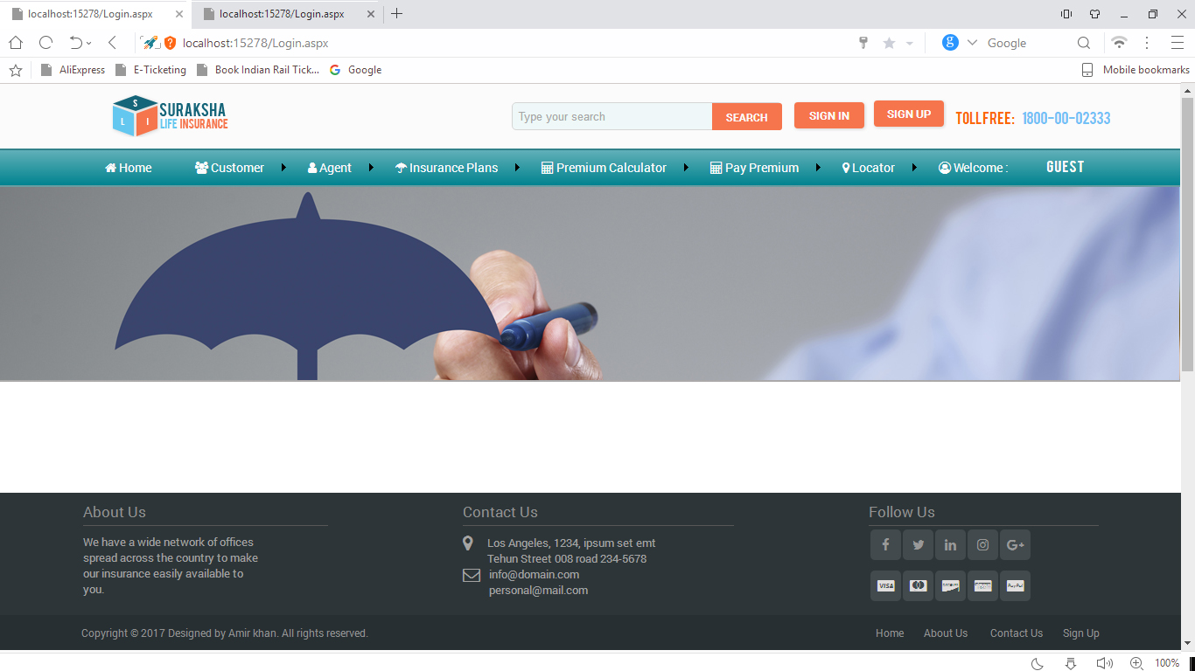

**MasterPage2.master**

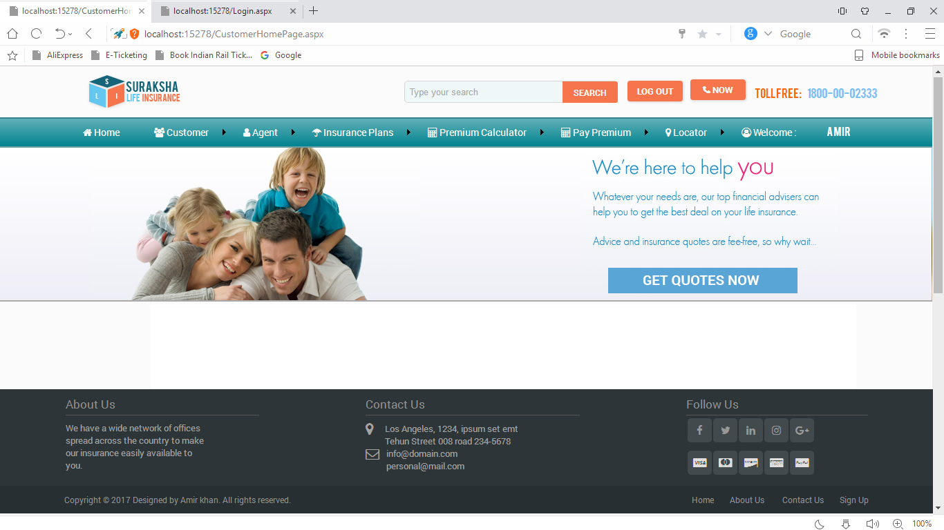

**Index.aspx**

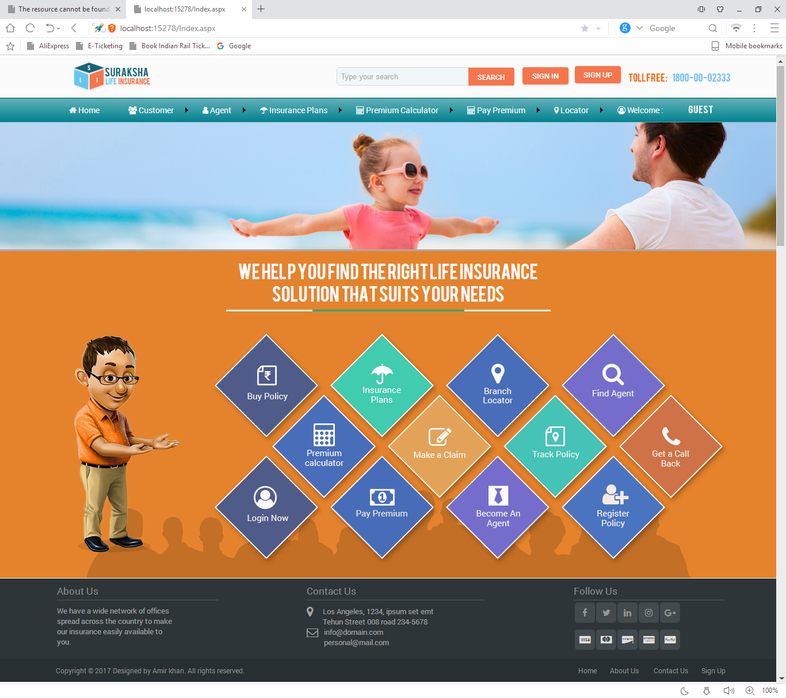

**AboutUs.aspx**

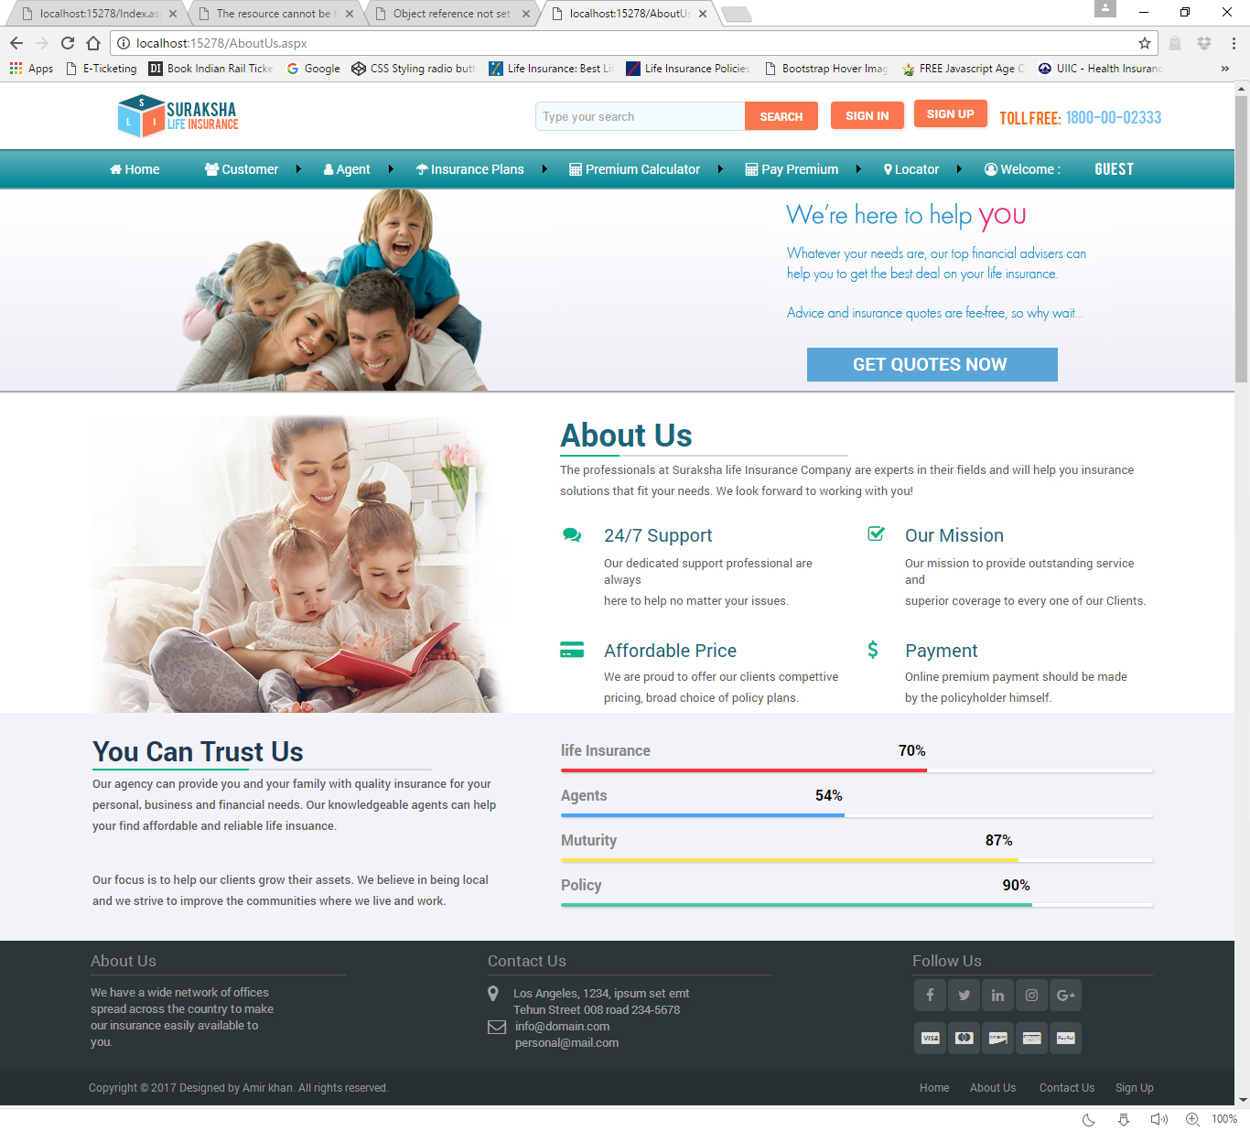

**ContactUs.aspx**

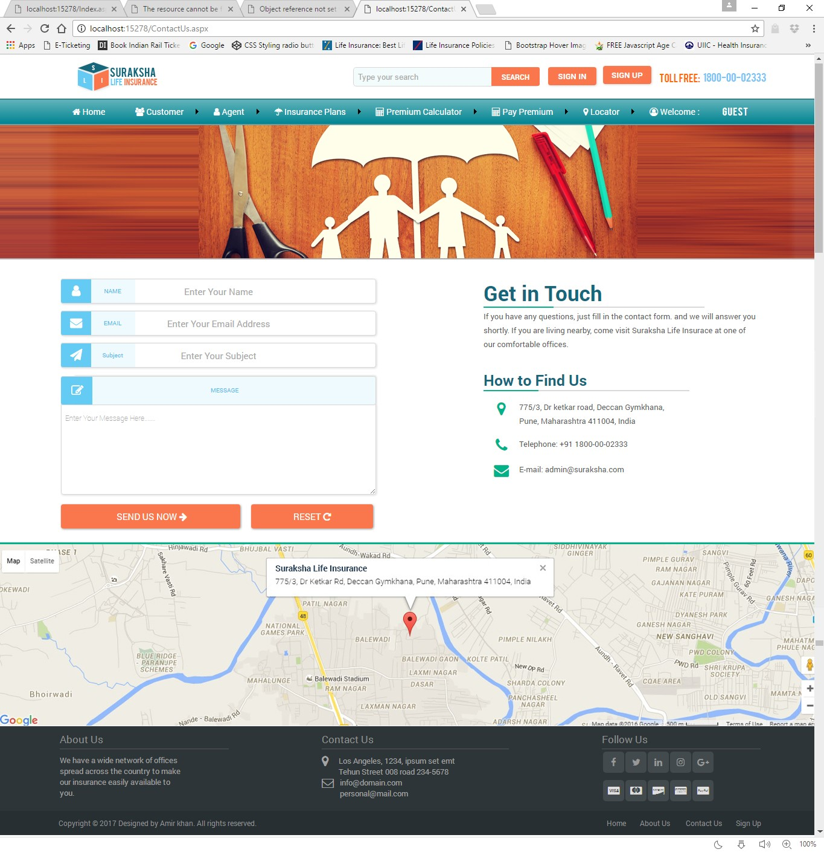

**Forgetpassword.aspx**

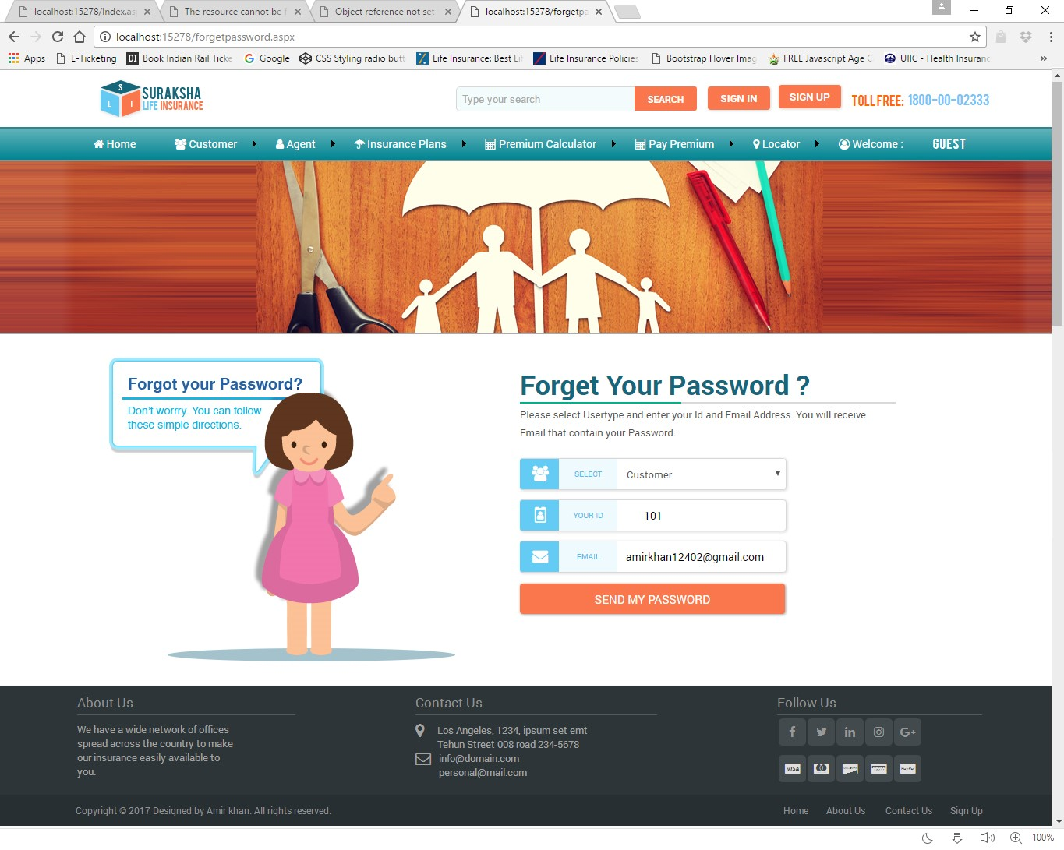

**InsurancePlans.aspx**

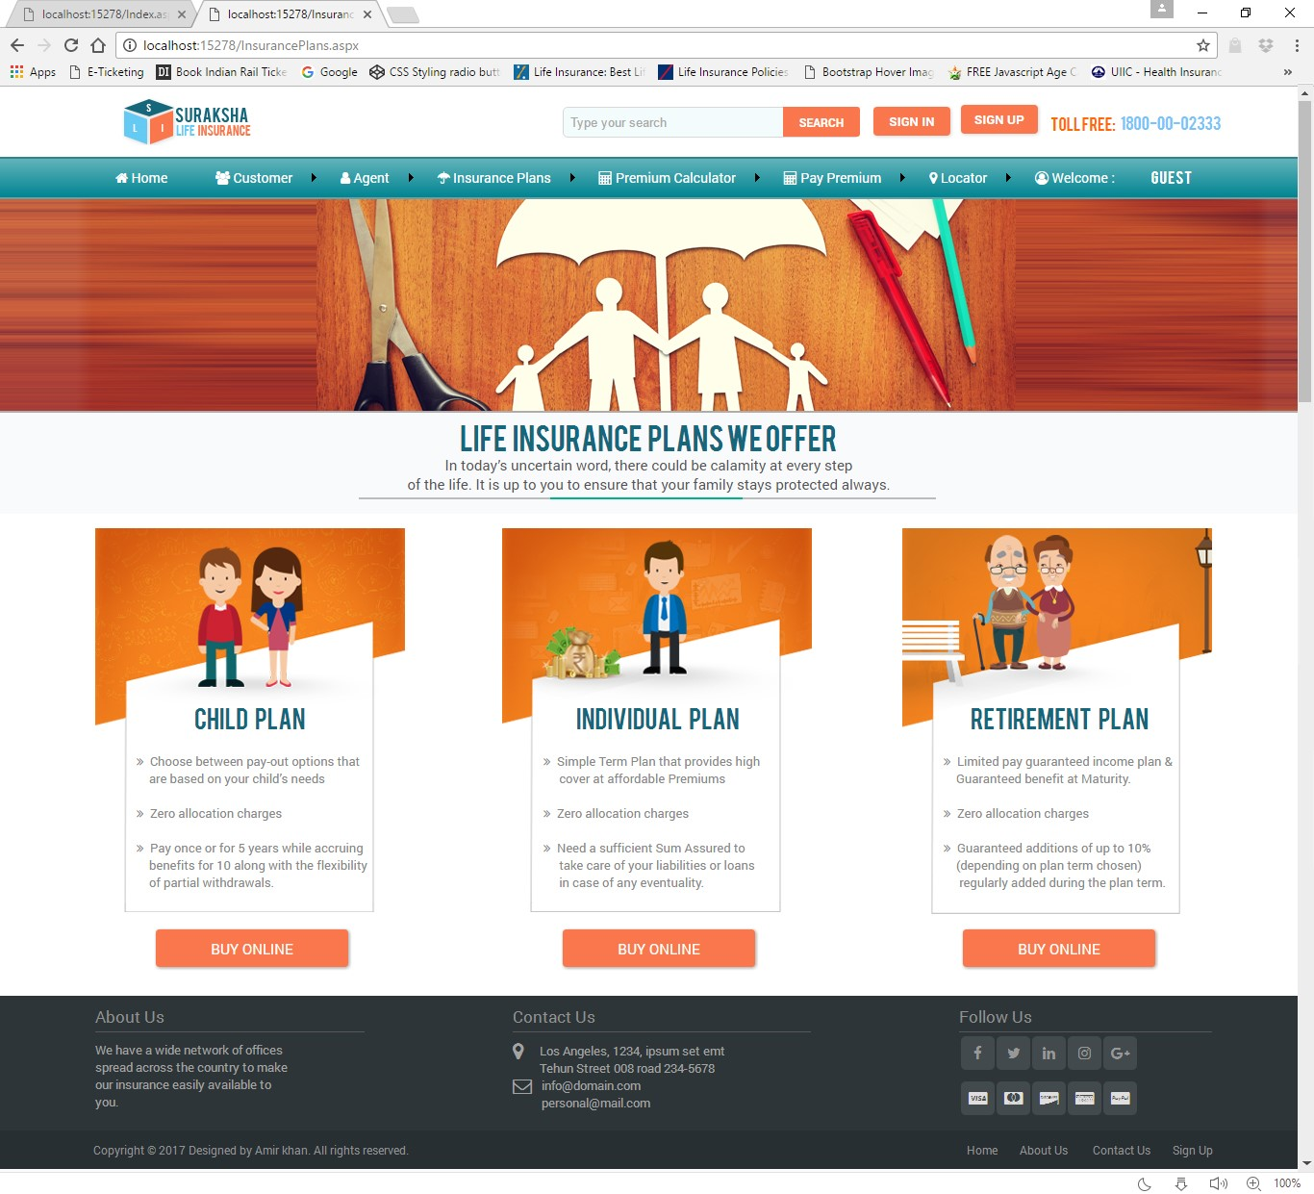

**SignUpPage.aspx**

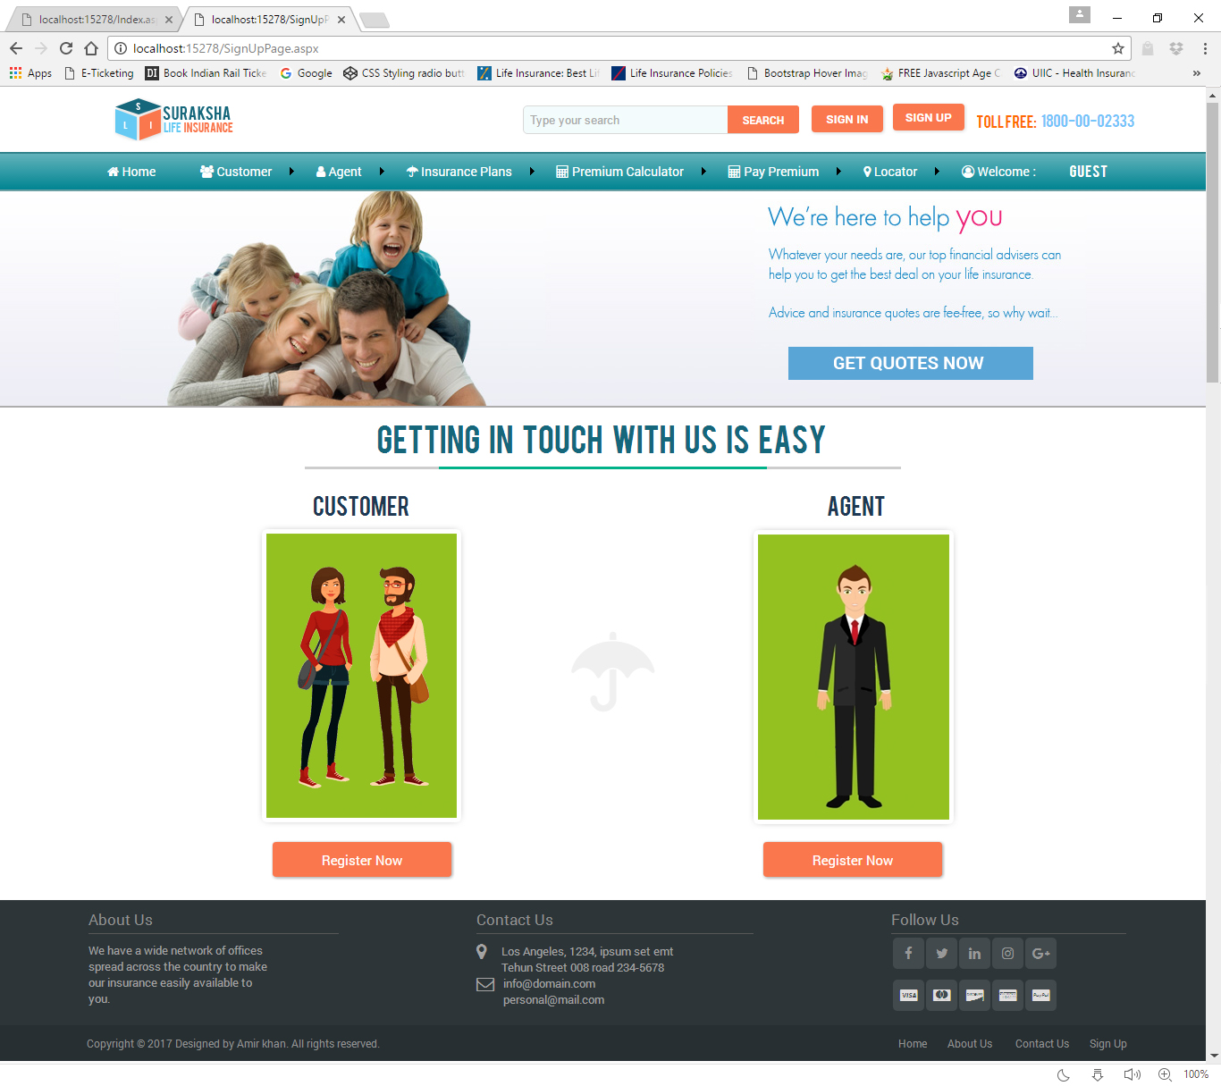

**CustomerRegistration.aspx**

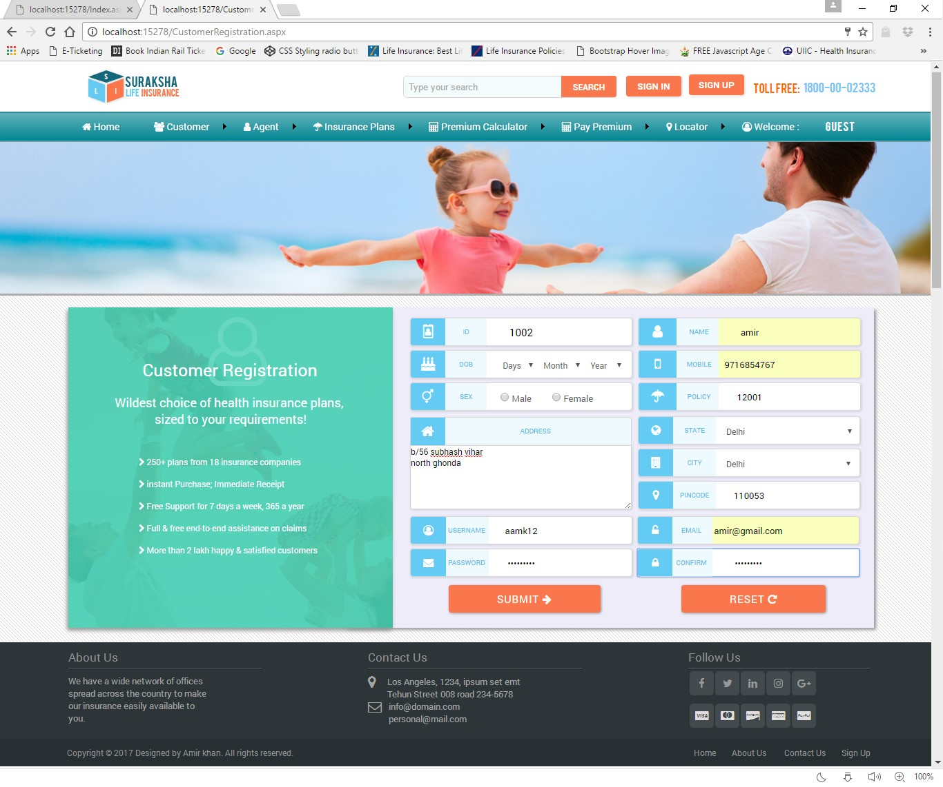

**AgentRegistration.aspx**

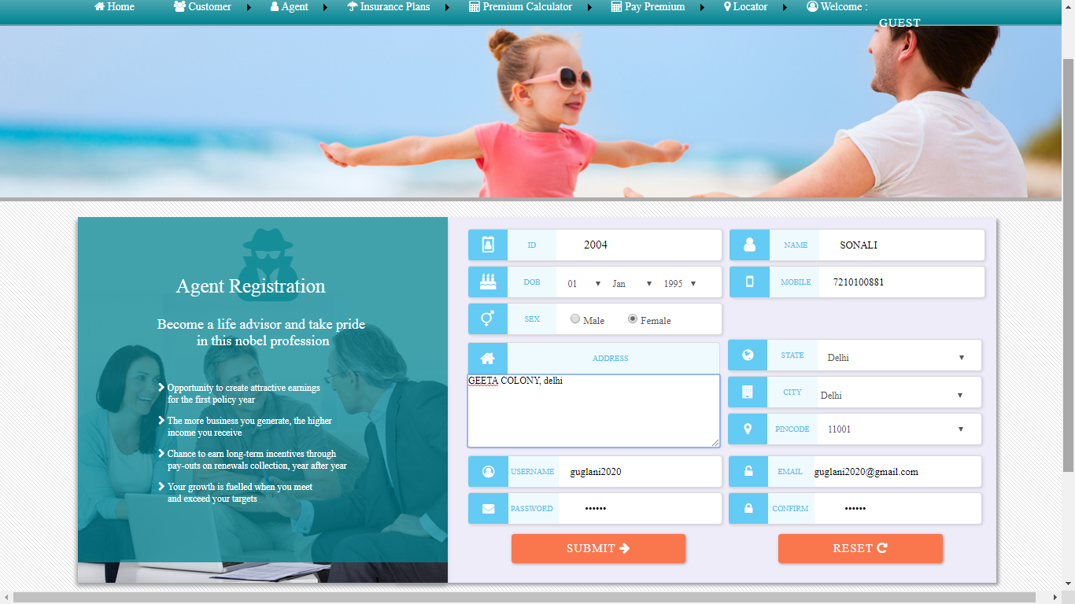

**Login.aspx**

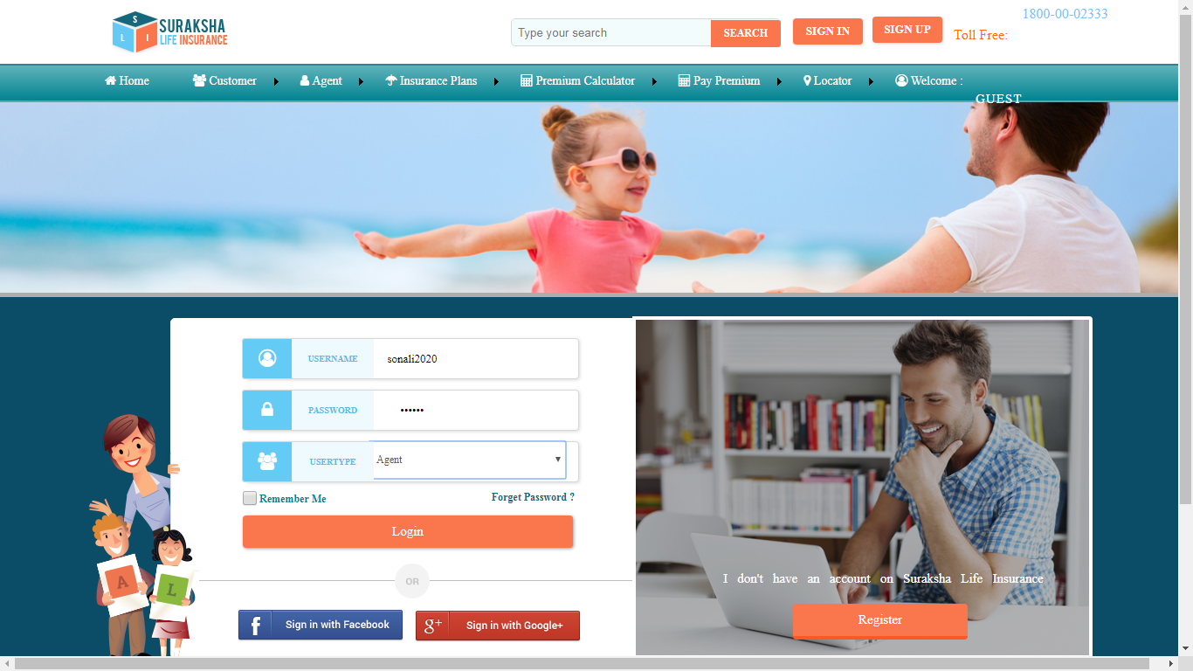

**CustomerHomePage.aspx**

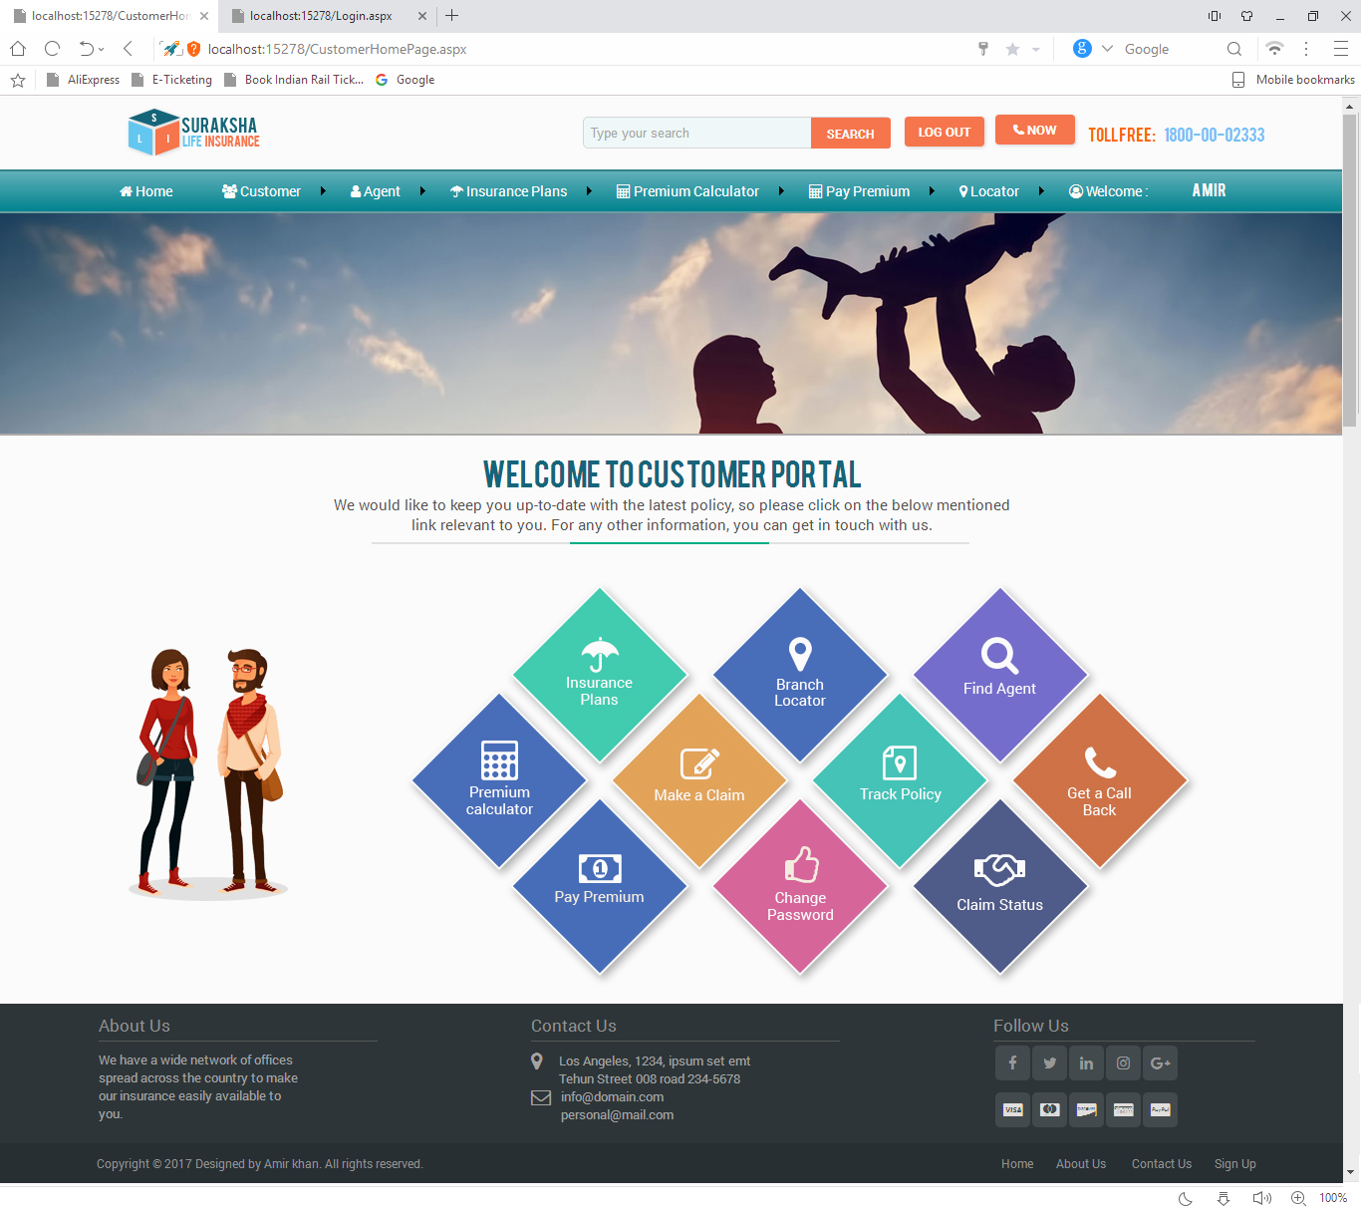

**AgentHomePage.aspx**

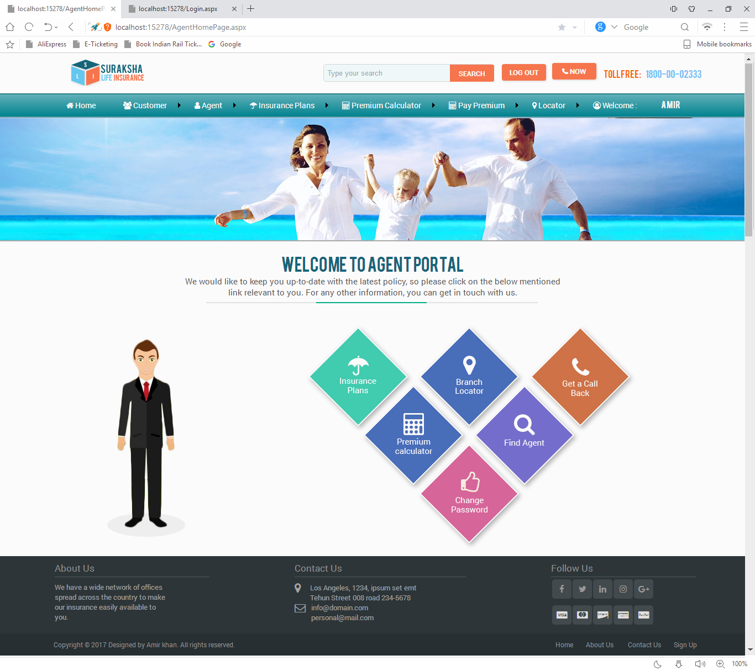

**Changepassword.aspx**

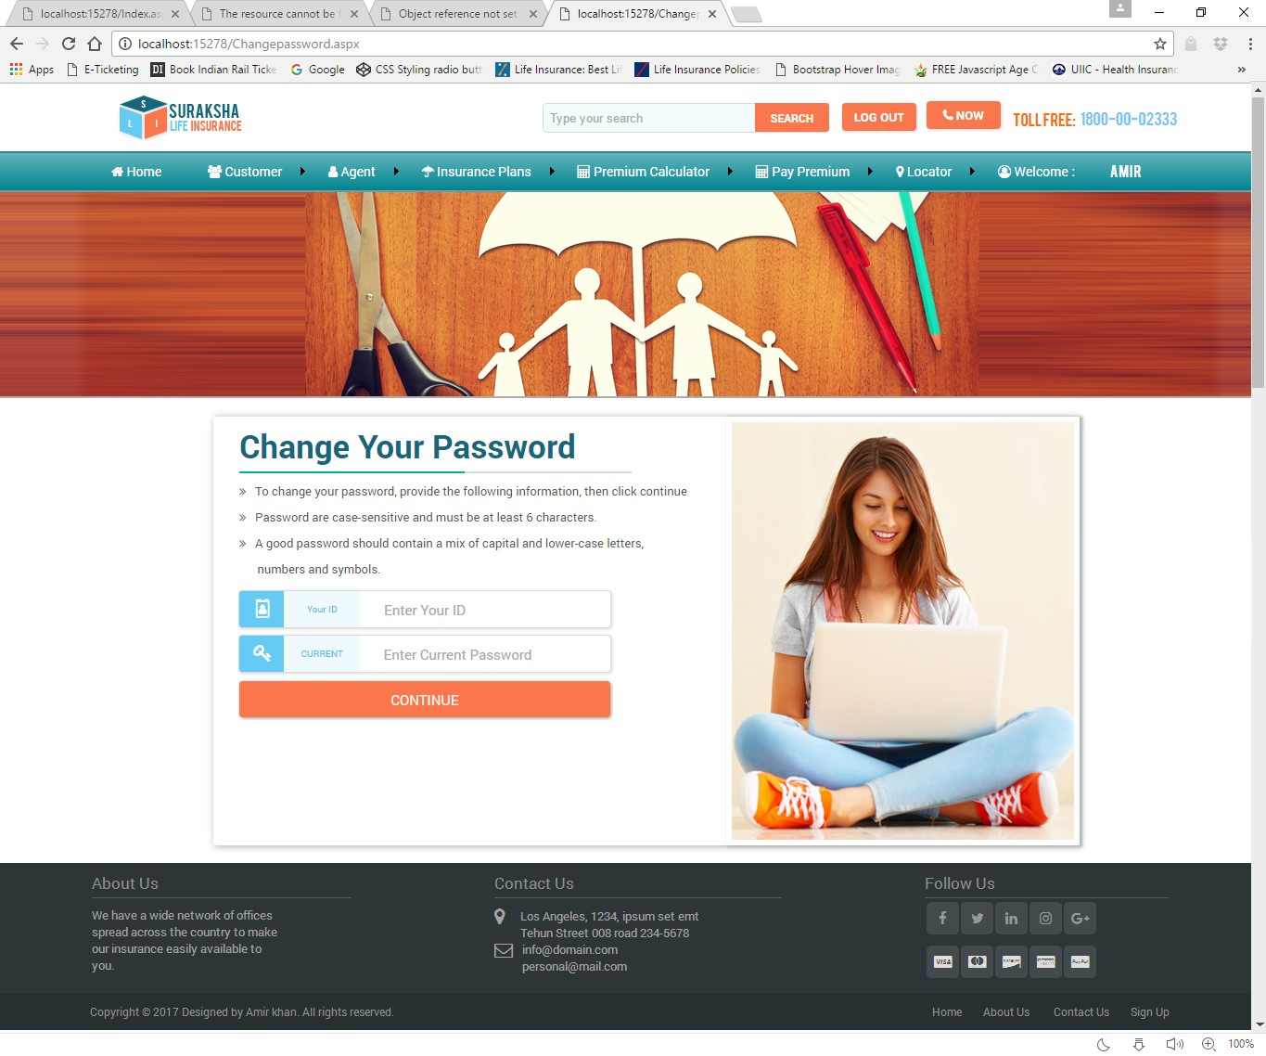

**ClaimPage.aspx**

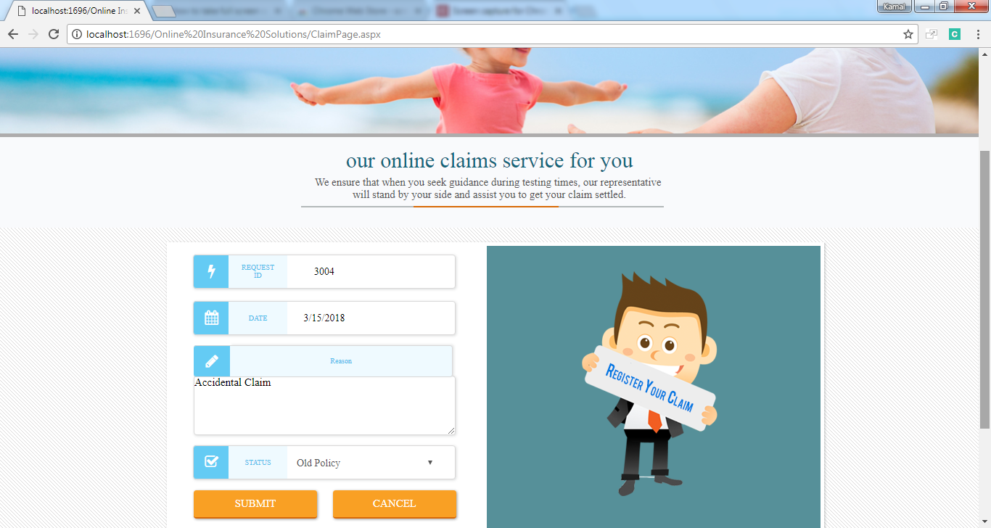

**PremiumCalculatorPage.aspx**

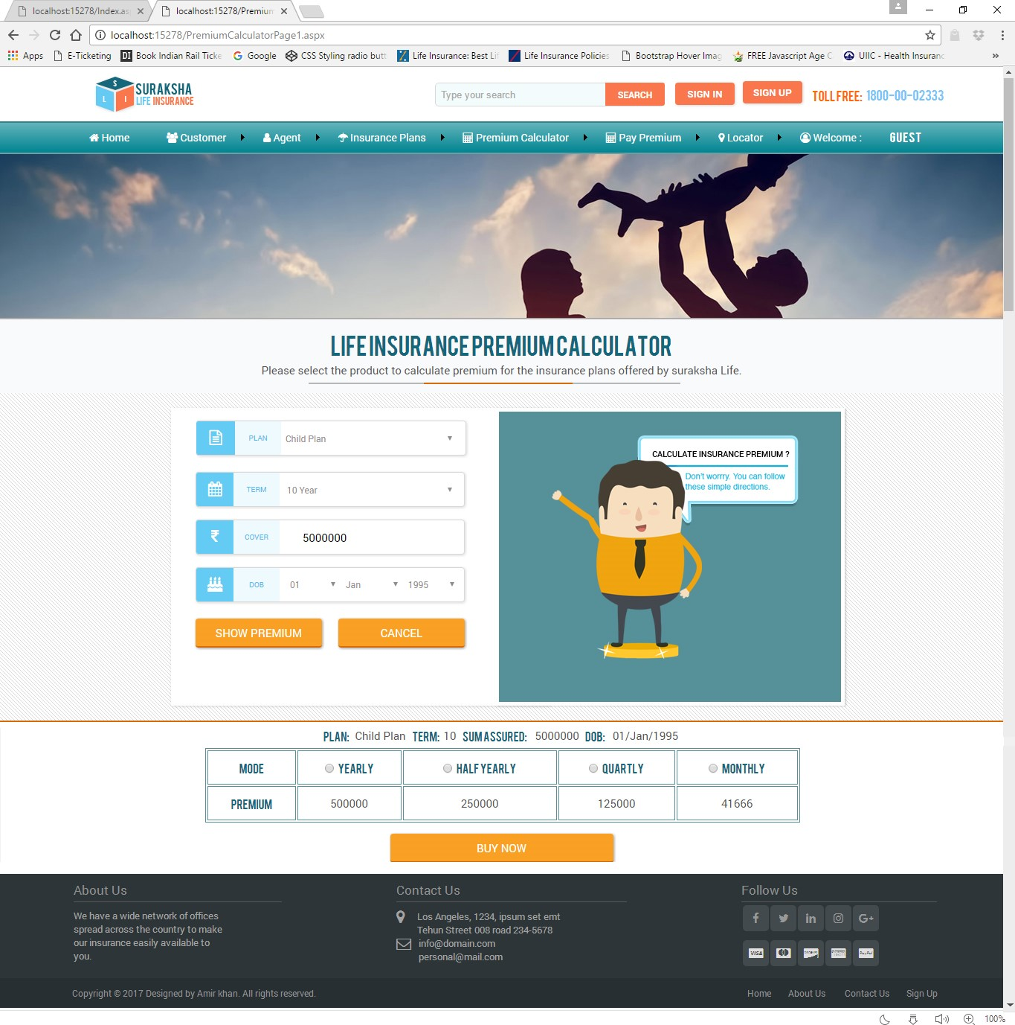

**PolicyformPage.aspx**

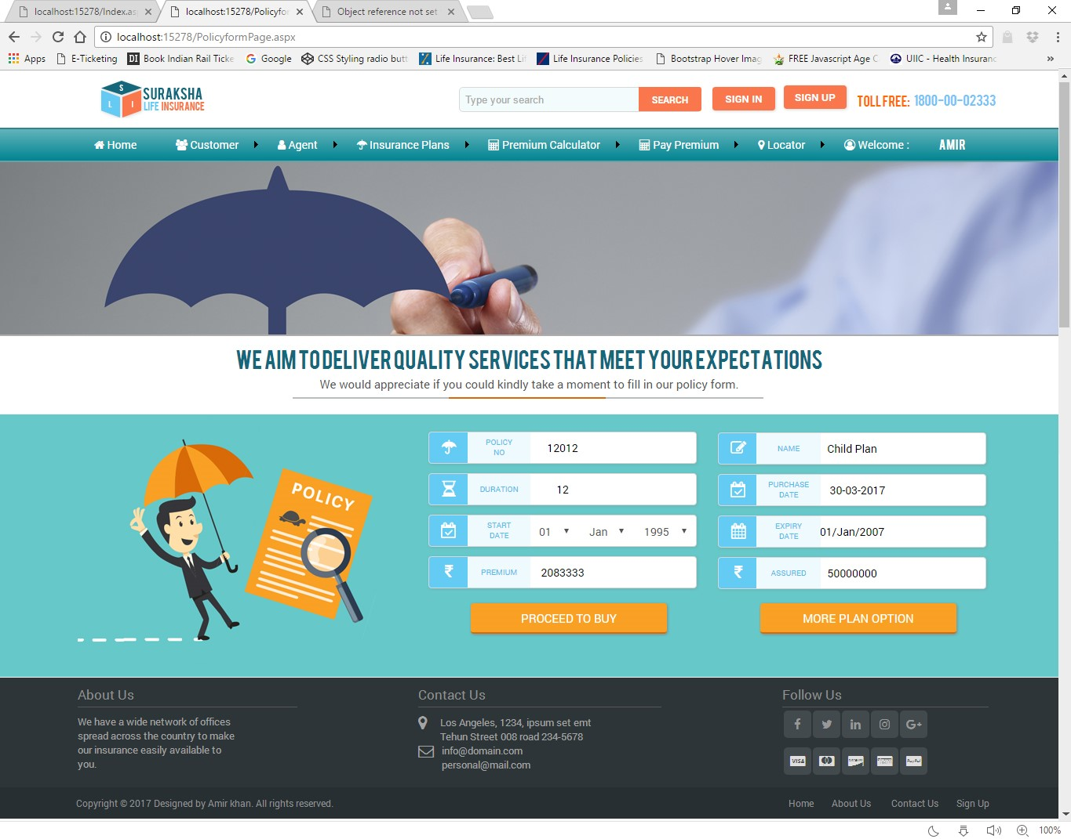

**PaymentPage.aspx**

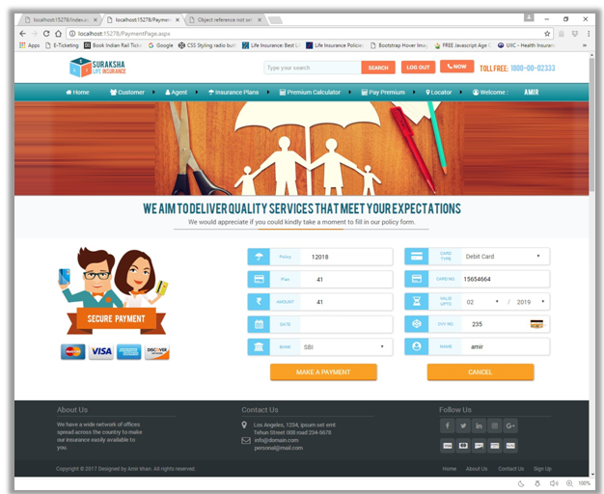

**ClaimStatus.aspx**

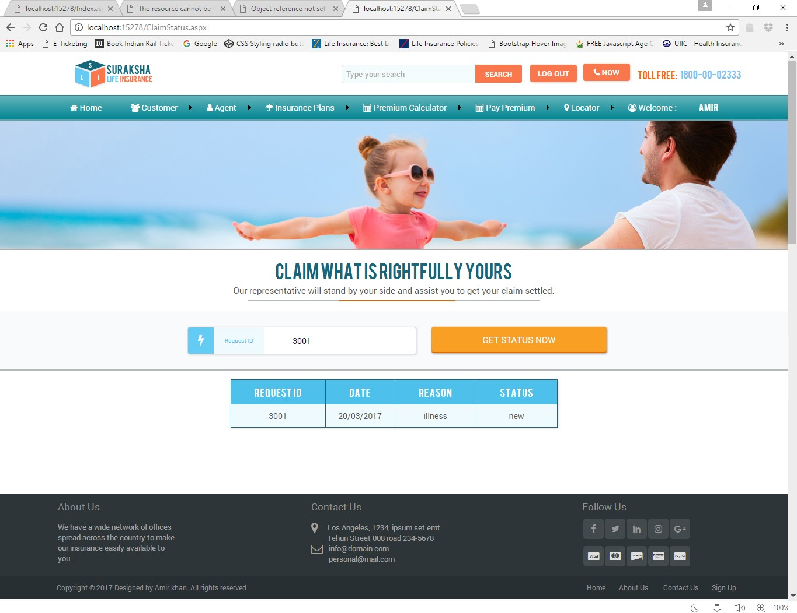

**PayPremiumPage.aspx**

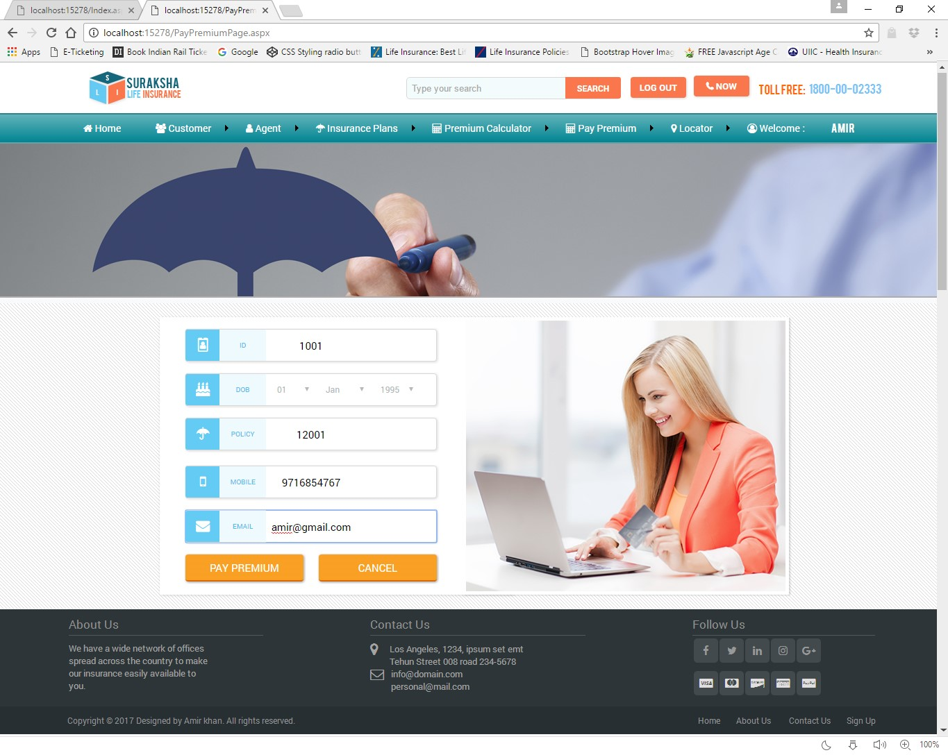

**PolicyStatus.aspx**

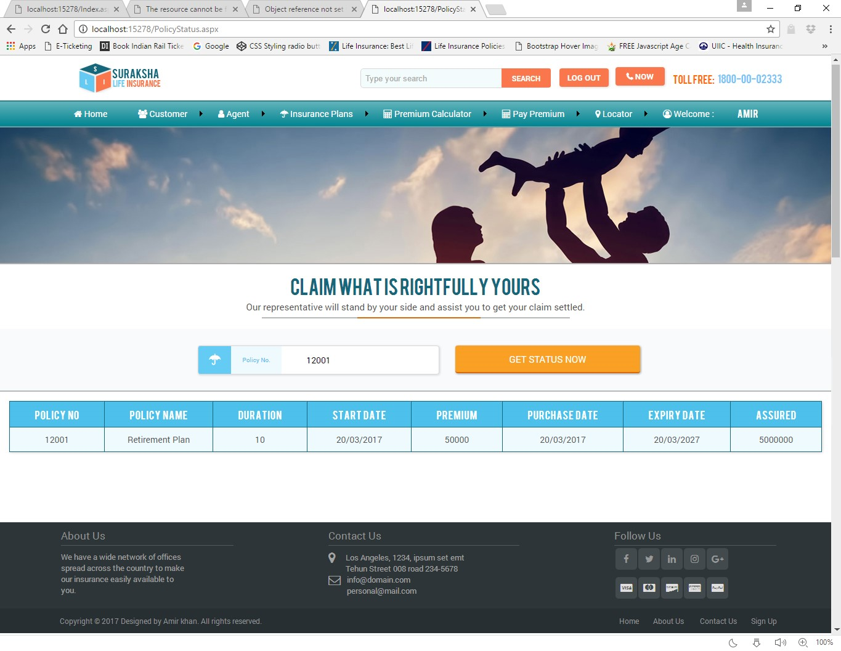

**AgentSearch.aspx**

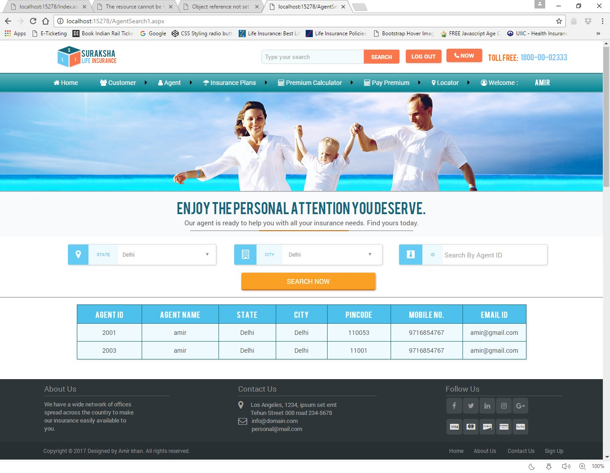

**OfficeSearch.aspx**

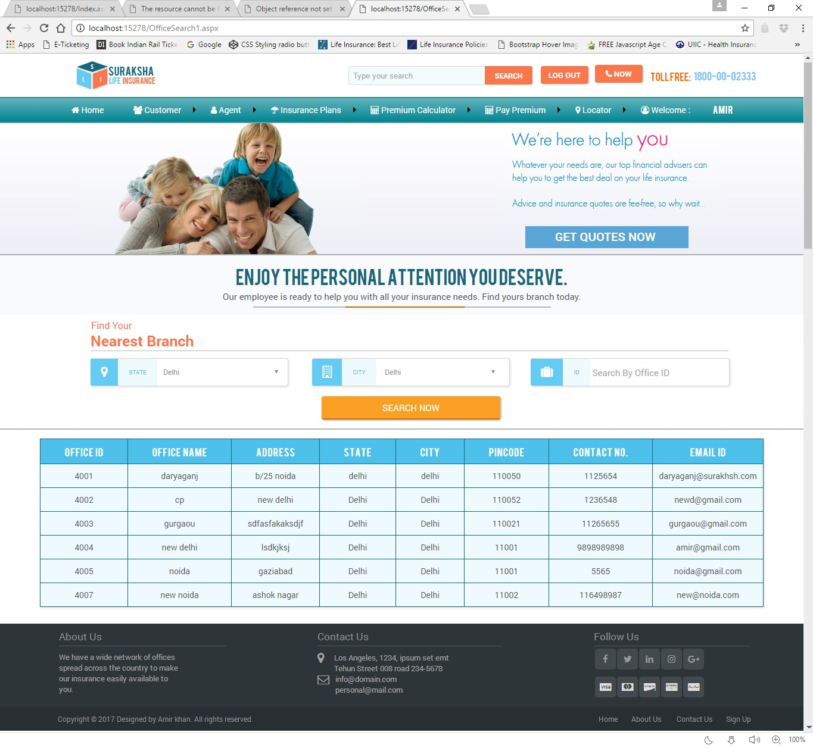

**AdminMasterPage2.master**

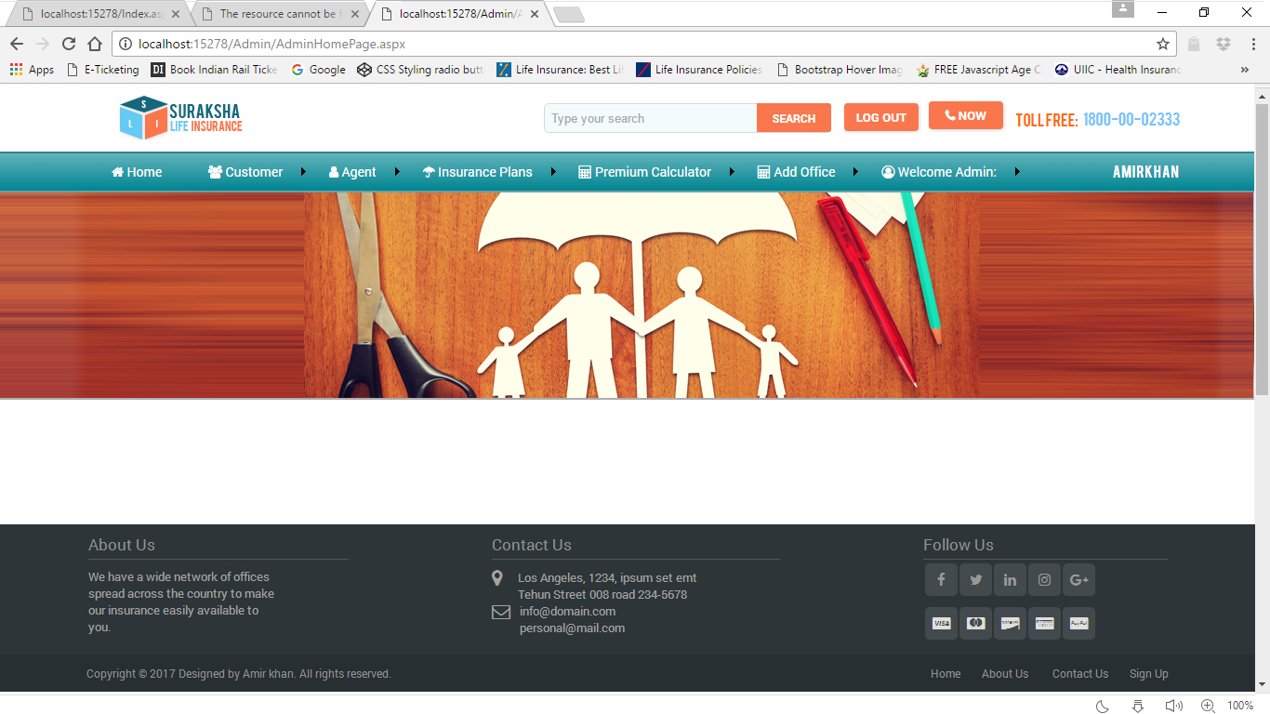

**AdminHomePage.aspx**

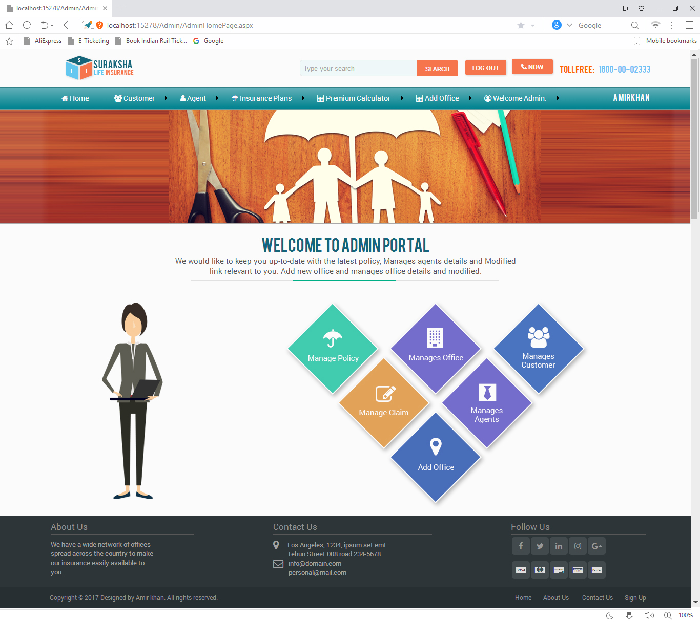

**AdminChangepassword.aspx**

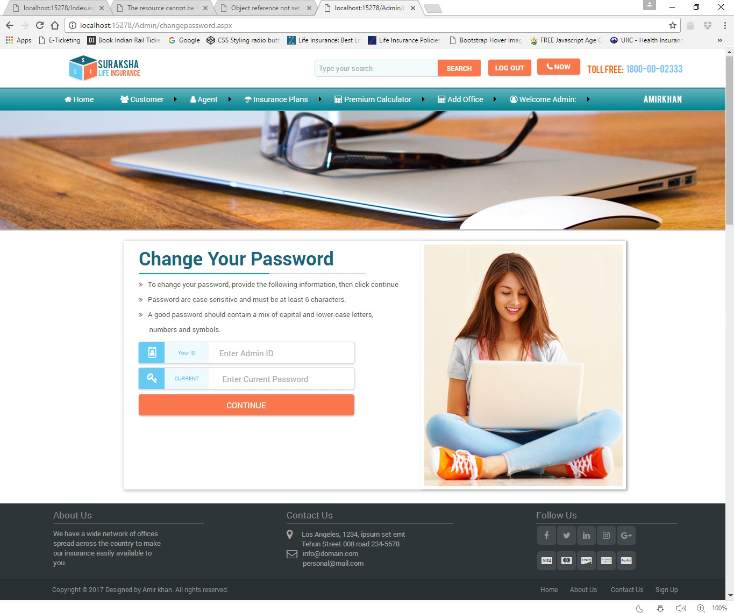

**AddOffice.aspx**

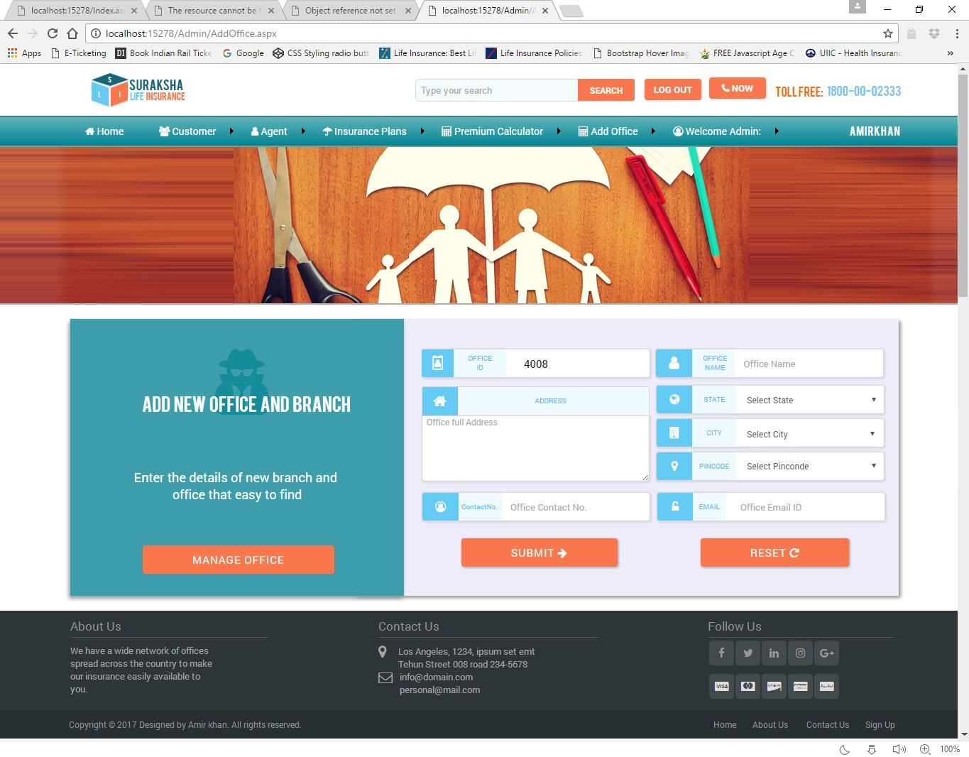

**ManageAgent.aspx**

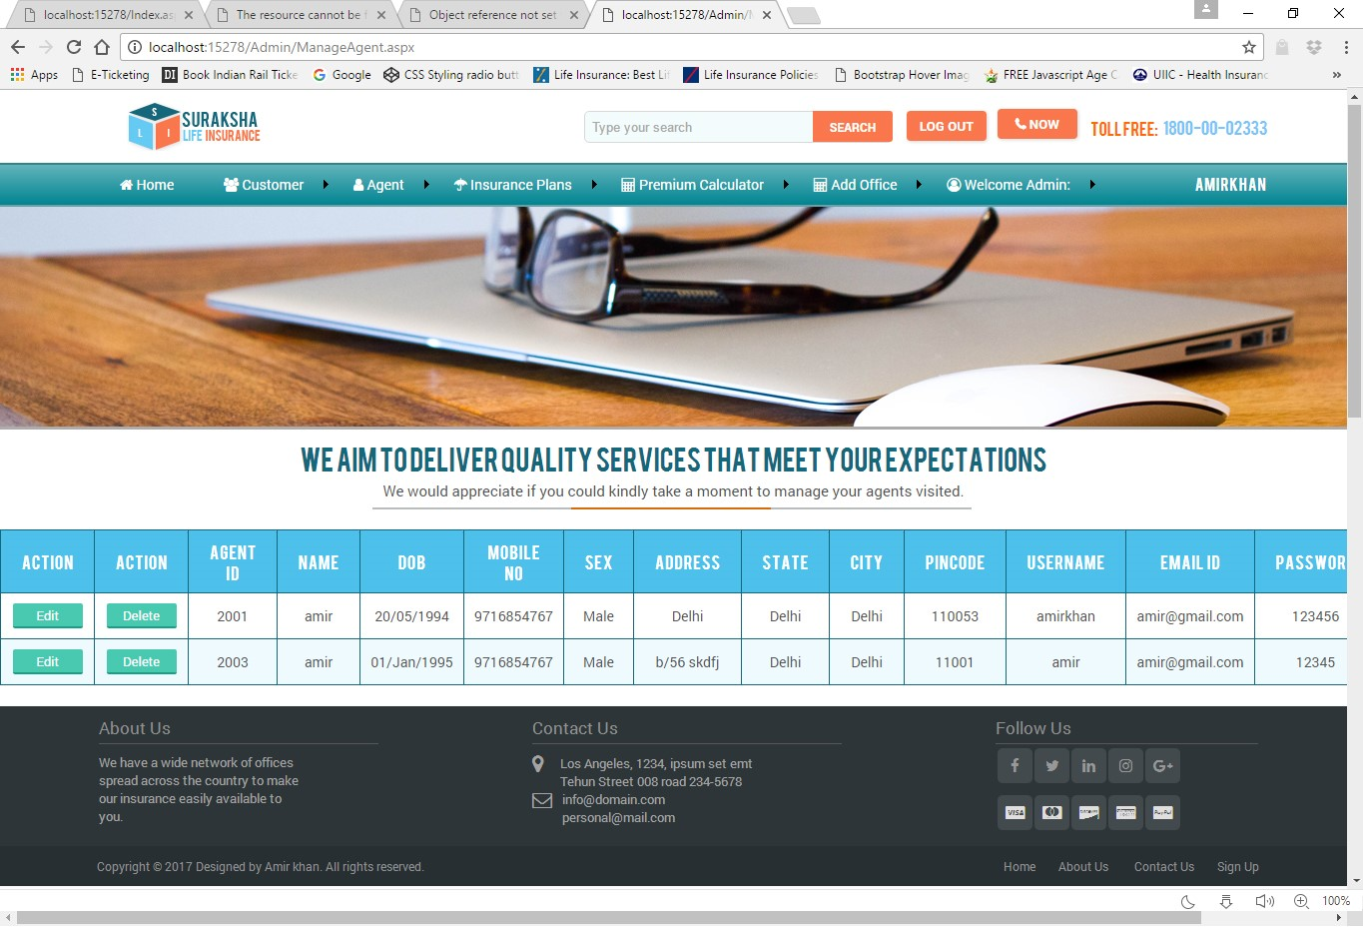

**ManageCustomer.aspx**

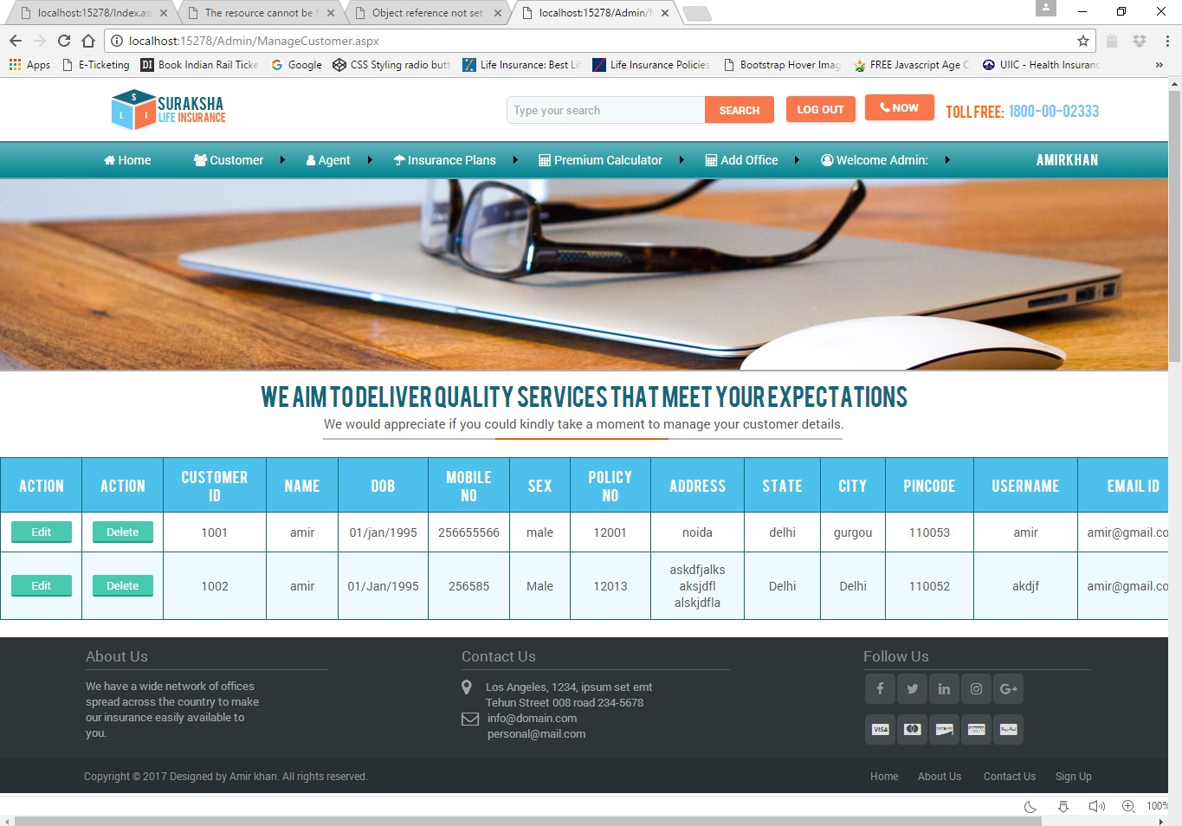

**ManageOffice.aspx**

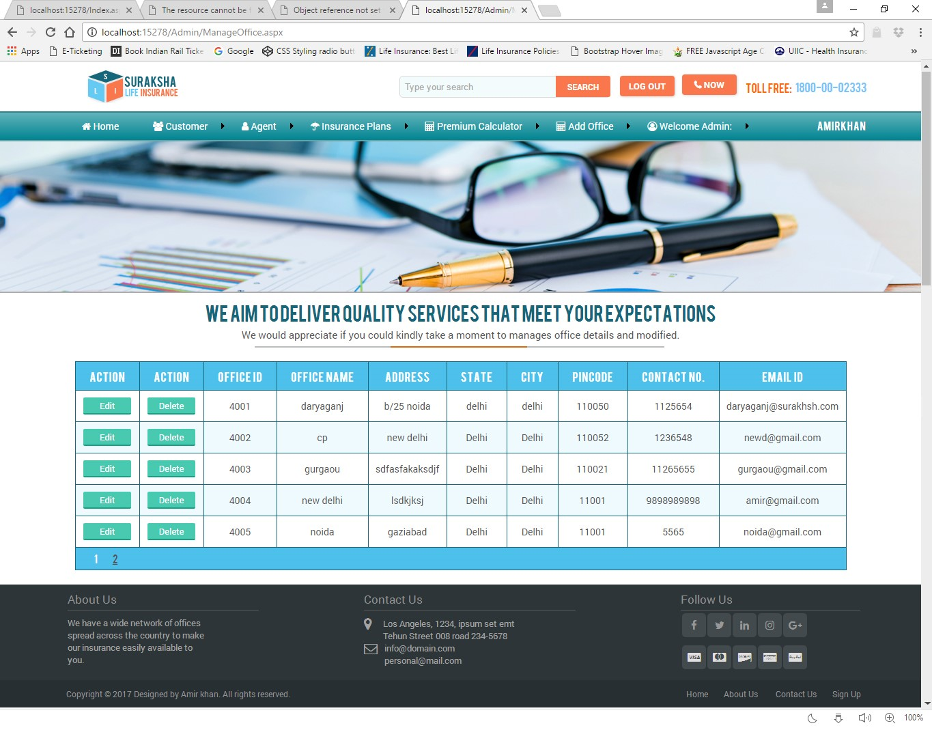

**ManagePolicy.aspx**

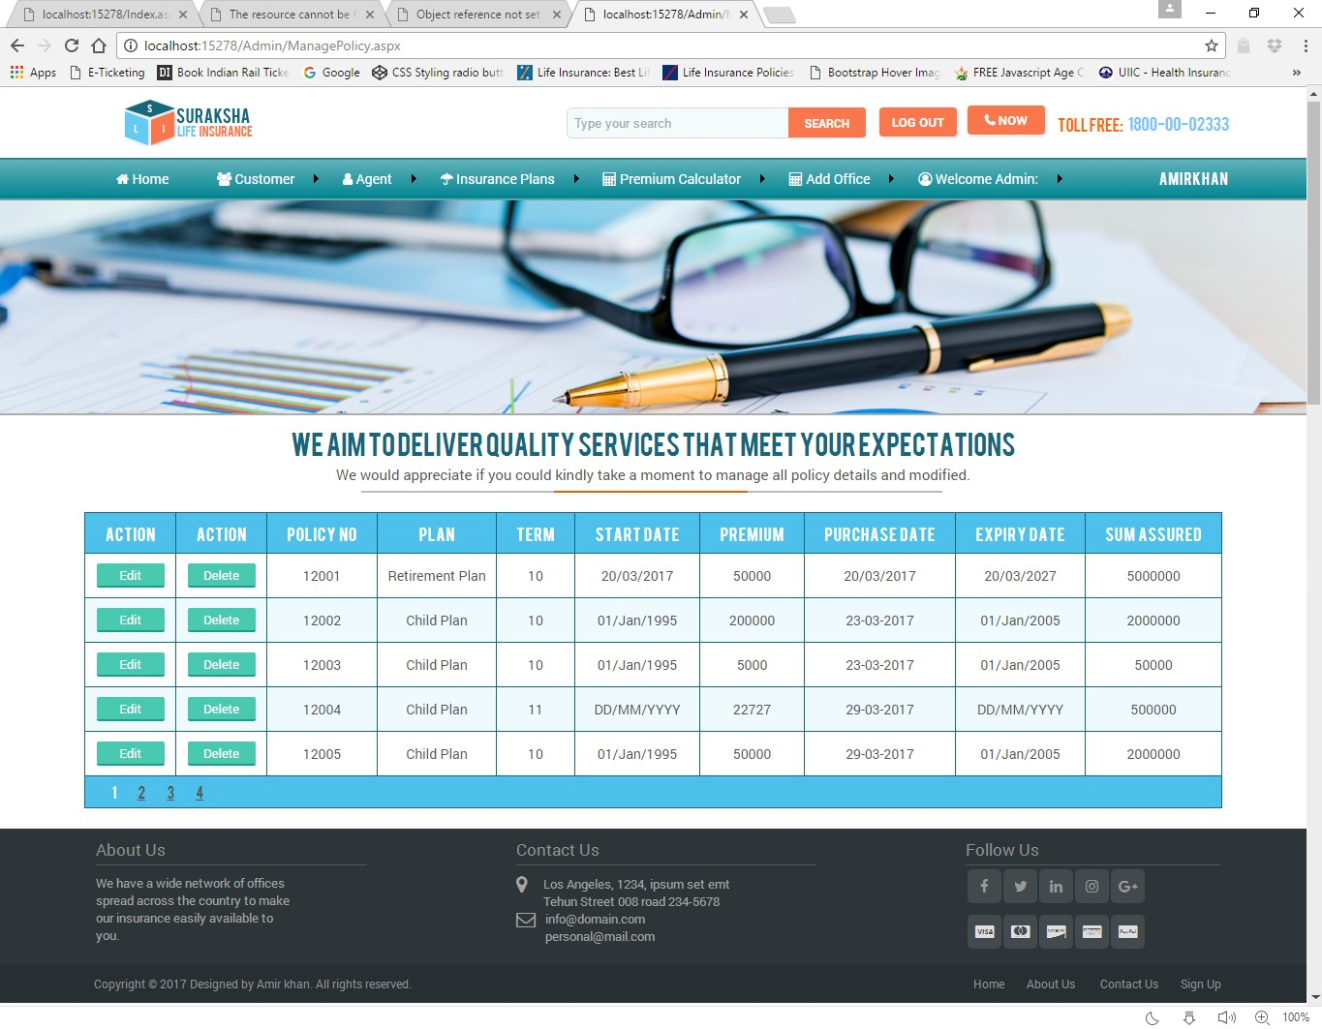

**LogOut.aspx**

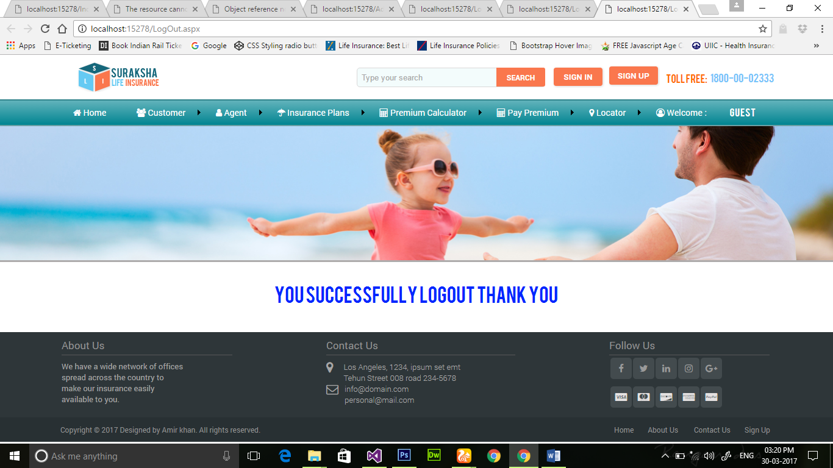

**Coding**

**with comments**

**MasterPage2.master.cs**

using System;

using System.Collections.Generic;

using System.Linq;

using System.Web;

using System.Web.UI;

using System.Web.UI.WebControls;

publicpartialclassMasterPage1 : System.Web.UI.MasterPage

{

protectedvoid Page_Load(object sender, EventArgs e)

{

if (Session["ctuser"] == null)

Response.Redirect("Login.aspx");

else

{

Label6.Visible = true;

Label6.Text = Session["ctuser"].ToString();

}

}

protectedvoid btnsignin_Click(object sender, EventArgs e)

{

Session.RemoveAll();

Session.Clear();

Response.Redirect("LogOut.aspx");

}

protectedvoid btnsignup_Click(object sender, EventArgs e)

{

Response.Redirect("ContactUs.aspx");

}

}

**Index.cs**

using System;

using System.Collections.Generic;

using System.Linq;

using System.Web;

using System.Web.UI;

using System.Web.UI.WebControls;

publicpartialclassHomePage : System.Web.UI.Page

{protectedvoid Page_Load(object sender, EventArgs e)

{}

protectedvoid ImageButton14_Click(object sender, ImageClickEventArgs e)

{

Response.Redirect("PremiumCalculatorPage1.aspx");

}

protectedvoid ImageButton15_Click(object sender, ImageClickEventArgs e)

{

Response.Redirect("InsurancePlans.aspx");

}

protectedvoid ImageButton16_Click(object sender, ImageClickEventArgs e)

{

Response.Redirect("OfficeSearch.aspx");

}

protectedvoid ImageButton17_Click(object sender, ImageClickEventArgs e)

{

Response.Redirect("AgentSearch.aspx");

}

protectedvoid ImageButton6_Click(object sender, ImageClickEventArgs e)

{

Response.Redirect("PremiumCalculatorPage1.aspx");

}

protectedvoid ImageButton7_Click(object sender, ImageClickEventArgs e)

{

Response.Redirect("ClaimPage.aspx");

}

protectedvoid ImageButton8_Click(object sender, ImageClickEventArgs e)

{

Response.Redirect("PolicyStatus.aspx");

}

protectedvoid ImageButton9_Click(object sender, ImageClickEventArgs e)

{

Response.Redirect("ContactUs.aspx");

}

protectedvoid ImageButton10_Click(object sender, ImageClickEventArgs e)

{

Response.Redirect("Login.aspx");

}

protectedvoid ImageButton11_Click(object sender, ImageClickEventArgs e)

{

Response.Redirect("PayPremiumPage.aspx");

}

protectedvoid ImageButton12_Click(object sender, ImageClickEventArgs e)

{

Response.Redirect("AgentRegistration.aspx");

}

protectedvoid ImageButton13_Click(object sender, ImageClickEventArgs e)

{

Response.Redirect("CustomerRegistration.aspx");

}

**SignUpPage.cs**

using System;

using System.Collections.Generic;

using System.Linq;

using System.Web;

using System.Web.UI;

using System.Web.UI.WebControls;

publicpartialclassSignUpPage : System.Web.UI.Page

{

protectedvoid Page_Load(object sender, EventArgs e)

{

}

protectedvoid Button1_Click(object sender, EventArgs e)

{

Response.Redirect("CustomerRegistration.aspx");

}

protectedvoid Button2_Click(object sender, EventArgs e)

{

Response.Redirect("AgentRegistration.aspx");

}

}

**CustomerRegistration.cs**

using System;

using System.Collections.Generic;

using System.Linq;

using System.Web;

using System.Web.UI;

using System.Web.UI.WebControls;

using System.Data;

using System.Data.SqlClient;

using System.Configuration;

publicpartialclassCustomerRegistration : System.Web.UI.Page

{

protectedvoid Page_Load(object sender, EventArgs e)

{

TextBox6.Text = Convert.ToString(Session["policyno"]);

SqlConnection con = newSqlConnection(ConfigurationManager.ConnectionStrings["dbcon"].ConnectionString);

con.Open();

string qry = "select max(CustId) from Customer";

SqlCommand cmd = newSqlCommand(qry, con);

SqlDataReader dr = cmd.ExecuteReader();

dr.Read();

int cid = Convert.ToInt32(dr[0]);

cid++;

TextBox1.Text = cid.ToString();

dr.Close();

con.Close();

}

protectedvoid Button1_Click(object sender, EventArgs e)

{

SqlConnection con = newSqlConnection(ConfigurationManager.ConnectionStrings["dbcon"].ConnectionString);

con.Open();

string qry = "insert into Customer values(@t1,@t2,@t3,@t4,@t5,@t6,@t7,@t8,@t9,@t10,@t11,@t12,@t13)";

SqlCommand cmd = newSqlCommand(qry, con);

cmd.Parameters.AddWithValue("@t1", TextBox1.Text);

cmd.Parameters.AddWithValue("@t2", TextBox4.Text);

string dob = DropDownList1.Text + "/" + DropDownList2.Text + "/" + DropDownList3.Text;

cmd.Parameters.AddWithValue("@t3", dob);

cmd.Parameters.AddWithValue("@t4", TextBox5.Text);

string s;

if(RadioButton1.Checked)

{

s = "Male";

}

else

{

s = "Female";

}

cmd.Parameters.AddWithValue("@t5", s);

cmd.Parameters.AddWithValue("@t6", TextBox6.Text);

cmd.Parameters.AddWithValue("@t7", TextBox15.Text);

cmd.Parameters.AddWithValue("@t8", DropDownList4.Text);

cmd.Parameters.AddWithValue("@t9", DropDownList5.Text);

cmd.Parameters.AddWithValue("@t10", TextBox10.Text);

cmd.Parameters.AddWithValue("@t11", TextBox11.Text);

cmd.Parameters.AddWithValue("@t12", TextBox13.Text);

cmd.Parameters.AddWithValue("@t13", TextBox14.Text);

int i = cmd.ExecuteNonQuery();

if(i==1)

{

Response.Redirect("Login.aspx");

}

else

{

Label1.Visible = true;

Label1.Text = "Please Check Details";

}

}

protectedvoid Button2_Click(object sender, EventArgs e)

{

TextBox11.Text = "";

TextBox12.Text = "";

TextBox13.Text = "";

TextBox14.Text = "";

TextBox15.Text = "";

TextBox4.Text = "";

TextBox5.Text = "";

}

}

**AgentRegistration.cs**

using System;

using System.Collections.Generic;

using System.Linq;

using System.Web;

using System.Web.UI;

using System.Web.UI.WebControls;

using System.Data;

using System.Data.SqlClient;

using System.Configuration;

publicpartialclassCustomerRegistration : System.Web.UI.Page

{

protectedvoid Page_Load(object sender, EventArgs e)

{

SqlConnection con = newSqlConnection(ConfigurationManager.ConnectionStrings["dbcon"].ConnectionString);

con.Open();

string qry = "select max(AgentId) from Agent";

SqlCommand cmd = newSqlCommand(qry, con);

SqlDataReader dr = cmd.ExecuteReader();

dr.Read();

int cid = Convert.ToInt32(dr[0]);

cid++;

TextBox1.Text = cid.ToString();

dr.Close();

con.Close();

}

protectedvoid Button1_Click(object sender, EventArgs e)

{

SqlConnection con = newSqlConnection(ConfigurationManager.ConnectionStrings["dbcon"].ConnectionString);

con.Open();

string qry = "insert into Agent values(@t1,@t2,@t3,@t4,@t5,@t6,@t7,@t8,@t9,@t10,@t11,@t12)";

SqlCommand cmd = newSqlCommand(qry, con);

cmd.Parameters.AddWithValue("@t1", TextBox1.Text);

cmd.Parameters.AddWithValue("@t2", TextBox4.Text);

string dob = DropDownList1.Text + "/" + DropDownList2.Text + "/" + DropDownList3.Text;

cmd.Parameters.AddWithValue("@t3", dob);

cmd.Parameters.AddWithValue("@t4", TextBox5.Text);

string s;

if(RadioButton1.Checked)

{

s = "Male";

}

else

{

s = "Female";

}

cmd.Parameters.AddWithValue("@t5", s);

cmd.Parameters.AddWithValue("@t6", TextBox15.Text);

cmd.Parameters.AddWithValue("@t7", DropDownList4.Text);

cmd.Parameters.AddWithValue("@t8", DropDownList5.Text);

cmd.Parameters.AddWithValue("@t9", DropDownList6.Text);

cmd.Parameters.AddWithValue("@t10", TextBox11.Text);

cmd.Parameters.AddWithValue("@t11", TextBox13.Text);

cmd.Parameters.AddWithValue("@t12", TextBox14.Text);

int i = cmd.ExecuteNonQuery();

if(i==1)

{

Response.Redirect("Login.aspx");

}

else

{

Label1.Visible = true;

Label1.Text = "Invalid Details";

}

}

protectedvoid Button2_Click(object sender, EventArgs e)

{

TextBox11.Text = "";

TextBox12.Text = "";

TextBox13.Text = "";

TextBox14.Text = "";

TextBox15.Text = "";

TextBox4.Text = "";

TextBox5.Text = "";

}

}

**Login.cs**

using System;

using System.Collections.Generic;

using System.Linq;

using System.Web;

using System.Web.UI;

using System.Web.UI.WebControls;

using System.Data;

using System.Data.SqlClient;

using System.Configuration;

publicpartialclassLogin : System.Web.UI.Page

{

protectedvoid Page_Load(object sender, EventArgs e)

{

}

protectedvoid Button2_Click(object sender, EventArgs e)

{

Response.Redirect("SignUpPage.aspx");

}

protectedvoid Button1_Click(object sender, EventArgs e)

{

if(DropDownList1.SelectedIndex==0)

{

Label1.Visible = true;

Label1.Text = "Please Select User Type";

}

elseif (DropDownList1.SelectedIndex==1)

{

SqlConnection con = newSqlConnection(ConfigurationManager.ConnectionStrings["dbcon"].ConnectionString); //creating connection with db

con.Open(); //open db connection

string qry = "select * from Customer where usernm=@t1 and passwd=@t2"; //creating SQL query

SqlCommand cmd = newSqlCommand(qry, con); // sending SQL query for execution

cmd.Parameters.AddWithValue("@t1", txtusername.Text); // adding values to query parameters

cmd.Parameters.AddWithValue("@t2", txtpassword.Text);

SqlDataReader dr = cmd.ExecuteReader(); // Executing Sql query & Reading output

if (dr.HasRows) // if username/password matched

{

dr.Read();

Session["ctuser"] = txtusername.Text;

Response.Redirect("CustomerHomePage.aspx"); //redirecting to homepage2

}

else

{

Label1.Visible = true; // if mismatched then error message

Label1.Text = "Invalid Username and Password";

}

}

elseif(DropDownList1.SelectedIndex==2)

{

SqlConnection con = newSqlConnection(ConfigurationManager.ConnectionStrings["dbcon"].ConnectionString); //creating connection with db

con.Open(); //open db connection

string qry = "select * from Agent where usernm=@t1 and passwd=@t2"; //creating SQL query

SqlCommand cmd = newSqlCommand(qry, con); // sending SQL query for execution

cmd.Parameters.AddWithValue("@t1", txtusername.Text); // adding values to query parameters

cmd.Parameters.AddWithValue("@t2", txtpassword.Text);

SqlDataReader dr = cmd.ExecuteReader(); // Executing Sql query & Reading output

if (dr.HasRows) // if username/password matched

{

dr.Read();

Session["aguser"] = txtusername.Text;

Response.Redirect("AgentHomePage.aspx"); //redirecting to homepage2

}

else

{

Label1.Visible = true; // if mismatched then error message

Label1.Text = "Invalid Username and Password";

}

}

elseif(DropDownList1.SelectedIndex==3)

{

SqlConnection con = newSqlConnection(ConfigurationManager.ConnectionStrings["dbcon"].ConnectionString); //creating connection with db

con.Open(); //open db connection

string qry = "select * from Admin where usernm=@t1 and passwd=@t2"; //creating SQL query

SqlCommand cmd = newSqlCommand(qry, con); // sending SQL query for execution

cmd.Parameters.AddWithValue("@t1", txtusername.Text); // adding values to query parameters

cmd.Parameters.AddWithValue("@t2", txtpassword.Text);

SqlDataReader dr = cmd.ExecuteReader(); // Executing Sql query & Reading output

if (dr.HasRows) // if username/password matched

{

dr.Read();

Session["aduser"] = txtusername.Text;

Response.Redirect("Admin/AdminHomePage.aspx"); //redirecting to homepage2

}

else

{

Label1.Visible = true; // if mismatched then error message

Label1.Text = "Invalid Username and Password";

}

}

}

}

**Forgetpassword.cs**

using System;

using System.Collections.Generic;

using System.Linq;

using System.Web;

using System.Web.UI;

using System.Web.UI.WebControls;

using System.Data;

using System.Data.SqlClient;

using System.Configuration;

using System.Net.Mail;

publicpartialclassforgetpassword : System.Web.UI.Page

{

protectedvoid Page_Load(object sender, EventArgs e)

{

}

protectedvoid Button1_Click(object sender, EventArgs e)

{

if(DropDownList1.SelectedIndex==0)

{

Label6.Visible = true;

Label6.Text = "Please Select UserType";

}

elseif (DropDownList1.SelectedIndex == 1)

{

SqlConnection con = newSqlConnection(ConfigurationManager.ConnectionStrings["dbcon"].ConnectionString); //creating connection with db

con.Open(); //open db connection

string qry = "select * from Customer where CustId=@t1 and emailid=@t2"; //creating SQL query

SqlCommand cmd = newSqlCommand(qry, con); // sending SQL query for execution

cmd.Parameters.AddWithValue("@t1", TextBox2.Text); // adding values to query parameters

cmd.Parameters.AddWithValue("@t2", TextBox3.Text);

SqlDataReader dr = cmd.ExecuteReader(); // Executing Sql query & Reading output

if (dr.HasRows) // if username matched

{

MailMessage msg = newMailMessage(); //Create a mailmessage variable

msg.To.Add(TextBox3.Text); //Adding value to send

dr.Read();

msg.Subject="Your Password";

msg.Body = "Your Username is:" + dr["usernm"].ToString() + "and Password is:" + dr["passwd"].ToString(); //Send body of msg

msg.IsBodyHtml = true;

msg.From = newMailAddress("sonaliguglani2020@gmail.com");

SmtpClient sm = newSmtpClient(); //Create smtpclient

sm.Port = 587; //Gmail mail port number

sm.Host = "smtp.gmail.com"; //Gmail host name

sm.Credentials = new System.Net.NetworkCredential("sonaliguglani2020@gmail.com", "sonali1234"); //Receive mail

sm.EnableSsl = false;

// sm.Send(msg);

Label6.Visible = true;

Label6.Text = "UserName and Password has been sent to your Email Id"; //Show msg mail send

}

else

{

Label6.Visible = true;

Label6.Text = "Email id Does Not Exists"; //Show msg mail not send

}

}

}

}

**ContactUs.cs**

using System;

using System.Collections.Generic;

using System.Linq;

using System.Web;

using System.Web.UI;

using System.Web.UI.WebControls;

using System.Net.Mail;

publicpartialclassContactUs : System.Web.UI.Page

{

protectedvoid SendMail()

{

var fromAddress = "sonaliguglani2020@gmail.com";

var toaddress = TextBox2.Text.ToString();

conststring frompassword = "sonali1234";

string subject = TextBox3.Text.ToString();

string body = "form:" + TextBox1.Text + "\n";

body += "Email:" + TextBox2.Text + "\n";

body += "Subject:" + TextBox3.Text + "\n";

body += "Question:" + TextBox4.Text + "\n";

var smtp = newSmtpClient();

{

smtp.Host = "smtp.gmail.com";

smtp.Port = 587;

smtp.EnableSsl = true;

smtp.DeliveryMethod = SmtpDeliveryMethod.Network;

smtp.Credentials = new System.Net.NetworkCredential(fromAddress, frompassword);

smtp.Timeout = 20000;

}

}

protectedvoid Page_Load(object sender, EventArgs e)

{

Label1.Visible = false;

}

protectedvoid Button1_Click(object sender, EventArgs e)

{

SendMail();

Label1.Visible = true;

Label1.Text = "Your Mail Has been Sent";

TextBox1.Text = "";

TextBox2.Text = "";

TextBox3.Text = "";

TextBox4.Text = "";

}

protectedvoid Button2_Click(object sender, EventArgs e)

{

Response.Redirect("Index.aspx");

}

}

**Changepassword.cs**

using System;

using System.Collections.Generic;

using System.Linq;

using System.Web;

using System.Web.UI;

using System.Web.UI.WebControls;

using System.Data;

using System.Data.SqlClient;

using System.Configuration;

publicpartialclasschangepassword : System.Web.UI.Page

{

protectedvoid Page_Load(object sender, EventArgs e)

{

Label2.Visible = false;

}

protectedvoid Button1_Click(object sender, EventArgs e)

{

SqlConnection con = newSqlConnection(ConfigurationManager.ConnectionStrings["dbcon"].ConnectionString); //creating connection with db

con.Open(); //open db connection

string qry = "select * from Admin where AdminId=@t1 and passwd=@t2 and usernm=@t3"; //creating SQL query

SqlCommand cmd = newSqlCommand(qry, con); // sending SQL query for execution

cmd.Parameters.AddWithValue("@t1", TextBox1.Text); // adding values to query parameters

cmd.Parameters.AddWithValue("@t2", TextBox2.Text);

cmd.Parameters.AddWithValue("@t3", Session["aduser"].ToString());

SqlDataReader dr = cmd.ExecuteReader(); // Executing Sql query & Reading output

if (dr.Read()) // if username/password matched

{

Panel1.Visible = false;

Panel2.Visible = true;

}

else

{

Label2.Visible = true;

Label2.Text = "Invalid AdminId and Password";

}

}

protectedvoid Button2_Click(object sender, EventArgs e)

{

SqlConnection con = newSqlConnection(ConfigurationManager.ConnectionStrings["dbcon"].ConnectionString); //creating connection with db

con.Open(); //open db connection

string qry = "update Admin set passwd=@t1 where usernm=@t2"; //creating SQL query

SqlCommand cmd = newSqlCommand(qry, con); // sending SQL query for execution

cmd.Parameters.AddWithValue("@t1", TextBox4.Text); // adding values to query parameters

cmd.Parameters.AddWithValue("@t2", Session["aduser"].ToString());

cmd.ExecuteNonQuery(); // Executing Sql query & Reading output

Label2.Visible = true;

Label2.Text = "Your Password Changed Successfully";

}

}

**PremiumCalculatorPage.cs**

using System;

using System.Collections.Generic;

using System.Linq;

using System.Web;

using System.Web.UI;

using System.Web.UI.WebControls;

publicpartialclassPayPremiumPage : System.Web.UI.Page

{

protectedvoid Page_Load(object sender, EventArgs e)

{

for (int n = 1970; n <= 2017; n++)

DropDownList4.Items.Add(n.ToString());

}

protectedvoid DropDownList1_SelectedIndexChanged(object sender, EventArgs e)

{

Panel3.Visible = false;

Panel2.Visible = false;

Panel1.Visible = false;

switch(DropDownList1.SelectedItem.Text)

{

case"Child Plan":

Panel1.Visible = true;

break;

case"Individual Plan":

Panel2.Visible = true;

break;

case"Retirement Plan":

Panel3.Visible = true;

break;

}

}

protectedvoid Button1_Click(object sender, EventArgs e)

{

Panel4.Visible = true;

Label2.Text = DropDownList1.Text;

Label4.Text = DropDownList5.Text;

Label6.Text = TextBox3.Text;

Label8.Text = DropDownList2.Text + "/" + DropDownList3.Text + "/" + DropDownList4.Text;

int trm = Convert.ToInt32(DropDownList5.SelectedValue);

int sum = Convert.ToInt32(TextBox3.Text);

int yearly = sum / trm;

int halfyrl = sum / (trm * 2);

int qurtly = sum / (trm * 4);

int month = sum / (trm * 12);

Label9.Text = Convert.ToString(yearly);

Label10.Text = Convert.ToString(halfyrl);

Label11.Text = Convert.ToString(qurtly);

Label12.Text = Convert.ToString(month);

}

protectedvoid Button7_Click(object sender, EventArgs e)

{

if(RadioButton1.Checked)

{

Session["premium"] = Label9.Text;

Session["sumassrd"] = Label6.Text;

Session["duration"] = Label4.Text;

Session["plcynm"] = Label2.Text;

Response.Redirect("PolicyformPage.aspx");

}

elseif(RadioButton2.Checked)

{

Session["premium"] = Label10.Text;

Session["sumassrd"] = Label6.Text;

Session["duration"] = Label4.Text;

Session["plcynm"] = Label2.Text;

Response.Redirect("PolicyformPage.aspx");

}

elseif(RadioButton3.Checked)

{

Session["premium"] = Label11.Text;

Session["sumassrd"] = Label6.Text;

Session["duration"] = Label4.Text;

Session["plcynm"] = Label2.Text;

Response.Redirect("PolicyformPage.aspx");

}

elseif(RadioButton4.Checked)

{

Session["premium"] = Label12.Text;

Session["sumassrd"] = Label6.Text;

Session["duration"] = Label4.Text;

Session["plcynm"] = Label2.Text;

Response.Redirect("PolicyformPage.aspx");

}

else

{

Label1.Visible = true;

Label1.Text = "Please Select Premium Cycle";

}

}

protectedvoid Button2_Click(object sender, EventArgs e)

{

Response.Redirect("Index.aspx");

}

protectedvoid Button3_Click(object sender, EventArgs e)

{

Panel4.Visible = true;

Label2.Text = DropDownList1.Text;

Label4.Text = DropDownList5.Text;

Label6.Text = TextBox3.Text;

Label8.Text = DropDownList2.Text + "/" + DropDownList3.Text + "/" + DropDownList4.Text;

int trm = Convert.ToInt32(DropDownList5.SelectedValue);

int sum = Convert.ToInt32(TextBox3.Text);

int yearly = sum / trm;

int halfyrl = sum / (trm * 2);

int qurtly = sum / (trm * 4);

int month = sum / (trm * 12);

Label9.Text = Convert.ToString(yearly);

Label10.Text = Convert.ToString(halfyrl);

Label11.Text = Convert.ToString(qurtly);

Label12.Text = Convert.ToString(month);

}

protectedvoid Button4_Click(object sender, EventArgs e)

{

Response.Redirect("Index.aspx");

}

protectedvoid Button5_Click(object sender, EventArgs e)

{

Panel4.Visible = true;

Label2.Text = DropDownList1.Text;

Label4.Text = DropDownList5.Text;

Label6.Text = TextBox3.Text;

Label8.Text = DropDownList2.Text + "/" + DropDownList3.Text + "/" + DropDownList4.Text;

int trm = Convert.ToInt32(DropDownList5.SelectedValue);

int sum = Convert.ToInt32(TextBox3.Text);

int yearly = sum / trm;

int halfyrl = sum / (trm * 2);

int qurtly = sum / (trm * 4);

int month = sum / (trm * 12);

Label9.Text = Convert.ToString(yearly);

Label10.Text = Convert.ToString(halfyrl);

Label11.Text = Convert.ToString(qurtly);

Label12.Text = Convert.ToString(month);

}

protectedvoid Button6_Click(object sender, EventArgs e)

{

Response.Redirect("Index.aspx");

}

}

**PolicyStatus.cs**

using System;

using System.Collections.Generic;

using System.Linq;

using System.Web;

using System.Web.UI;

using System.Web.UI.WebControls;

using System.Data;

using System.Data.SqlClient;

using System.Configuration;

publicpartialclassAgentSearch : System.Web.UI.Page

{

protectedvoid Page_Load(object sender, EventArgs e)

{

Label1.Visible = false;

GridView1.Visible = false;

}

protectedvoid Button1_Click(object sender, EventArgs e)

{

if (TextBox3.Text == "")

{

Label1.Visible = true;

Label1.Text = "Please Enter Policy No";

}

else

{

SqlConnection conn = newSqlConnection(ConfigurationManager.ConnectionStrings["dbcon"].ConnectionString);

conn.Open();

string qryy = "select PolicyNo,policynm,duration,startdate,premium,purchdate,expirydate,assured from Policy where PolicyNo=@t1";

SqlCommand cmdd = newSqlCommand(qryy, conn);

cmdd.Parameters.AddWithValue("@t1", TextBox3.Text);

SqlDataReader drr = cmdd.ExecuteReader();

if (drr.HasRows)

{

GridView1.Visible = true;

GridView1.DataSource = drr;

GridView1.DataBind();

}

else

{

Label1.Visible = true;

Label1.Text = "Your Policy Not found";

}

}

}

}

**PolicyformPage.cs**

using System;

using System.Collections.Generic;

using System.Linq;

using System.Web;

using System.Web.UI;

using System.Web.UI.WebControls;

using System.Data;

using System.Data.SqlClient;

using System.Configuration;

publicpartialclassPolicyformPage : System.Web.UI.Page

{

protectedvoid Page_Load(object sender, EventArgs e)

{

TextBox6.Text = " "+DateTime.Now.ToShortDateString();

TextBox4.Text =Convert.ToString(Session["premium"]);

TextBox2.Text = Convert.ToString(Session["duration"]);

TextBox5.Text = Convert.ToString(Session["plcynm"]);

TextBox8.Text = Convert.ToString(Session["sumassrd"]);

if (DropDownList2.SelectedIndex == 0 || DropDownList3.SelectedIndex == 0 || DropDownList4.SelectedIndex == 0)

{

TextBox7.Text =" "+DropDownList2.Text + "/" + DropDownList3.Text + "/" + DropDownList4.Text;

}

else

{

int x =Convert.ToInt32(TextBox2.Text);

int y = Convert.ToInt32(DropDownList4.SelectedValue);

int z = x + y;

TextBox7.Text = DropDownList2.Text + "/" + DropDownList3.Text + "/" + z;

}

SqlConnection con = newSqlConnection(ConfigurationManager.ConnectionStrings["dbcon"].ConnectionString);

con.Open();

string qry = "select max(PolicyNo) from Policy";

SqlCommand cmd = newSqlCommand(qry, con);

SqlDataReader dr = cmd.ExecuteReader();

dr.Read();

int cid = Convert.ToInt32(dr[0]);

cid++;

TextBox1.Text = cid.ToString();

dr.Close();

con.Close();

}

protectedvoid Button1_Click(object sender, EventArgs e)

{

SqlConnection con = newSqlConnection(ConfigurationManager.ConnectionStrings["dbcon"].ConnectionString);

con.Open();

string qry = "insert into Policy values(@t1,@t2,@t3,@t4,@t5,@t6,@t7,@t8)";

SqlCommand cmd = newSqlCommand(qry, con);

cmd.Parameters.AddWithValue("@t1", TextBox1.Text);

cmd.Parameters.AddWithValue("@t2", TextBox5.Text);

cmd.Parameters.AddWithValue("@t3", TextBox2.Text);

string startdate = DropDownList2.Text + "/" + DropDownList3.Text + "/" + DropDownList4.Text;

cmd.Parameters.AddWithValue("@t4",startdate);

cmd.Parameters.AddWithValue("@t5", TextBox4.Text);

cmd.Parameters.AddWithValue("@t6",TextBox6.Text);

cmd.Parameters.AddWithValue("@t7",TextBox7.Text);

cmd.Parameters.AddWithValue("@t8",TextBox8.Text);

int i = cmd.ExecuteNonQuery();

if(i==1)

{

Session["policyno"] = TextBox1.Text;

Session["plcynm"]=TextBox5.Text;

Session["premium"] = TextBox4.Text;

Response.Redirect("PaymentPage.aspx");

}

else

{

Label1.Visible = true;

Label1.Text = "Please Input Valid Detail";

}

}

}

**PaypremiumPage.cs**

using System;

using System.Collections.Generic;

using System.Linq;

using System.Web;

using System.Web.UI;

using System.Web.UI.WebControls;

using System.Data;

using System.Data.SqlClient;

using System.Configuration;

publicpartialclassPayPremiumPage : System.Web.UI.Page

{

protectedvoid Page_Load(object sender, EventArgs e)

{

}

protectedvoid Button2_Click(object sender, EventArgs e)

{

Response.Redirect("CustomerHomePage.aspx");

}

protectedvoid Button1_Click(object sender, EventArgs e)

{

SqlConnection con = newSqlConnection(ConfigurationManager.ConnectionStrings["dbcon"].ConnectionString); //creating connection with db

con.Open(); //open db connection

string qry = "select * from Customer where CustId=@t1 and dob=@t2 and PolicyNo=@t3 and MobileNo=@t4 and emailid=@t5"; //creating SQL query

SqlCommand cmd = newSqlCommand(qry, con); // sending SQL query for execution

cmd.Parameters.AddWithValue("@t1", TextBox1.Text); // adding values to query parameters

string dob=DropDownList2.Text+"/"+DropDownList3.Text+"/"+DropDownList4.Text;

cmd.Parameters.AddWithValue("@t2",dob);

cmd.Parameters.AddWithValue("@t3",TextBox3.Text);

cmd.Parameters.AddWithValue("@t4", TextBox4.Text);

cmd.Parameters.AddWithValue("@t5", TextBox5.Text);

SqlDataReader dr = cmd.ExecuteReader(); // Executing Sql query & Reading output

if (dr.HasRows) // if username/password matched

{

dr.Read();

Response.Redirect("PaymentPage.aspx");

Session["policyNo"] = dr[0].ToString();

}

else

{

Label1.Visible = true;

Label1.Text = "Invalid Data";

}

}

}

**PaymentPage.cs**

using System;

using System.Collections.Generic;

using System.Linq;

using System.Web;

using System.Web.UI;

using System.Web.UI.WebControls;

using System.Data;

using System.Data.SqlClient;

using System.Configuration;

publicpartialclassPolicyformPage : System.Web.UI.Page

{

protectedvoid Page_Load(object sender, EventArgs e)

{

TextBox1.Text = Convert.ToString(Session["policyno"]);

TextBox2.Text = Convert.ToString(Session["plcynm"]);

TextBox4.Text = Convert.ToString(Session["premium"]);

TextBox3.Text = DateTime.Now.ToShortDateString();

SqlConnection con = newSqlConnection(ConfigurationManager.ConnectionStrings["dbcon"].ConnectionString);

con.Open();

string qry = "select max(TransId) from Payment";

SqlCommand cmd = newSqlCommand(qry, con);

SqlDataReader dr = cmd.ExecuteReader();

dr.Read();

int cid = Convert.ToInt32(dr[0]);

cid++;

Label1.Text = cid.ToString();

dr.Close();

con.Close();

}

protectedvoid Button1_Click(object sender, EventArgs e)

{

int cno = Convert.ToInt32(TextBox6.Text);

string ct = DropDownList8.Text;

string vu = DropDownList5.Text + "/" + DropDownList6.Text;

int cvv = Convert.ToInt32(TextBox8.Text);

string nm = TextBox10.Text;

int amt =Convert.ToInt32(TextBox4.Text);

BankService bs = newBankService();

bool res = bs.checkcard(cno, ct, vu, cvv, nm, amt);

if (res == false)

{

Label2.Visible = true;

Label2.Text = "Invalid Card Details";

}

else

{

SqlConnection con = newSqlConnection(ConfigurationManager.ConnectionStrings["dbcon"].ConnectionString);

con.Open();

string qry = "insert into Payment values(@t1,@t2,@t3,@t4,@t5,@t6,@t7,@t8,@t9)";

SqlCommand cmd = newSqlCommand(qry, con);

cmd.Parameters.AddWithValue("@t1", Label1.Text);

cmd.Parameters.AddWithValue("@t2", TextBox1.Text);

cmd.Parameters.AddWithValue("@t3", TextBox2.Text);

cmd.Parameters.AddWithValue("@t4", TextBox4.Text);

cmd.Parameters.AddWithValue("@t5", TextBox3.Text);

cmd.Parameters.AddWithValue("@t6", DropDownList7.Text);

cmd.Parameters.AddWithValue("@t7", DropDownList8.Text);

cmd.Parameters.AddWithValue("@t8", TextBox6.Text);

cmd.Parameters.AddWithValue("@t9", TextBox10.Text);

int i = cmd.ExecuteNonQuery();

if (i == 1)

{

Session["transaction"] = Label1.Text;

Response.Redirect("ReceiptPage.aspx");

}

else

{

Label1.Visible = true;

Label1.Text = "Please Check Details";

}

}

}

protectedvoid Button2_Click(object sender, EventArgs e)

{

Response.Redirect("PolicyformPage.aspx");

}

}

**OfficeSearch.cs**

using System;

using System.Collections.Generic;

using System.Linq;

using System.Web;

using System.Web.UI;

using System.Web.UI.WebControls;

using System.Data;

using System.Data.SqlClient;

using System.Configuration;

publicpartialclassAgentSearch : System.Web.UI.Page

{

protectedvoid Page_Load(object sender, EventArgs e)

{

Label1.Visible = false;

Label2.Visible = false;

GridView1.Visible = false;

}

protectedvoid Button1_Click(object sender, EventArgs e)

{

if(DropDownList2.SelectedIndex==0 || DropDownList1.SelectedIndex==0)

{

if(TextBox3.Text=="")

{

Label1.Visible = true;

Label1.Text = "Please Select the State and city";

}

else

{

SqlConnection conn = newSqlConnection(ConfigurationManager.ConnectionStrings["dbcon"].ConnectionString);

conn.Open();

string qryy = "select * from Office where OfficeId=@t1";

SqlCommand cmdd = newSqlCommand(qryy, conn);

cmdd.Parameters.AddWithValue("@t1", TextBox3.Text);

SqlDataReader drr = cmdd.ExecuteReader();

if (drr.HasRows)

{

GridView1.Visible = true;

GridView1.DataSource = drr;

GridView1.DataBind();

}

else

{

Label2.Visible = true;

Label2.Text = "Office Not found";

}

}

}

else

{

SqlConnection con = newSqlConnection(ConfigurationManager.ConnectionStrings["dbcon"].ConnectionString);

con.Open();

string qry = "select * from Office where state=@t1 or city=@t2";

SqlCommand cmd = newSqlCommand(qry, con);

cmd.Parameters.AddWithValue("@t1", DropDownList2.Text);

cmd.Parameters.AddWithValue("@t2", DropDownList1.Text);

SqlDataReader dr = cmd.ExecuteReader();

if(dr.HasRows)

{

GridView1.Visible = true;

GridView1.DataSource = dr;

GridView1.DataBind();

}

else

{

Label2.Visible = true;

Label2.Text = "Office Not found";

}

}

}

}

**ClaimStatus.cs**

using System;

using System.Collections.Generic;

using System.Linq;

using System.Web;

using System.Web.UI;

using System.Web.UI.WebControls;

using System.Data;

using System.Data.SqlClient;

using System.Configuration;

publicpartialclassAgentSearch : System.Web.UI.Page

{

protectedvoid Page_Load(object sender, EventArgs e)

{

Label1.Visible = false;

GridView1.Visible = false;

}

protectedvoid Button1_Click(object sender, EventArgs e)

{

if(TextBox3.Text=="")

{

Label1.Visible = true;

Label1.Text = "Please Enter Request ID";

}

else

{

SqlConnection conn = newSqlConnection(ConfigurationManager.ConnectionStrings["dbcon"].ConnectionString);

conn.Open();

string qryy = "select ReqestId,date,reason,status from Claim where ReqestId=@t1";

SqlCommand cmdd = newSqlCommand(qryy, conn);

cmdd.Parameters.AddWithValue("@t1", TextBox3.Text);

SqlDataReader drr = cmdd.ExecuteReader();

if (drr.HasRows)

{

GridView1.Visible = true;

GridView1.DataSource = drr;

GridView1.DataBind();

}

else

{

Label1.Visible = true;

Label1.Text = "Your Request ID Not found";

}

}

}

}

**ClaimPage.cs**

using System;

using System.Collections.Generic;

using System.Linq;

using System.Web;

using System.Web.UI;

using System.Web.UI.WebControls;

using System.Data;

using System.Data.SqlClient;

using System.Configuration;

publicpartialclassPayPremiumPage : System.Web.UI.Page

{

protectedvoid Page_Load(object sender, EventArgs e)

{

Label1.Visible = false;

TextBox2.Text=System.DateTime.Now.ToShortDateString();

SqlConnection con = newSqlConnection(ConfigurationManager.ConnectionStrings["dbcon"].ConnectionString);

con.Open();

string qry = "select max(ReqestId) from Claim";

SqlCommand cmd = newSqlCommand(qry, con);

SqlDataReader dr = cmd.ExecuteReader();

dr.Read();

int cid = Convert.ToInt32(dr[0]);

cid++;

TextBox1.Text = cid.ToString();

dr.Close();

con.Close();

}

protectedvoid Button1_Click(object sender, EventArgs e)

{

SqlConnection con = newSqlConnection(ConfigurationManager.ConnectionStrings["dbcon"].ConnectionString);

con.Open();

string qry = "insert into Claim values(@t1,@t2,@t3,@t4)";

SqlCommand cmd = newSqlCommand(qry, con);

cmd.Parameters.AddWithValue("@t1",TextBox1.Text);

cmd.Parameters.AddWithValue("@t2",TextBox2.Text);

cmd.Parameters.AddWithValue("@t3",TextBox4.Text);

cmd.Parameters.AddWithValue("@t4", DropDownList1.Text);

int i = cmd.ExecuteNonQuery();

if(i==1)

{

Label1.Visible = true;

Label1.Text = "Your Claim Successfully Registered";

}

else

{

Label1.Visible = true;

Label1.Text = "You Already Registered";

}

}

protectedvoid Button2_Click(object sender, EventArgs e)

{

Response.Redirect("CustomerHomePage.aspx");

}

**AgentSearch.cs**

using System;

using System.Collections.Generic;

using System.Linq;

using System.Web;

using System.Web.UI;

using System.Web.UI.WebControls;

using System.Data;

using System.Data.SqlClient;

using System.Configuration;

publicpartialclassAgentSearch : System.Web.UI.Page

{

protectedvoid Page_Load(object sender, EventArgs e)

{

Label1.Visible = false;

GridView1.Visible = false;

Label2.Visible = false;

}

protectedvoid Button1_Click(object sender, EventArgs e)

{

if(DropDownList2.SelectedIndex==0 || DropDownList1.SelectedIndex==0)

{

if(TextBox3.Text=="")

{

Label1.Visible = true;

Label1.Text = "Please Select the State and city";

}

else

{

SqlConnection conn = newSqlConnection(ConfigurationManager.ConnectionStrings["dbcon"].ConnectionString);

conn.Open();

string qryy = "select AgentId,name,MobilNo,state,city,pincode,email from Agent where AgentId=@t1";

SqlCommand cmdd = newSqlCommand(qryy, conn);

cmdd.Parameters.AddWithValue("@t1", TextBox3.Text);

SqlDataReader drr = cmdd.ExecuteReader();

if (drr.HasRows)

{

GridView1.Visible = true;

GridView1.DataSource = drr;

GridView1.DataBind();

}

else

{

Label2.Visible = true;

Label2.Text = "Office Not found";

}

}

}

else

{

SqlConnection con = newSqlConnection(ConfigurationManager.ConnectionStrings["dbcon"].ConnectionString);

con.Open();

string qry = "select AgentId,name,MobilNo,state,city,pincode,email from Agent where state=@t1 or city=@t2";

SqlCommand cmd = newSqlCommand(qry, con);

cmd.Parameters.AddWithValue("@t1", DropDownList2.Text);

cmd.Parameters.AddWithValue("@t2", DropDownList1.Text);

SqlDataReader dr = cmd.ExecuteReader();

if(dr.HasRows)

{

GridView1.Visible = true;

GridView1.DataSource = dr;

GridView1.DataBind();

}

else

{

Label2.Visible = true;

Label2.Text = "Office Not found";

}

}

}

}

**AgentHomePage.cs**

using System;

using System.Collections.Generic;

using System.Linq;

using System.Web;

using System.Web.UI;

using System.Web.UI.WebControls;

publicpartialclassHomePage : System.Web.UI.Page

{

protectedvoid Page_Load(object sender, EventArgs e)

{

}

protectedvoid ImageButton15_Click(object sender, ImageClickEventArgs e)

{

Response.Redirect("InsurancePlans1.aspx");

}

protectedvoid ImageButton16_Click(object sender, ImageClickEventArgs e)

{

Response.Redirect("OfficeSearch1.aspx");

}

protectedvoid ImageButton17_Click(object sender, ImageClickEventArgs e)

{

Response.Redirect("ContactUs.aspx");

}

protectedvoid ImageButton7_Click(object sender, ImageClickEventArgs e)

{

Response.Redirect("PremiumCalculatorPage.aspx");

}

protectedvoid ImageButton8_Click(object sender, ImageClickEventArgs e)

{

Response.Redirect("AgentSearch1.aspx");

}

protectedvoid ImageButton12_Click(object sender, ImageClickEventArgs e)

{

Response.Redirect("Changepassword.aspx");

}

}

**CustomerHomePage.cs**

using System;

using System.Collections.Generic;

using System.Linq;

using System.Web;

using System.Web.UI;

using System.Web.UI.WebControls;

publicpartialclassHomePage : System.Web.UI.Page

{

protectedvoid Page_Load(object sender, EventArgs e)

{

}

protectedvoid ImageButton15_Click(object sender, ImageClickEventArgs e)

{

Response.Redirect("InsurancePlans.aspx");

}

protectedvoid ImageButton16_Click(object sender, ImageClickEventArgs e)

{

Response.Redirect("OfficeSearch1.aspx");

}

protectedvoid ImageButton17_Click(object sender, ImageClickEventArgs e)

{

Response.Redirect("AgentSearch.aspx");

}

protectedvoid ImageButton6_Click(object sender, ImageClickEventArgs e)

{

Response.Redirect("PremiumCalculatorPage.aspx");

}

protectedvoid ImageButton7_Click(object sender, ImageClickEventArgs e)

{

Response.Redirect("ClaimPage.aspx");

}

protectedvoid ImageButton8_Click(object sender, ImageClickEventArgs e)

{

Response.Redirect("PolicyStatus.aspx");

}

protectedvoid ImageButton9_Click(object sender, ImageClickEventArgs e)

{

Response.Redirect("ContactUs.aspx");

}

protectedvoid ImageButton11_Click(object sender, ImageClickEventArgs e)

{

Response.Redirect("PayPremiumPage.aspx");

}

protectedvoid ImageButton12_Click(object sender, ImageClickEventArgs e)

{

Response.Redirect("Changepassword.aspx");

}

protectedvoid ImageButton13_Click(object sender, ImageClickEventArgs e)

{

Response.Redirect("ClaimStatus.aspx");

}

}

**InsurancePlans.cs**

using System;

using System.Collections.Generic;

using System.Linq;

using System.Web;

using System.Web.UI;

using System.Web.UI.WebControls;

publicpartialclassInsurancePlans : System.Web.UI.Page

{

protectedvoid Page_Load(object sender, EventArgs e)

{

}

protectedvoid Button3_Click(object sender, EventArgs e)

{

Response.Redirect("PremiumCalculatorPage.aspx");

}

protectedvoid Button2_Click(object sender, EventArgs e)

{

Response.Redirect("PremiumCalculatorPage.aspx");

}

protectedvoid Button1_Click(object sender, EventArgs e)

{

Response.Redirect("PremiumCalculatorPage.aspx");

}

}

**AdminPage.cs**

using System;

using System.Collections.Generic;

using System.Linq;

using System.Web;

using System.Web.UI;

using System.Web.UI.WebControls;

publicpartialclassHomePage : System.Web.UI.Page

{

protectedvoid Page_Load(object sender, EventArgs e)

{

}

protectedvoid ImageButton15_Click(object sender, ImageClickEventArgs e)

{

Response.Redirect("ManageOffice.aspx");

}

protectedvoid ImageButton16_Click(object sender, ImageClickEventArgs e)

{

Response.Redirect("ManageOffice.aspx");

}

protectedvoid ImageButton17_Click(object sender, ImageClickEventArgs e)

{

Response.Redirect("ManageCustomer.aspx");

}

protectedvoid ImageButton7_Click(object sender, ImageClickEventArgs e)

{

Response.Redirect("ManageClaim.aspx");

}

protectedvoid ImageButton8_Click(object sender, ImageClickEventArgs e)

{

Response.Redirect("ManageAgent.aspx");

}

protectedvoid ImageButton12_Click(object sender, ImageClickEventArgs e)

{

Response.Redirect("AddOffice.aspx");

}

}

**AdminChangePassword.cs**

using System;

using System.Collections.Generic;

using System.Linq;

using System.Web;

using System.Web.UI;

using System.Web.UI.WebControls;

using System.Data;

using System.Data.SqlClient;

using System.Configuration;

publicpartialclasschangepassword : System.Web.UI.Page

{

protectedvoid Page_Load(object sender, EventArgs e)

{

Label2.Visible = false;

}

protectedvoid Button1_Click(object sender, EventArgs e)

{

SqlConnection con = newSqlConnection(ConfigurationManager.ConnectionStrings["dbcon"].ConnectionString); //creating connection with db

con.Open(); //open db connection

string qry = "select * from Customer where CustId=@t1 and passwd=@t2 and usernm=@t3"; //creating SQL query

SqlCommand cmd = newSqlCommand(qry, con); // sending SQL query for execution

cmd.Parameters.AddWithValue("@t1", TextBox1.Text); // adding values to query parameters

cmd.Parameters.AddWithValue("@t2", TextBox2.Text);

cmd.Parameters.AddWithValue("@t3", Session["ctuser"].ToString());

SqlDataReader dr = cmd.ExecuteReader(); // Executing Sql query & Reading output

if (dr.Read()) // if username/password matched

{

Panel1.Visible = false;

Panel2.Visible = true;

}

else

{

Label2.Visible = true;

Label2.Text = "Invalid Customer and Password";

}

}

protectedvoid Button2_Click(object sender, EventArgs e)

{

SqlConnection con = newSqlConnection(ConfigurationManager.ConnectionStrings["dbcon"].ConnectionString); //creating connection with db

con.Open(); //open db connection

string qry = "update Customer set passwd=@t1 where usernm=@t2"; //creating SQL query

SqlCommand cmd = newSqlCommand(qry, con); // sending SQL query for execution

cmd.Parameters.AddWithValue("@t1", TextBox4.Text); // adding values to query parameters

cmd.Parameters.AddWithValue("@t2", Session["ctuser"].ToString());

cmd.ExecuteNonQuery(); // Executing Sql query & Reading output

Label2.Visible = true;

Label2.Text = "Your Password Changed Successfully";

}

}

**ManageAgent.cs**

using System;

using System.Collections.Generic;

using System.Linq;

using System.Web;

using System.Web.UI;

using System.Web.UI.WebControls;

using System.Data;

using System.Data.SqlClient;

using System.Configuration;

publicpartialclassAdmin_ManageOffice : System.Web.UI.Page

{

SqlConnection con = newSqlConnection(ConfigurationManager.ConnectionStrings["dbcon"].ConnectionString); //Creating Connection with db

DataTable dt;

publicvoid showgrid()

{

string qry = "select * from Agent"; // Creating sql query

SqlDataAdapter da = newSqlDataAdapter(qry, con); //Sending query for execution

dt = newDataTable(); //Create a table

da.Fill(dt); //Data fill in the table

GridView1.DataSource = dt;

GridView1.DataBind(); //Show the data in gridview

}

protectedvoid Page_Load(object sender, EventArgs e)

{

if(!IsPostBack)

{

showgrid();

}

}

protectedvoid GridView1_PageIndexChanging(object sender, GridViewPageEventArgs e)

{

GridView1.PageIndex = e.NewPageIndex;

showgrid();

GridView1.DataBind();

}

protectedvoid GridView1_RowEditing(object sender, GridViewEditEventArgs e)

{

GridView1.EditIndex = e.NewEditIndex;

showgrid();

}

protectedvoid GridView1_RowCancelingEdit(object sender, GridViewCancelEditEventArgs e)

{

GridView1.EditIndex = -1;

showgrid();

}

protectedvoid GridView1_RowUpdating(object sender, GridViewUpdateEventArgs e)

{

int aid = Convert.ToInt32(GridView1.DataKeys[e.RowIndex].Value); //convert data value to int

string name = ((TextBox)GridView1.Rows[e.RowIndex].Cells[3].Controls[0]).Text; // creating values in gridview cells

string dob = ((TextBox)GridView1.Rows[e.RowIndex].Cells[4].Controls[0]).Text;

string mob = ((TextBox)GridView1.Rows[e.RowIndex].Cells[5].Controls[0]).Text;

string sex = ((TextBox)GridView1.Rows[e.RowIndex].Cells[6].Controls[0]).Text;

string addr = ((TextBox)GridView1.Rows[e.RowIndex].Cells[7].Controls[0]).Text;

string state = ((TextBox)GridView1.Rows[e.RowIndex].Cells[8].Controls[0]).Text;

string city = ((TextBox)GridView1.Rows[e.RowIndex].Cells[9].Controls[0]).Text;

int pincd = Convert.ToInt32(((TextBox)GridView1.Rows[e.RowIndex].Cells[10].Controls[0]).Text);

string usrm = ((TextBox)GridView1.Rows[e.RowIndex].Cells[11].Controls[0]).Text;

string emaid = ((TextBox)GridView1.Rows[e.RowIndex].Cells[12].Controls[0]).Text;

string pswd = ((TextBox)GridView1.Rows[e.RowIndex].Cells[13].Controls[0]).Text;

con.Open();

string qry = "update Agent set name=@t2,dob=@t3,MobilNo=@t4,sex=@t5,address=@t6,state=@t7,city=@t8,pincode=@t9,usernm=@t10,email=@t11,passwd=@t12 where AgentId=@t1"; //creating sql query

SqlCommand cmd = newSqlCommand(qry, con); //sending sql query for execution

cmd.Parameters.AddWithValue("@t1",aid); //adding values query parameters

cmd.Parameters.AddWithValue("@t2",name);

cmd.Parameters.AddWithValue("@t3", dob);

cmd.Parameters.AddWithValue("@t4", mob);

cmd.Parameters.AddWithValue("@t5", sex);

cmd.Parameters.AddWithValue("@t6", addr);

cmd.Parameters.AddWithValue("@t7", state);

cmd.Parameters.AddWithValue("@t8", city);

cmd.Parameters.AddWithValue("@t9", pincd);

cmd.Parameters.AddWithValue("@t10", usrm);

cmd.Parameters.AddWithValue("@t11", emaid);

cmd.Parameters.AddWithValue("@t12", pswd);

int i = cmd.ExecuteNonQuery(); // executing sql query

con.Close();

GridView1.EditIndex = -1;

showgrid();

}

protectedvoid GridView1_RowDeleting(object sender, GridViewDeleteEventArgs e)

{

int CustId = Convert.ToInt32(GridView1.DataKeys[e.RowIndex].Value); //convert data value to int

con.Open();

string qry = "delete from Agent where AgentId=@t1"; //creating sql query

SqlCommand cmd = newSqlCommand(qry, con); //sending sql query for execution

cmd.Parameters.AddWithValue("@t1", CustId); //adding values query parameters

int i = cmd.ExecuteNonQuery(); // executing sql query

con.Close();

GridView1.EditIndex = -1;

showgrid();

}

**ManageClaim.cs**

using System;

using System.Collections.Generic;

using System.Linq;

using System.Web;

using System.Web.UI;

using System.Web.UI.WebControls;

using System.Data;

using System.Data.SqlClient;

using System.Configuration;

publicpartialclassAdmin_ManageOffice : System.Web.UI.Page

{

SqlConnection con = newSqlConnection(ConfigurationManager.ConnectionStrings["dbcon"].ConnectionString); //Creating Connection with db

DataTable dt;

publicvoid showgrid()

{

string qry = "select * from Claim"; // Creating sql query

SqlDataAdapter da = newSqlDataAdapter(qry, con); //Sending query for execution

dt = newDataTable(); //Create a table

da.Fill(dt); //Data fill in the table

GridView1.DataSource = dt;

GridView1.DataBind(); //Show the data in gridview

}

protectedvoid Page_Load(object sender, EventArgs e)

{

if(!IsPostBack)

{

showgrid();

}

}

protectedvoid GridView1_PageIndexChanging(object sender, GridViewPageEventArgs e)

{

GridView1.PageIndex = e.NewPageIndex;

showgrid();

GridView1.DataBind();

}

protectedvoid GridView1_RowEditing(object sender, GridViewEditEventArgs e)

{

GridView1.EditIndex = e.NewEditIndex;

showgrid();

}

protectedvoid GridView1_RowCancelingEdit(object sender, GridViewCancelEditEventArgs e)

{

GridView1.EditIndex = -1;

showgrid();

}

protectedvoid GridView1_RowUpdating(object sender, GridViewUpdateEventArgs e)

{

int rid = Convert.ToInt32(GridView1.DataKeys[e.RowIndex].Value); //convert data value to int

string date = ((TextBox)GridView1.Rows[e.RowIndex].Cells[3].Controls[0]).Text; // creating values in gridview cells

string reason = ((TextBox)GridView1.Rows[e.RowIndex].Cells[4].Controls[0]).Text;

string status = ((TextBox)GridView1.Rows[e.RowIndex].Cells[5].Controls[0]).Text;

con.Open();

string qry = "update Claim set date=@t2,reason=@t3,status=@t4 where ReqestId=@t1"; //creating sql query

SqlCommand cmd = newSqlCommand(qry, con); //sending sql query for execution

cmd.Parameters.AddWithValue("@t1",rid); //adding values query parameters

cmd.Parameters.AddWithValue("@t2",date);

cmd.Parameters.AddWithValue("@t3", reason);

cmd.Parameters.AddWithValue("@t4", status);

int i = cmd.ExecuteNonQuery(); // executing sql query

con.Close();

GridView1.EditIndex = -1;

showgrid();

}

protectedvoid GridView1_RowDeleting(object sender, GridViewDeleteEventArgs e)

{

int rid = Convert.ToInt32(GridView1.DataKeys[e.RowIndex].Value); //convert data value to int

con.Open();

string qry = "delete from Claim where ReqestId=@t1"; //creating sql query

SqlCommand cmd = newSqlCommand(qry, con); //sending sql query for execution

cmd.Parameters.AddWithValue("@t1", rid); //adding values query parameters

int i = cmd.ExecuteNonQuery(); // executing sql query

con.Close();

GridView1.EditIndex = -1;

showgrid();

}

}

**ManageCustomer.cs**

using System;

using System.Collections.Generic;

using System.Linq;

using System.Web;

using System.Web.UI;

using System.Web.UI.WebControls;

using System.Data;

using System.Data.SqlClient;

using System.Configuration;

publicpartialclassAdmin_ManageOffice : System.Web.UI.Page

{

SqlConnection con = newSqlConnection(ConfigurationManager.ConnectionStrings["dbcon"].ConnectionString); //Creating Connection with db

DataTable dt;

publicvoid showgrid()

{

string qry = "select * from Customer"; // Creating sql query

SqlDataAdapter da = newSqlDataAdapter(qry, con); //Sending query for execution

dt = newDataTable(); //Create a table

da.Fill(dt); //Data fill in the table

GridView1.DataSource = dt;

GridView1.DataBind(); //Show the data in gridview

}

protectedvoid Page_Load(object sender, EventArgs e)

{

if(!IsPostBack)

{

showgrid();

}

}

protectedvoid GridView1_PageIndexChanging(object sender, GridViewPageEventArgs e)

{

GridView1.PageIndex = e.NewPageIndex;

showgrid();

GridView1.DataBind();

}

protectedvoid GridView1_RowEditing(object sender, GridViewEditEventArgs e)

{

GridView1.EditIndex = e.NewEditIndex;

showgrid();

}

protectedvoid GridView1_RowCancelingEdit(object sender, GridViewCancelEditEventArgs e)

{

GridView1.EditIndex = -1;

showgrid();

}

protectedvoid GridView1_RowUpdating(object sender, GridViewUpdateEventArgs e)

{

int cid = Convert.ToInt32(GridView1.DataKeys[e.RowIndex].Value); //convert data value to int

string name = ((TextBox)GridView1.Rows[e.RowIndex].Cells[3].Controls[0]).Text; // creating values in gridview cells

string dob = ((TextBox)GridView1.Rows[e.RowIndex].Cells[4].Controls[0]).Text;

int mob = Convert.ToInt32(((TextBox)GridView1.Rows[e.RowIndex].Cells[5].Controls[0]).Text);

string sex = ((TextBox)GridView1.Rows[e.RowIndex].Cells[6].Controls[0]).Text;

int polcynm = Convert.ToInt32(((TextBox)GridView1.Rows[e.RowIndex].Cells[7].Controls[0]).Text);

string addr = ((TextBox)GridView1.Rows[e.RowIndex].Cells[8].Controls[0]).Text;

string state = ((TextBox)GridView1.Rows[e.RowIndex].Cells[9].Controls[0]).Text;

string city = ((TextBox)GridView1.Rows[e.RowIndex].Cells[10].Controls[0]).Text;

int pincd = Convert.ToInt32(((TextBox)GridView1.Rows[e.RowIndex].Cells[11].Controls[0]).Text);

string usrm = ((TextBox)GridView1.Rows[e.RowIndex].Cells[12].Controls[0]).Text;

string emaid = ((TextBox)GridView1.Rows[e.RowIndex].Cells[13].Controls[0]).Text;

string pswd = ((TextBox)GridView1.Rows[e.RowIndex].Cells[14].Controls[0]).Text;

con.Open();

string qry = "update Customer set name=@t2,dob=@t3,MobileNo=@t4,sex=@t5,PolicyNo=@t6,address=@t7,state=@t8,city=@t9,pincode=@t10,usernm=@t11,emailid=@t12,passwd=@t13 where CustId=@t1"; //creating sql query

SqlCommand cmd = newSqlCommand(qry, con); //sending sql query for execution

cmd.Parameters.AddWithValue("@t1",cid); //adding values query parameters

cmd.Parameters.AddWithValue("@t2",name);

cmd.Parameters.AddWithValue("@t3", dob);

cmd.Parameters.AddWithValue("@t4", mob);

cmd.Parameters.AddWithValue("@t5", sex);

cmd.Parameters.AddWithValue("@t6", polcynm);

cmd.Parameters.AddWithValue("@t7", addr);

cmd.Parameters.AddWithValue("@t8", state);

cmd.Parameters.AddWithValue("@t9", city);

cmd.Parameters.AddWithValue("@t10", pincd);

cmd.Parameters.AddWithValue("@t11", usrm);

cmd.Parameters.AddWithValue("@t12", emaid);

cmd.Parameters.AddWithValue("@t13", pswd);

int i = cmd.ExecuteNonQuery(); // executing sql query

con.Close();

GridView1.EditIndex = -1;

showgrid();

}

protectedvoid GridView1_RowDeleting(object sender, GridViewDeleteEventArgs e)

{

int CustId = Convert.ToInt32(GridView1.DataKeys[e.RowIndex].Value); //convert data value to int

con.Open();

string qry = "delete from Customer where CustId=@t1"; //creating sql query

SqlCommand cmd = newSqlCommand(qry, con); //sending sql query for execution

cmd.Parameters.AddWithValue("@t1", CustId); //adding values query parameters

int i = cmd.ExecuteNonQuery(); // executing sql query

con.Close();

GridView1.EditIndex = -1;

showgrid();

}

}

**ManageOffice.cs**

using System;

using System.Collections.Generic;

using System.Linq;

using System.Web;

using System.Web.UI;

using System.Web.UI.WebControls;

using System.Data;

using System.Data.SqlClient;

using System.Configuration;

publicpartialclassAdmin_ManageOffice : System.Web.UI.Page

{

SqlConnection con = newSqlConnection(ConfigurationManager.ConnectionStrings["dbcon"].ConnectionString); //Creating Connection with db

DataTable dt;

publicvoid showgrid()

{

string qry = "select * from Office"; // Creating sql query

SqlDataAdapter da = newSqlDataAdapter(qry, con); //Sending query for execution

dt = newDataTable(); //Create a table

da.Fill(dt); //Data fill in the table

GridView1.DataSource = dt;

GridView1.DataBind(); //Show the data in gridview

}

protectedvoid Page_Load(object sender, EventArgs e)

{

if(!IsPostBack)

{

showgrid();

}

}

protectedvoid GridView1_PageIndexChanging(object sender, GridViewPageEventArgs e)

{

GridView1.PageIndex = e.NewPageIndex;

showgrid();

GridView1.DataBind();

}

protectedvoid GridView1_RowEditing(object sender, GridViewEditEventArgs e)

{

GridView1.EditIndex = e.NewEditIndex;

showgrid();

}

protectedvoid GridView1_RowCancelingEdit(object sender, GridViewCancelEditEventArgs e)

{

GridView1.EditIndex = -1;

showgrid();

}

protectedvoid GridView1_RowUpdating(object sender, GridViewUpdateEventArgs e)

{

int oid = Convert.ToInt32(GridView1.DataKeys[e.RowIndex].Value); //convert data value to int

string name = ((TextBox)GridView1.Rows[e.RowIndex].Cells[3].Controls[0]).Text; // creating values in gridview cells

string address = ((TextBox)GridView1.Rows[e.RowIndex].Cells[4].Controls[0]).Text;

string state = ((TextBox)GridView1.Rows[e.RowIndex].Cells[5].Controls[0]).Text;

string city = ((TextBox)GridView1.Rows[e.RowIndex].Cells[6].Controls[0]).Text;

string pincode = ((TextBox)GridView1.Rows[e.RowIndex].Cells[7].Controls[0]).Text;

string phoneno = ((TextBox)GridView1.Rows[e.RowIndex].Cells[8].Controls[0]).Text;

string email = ((TextBox)GridView1.Rows[e.RowIndex].Cells[9].Controls[0]).Text;

con.Open();

string qry = "update Office set name=@t2,address=@t3,state=@t4,city=@t5,pincode=@t6,PhoneNo=@t7,email=@t8 where OfficeId=@t1"; //creating sql query

SqlCommand cmd = newSqlCommand(qry, con); //sending sql query for execution

cmd.Parameters.AddWithValue("@t1",oid); //adding values query parameters

cmd.Parameters.AddWithValue("@t2",name);

cmd.Parameters.AddWithValue("@t3", address);

cmd.Parameters.AddWithValue("@t4", state);

cmd.Parameters.AddWithValue("@t5", city);

cmd.Parameters.AddWithValue("@t6", pincode);

cmd.Parameters.AddWithValue("@t7", phoneno);

cmd.Parameters.AddWithValue("@t8", email);

int i = cmd.ExecuteNonQuery(); // executing sql query

con.Close();

GridView1.EditIndex = -1;

showgrid();

}

protectedvoid GridView1_RowDeleting(object sender, GridViewDeleteEventArgs e)

{

int policy = Convert.ToInt32(GridView1.DataKeys[e.RowIndex].Value); //convert data value to int

con.Open();

string qry = "delete from Office where OfficeId=@t1"; //creating sql query

SqlCommand cmd = newSqlCommand(qry, con); //sending sql query for execution

cmd.Parameters.AddWithValue("@t1", policy); //adding values query parameters

int i = cmd.ExecuteNonQuery(); // executing sql query

con.Close();

GridView1.EditIndex = -1;

showgrid();

}

}

**ManagePolicy.cs**

using System;

using System.Collections.Generic;

using System.Linq;

using System.Web;

using System.Web.UI;

using System.Web.UI.WebControls;

using System.Data;

using System.Data.SqlClient;

using System.Configuration;

publicpartialclassAdmin_ManageOffice : System.Web.UI.Page

{

SqlConnection con = newSqlConnection(ConfigurationManager.ConnectionStrings["dbcon"].ConnectionString); //Creating Connection with db

DataTable dt;

publicvoid showgrid()

{

string qry = "select * from Policy"; // Creating sql query

SqlDataAdapter da = newSqlDataAdapter(qry, con); //Sending query for execution

dt = newDataTable(); //Create a table

da.Fill(dt); //Data fill in the table

GridView1.DataSource = dt;

GridView1.DataBind(); //Show the data in gridview

}

protectedvoid Page_Load(object sender, EventArgs e)

{

if(!IsPostBack)

{

showgrid();

}

}

protectedvoid GridView1_PageIndexChanging(object sender, GridViewPageEventArgs e)

{

GridView1.PageIndex = e.NewPageIndex;

showgrid();

GridView1.DataBind();

}

protectedvoid GridView1_RowEditing(object sender, GridViewEditEventArgs e)

{

GridView1.EditIndex = e.NewEditIndex;

showgrid();

}

protectedvoid GridView1_RowCancelingEdit(object sender, GridViewCancelEditEventArgs e)

{

GridView1.EditIndex = -1;

showgrid();

}

protectedvoid GridView1_RowUpdating(object sender, GridViewUpdateEventArgs e)

{

int policy = Convert.ToInt32(GridView1.DataKeys[e.RowIndex].Value); //convert data value to int

string name = ((TextBox)GridView1.Rows[e.RowIndex].Cells[3].Controls[0]).Text; // creating values in gridview cells

int term = Convert.ToInt32(((TextBox)GridView1.Rows[e.RowIndex].Cells[4].Controls[0]).Text);

string strtdate = ((TextBox)GridView1.Rows[e.RowIndex].Cells[5].Controls[0]).Text;

int premium = Convert.ToInt32(((TextBox)GridView1.Rows[e.RowIndex].Cells[6].Controls[0]).Text);

string purhdate = ((TextBox)GridView1.Rows[e.RowIndex].Cells[7].Controls[0]).Text;

string expdate = ((TextBox)GridView1.Rows[e.RowIndex].Cells[8].Controls[0]).Text;

int assured = Convert.ToInt32(((TextBox)GridView1.Rows[e.RowIndex].Cells[9].Controls[0]).Text);

con.Open();

string qry = "update Policy set policynm=@t2,duration=@t3,startdate=@t4,premium=@t5,purchdate=@t6,expirydate=@t7,assured=@t8 where PolicyNo=@t1"; //creating sql query

SqlCommand cmd = newSqlCommand(qry, con); //sending sql query for execution

cmd.Parameters.AddWithValue("@t1", policy); //adding values query parameters

cmd.Parameters.AddWithValue("@t2", name);

cmd.Parameters.AddWithValue("@t3", term);

cmd.Parameters.AddWithValue("@t4", strtdate);

cmd.Parameters.AddWithValue("@t5", premium);

cmd.Parameters.AddWithValue("@t6", purhdate);

cmd.Parameters.AddWithValue("@t7", expdate);

cmd.Parameters.AddWithValue("@t8", assured);

int i = cmd.ExecuteNonQuery(); // executing sql query

con.Close();

GridView1.EditIndex = -1;

showgrid();

}

protectedvoid GridView1_RowDeleting(object sender, GridViewDeleteEventArgs e)

{

int policy = Convert.ToInt32(GridView1.DataKeys[e.RowIndex].Value); //convert data value to int

con.Open();

string qry = "delete from Policy where PolicyNo=@t1"; //creating sql query

SqlCommand cmd = newSqlCommand(qry, con); //sending sql query for execution

cmd.Parameters.AddWithValue("@t1", policy); //adding values query parameters

int i = cmd.ExecuteNonQuery(); // executing sql query

con.Close();

GridView1.EditIndex = -1;

showgrid();

}

}

**AddOffice.cs**

using System;

using System.Collections.Generic;

using System.Linq;

using System.Web;

using System.Web.UI;

using System.Web.UI.WebControls;

using System.Data;

using System.Data.SqlClient;

using System.Configuration;

publicpartialclassAdmin_AddOffice : System.Web.UI.Page

{

protectedvoid Page_Load(object sender, EventArgs e)

{

SqlConnection con = newSqlConnection(ConfigurationManager.ConnectionStrings["dbcon"].ConnectionString);

con.Open();

string qry = "select max(OfficeId) from Office";

SqlCommand cmd = newSqlCommand(qry, con);

SqlDataReader dr = cmd.ExecuteReader();

dr.Read();

int cid = Convert.ToInt32(dr[0]);

cid++;

TextBox1.Text = cid.ToString();

dr.Close();

con.Close();

}

protectedvoid Button1_Click(object sender, EventArgs e)

{

SqlConnection con = newSqlConnection(ConfigurationManager.ConnectionStrings["dbcon"].ConnectionString);

con.Open();

string qry = "insert into Office values(@t1,@t2,@t3,@t4,@t5,@t6,@t7,@t8)";

SqlCommand cmd = newSqlCommand(qry, con);

cmd.Parameters.AddWithValue("@t1", TextBox1.Text);

cmd.Parameters.AddWithValue("@t2", TextBox4.Text);

cmd.Parameters.AddWithValue("@t3", TextBox15.Text);

cmd.Parameters.AddWithValue("@t4", DropDownList4.Text);

cmd.Parameters.AddWithValue("@t5", DropDownList5.Text);

cmd.Parameters.AddWithValue("@t6", DropDownList6.Text);

cmd.Parameters.AddWithValue("@t7", TextBox11.Text);

cmd.Parameters.AddWithValue("@t8", TextBox13.Text);

int i = cmd.ExecuteNonQuery();

if (i == 1)

{

Label1.Visible = true;

Label1.Text = "New Office Successfully Added";

}

else

{

Label1.Visible = true;

}

}

protectedvoid Button3_Click(object sender, EventArgs e)

{

Response.Redirect("ManageOffice.aspx");

}

}

**StyleSheet.cs**

* {

position: relative;

margin: 0px;

padding: 0px;

}

#logo{

width:1165px;

height:52px;

left:99px;

top:10px;

display:inline-block;

}

#btnsearch{

border:none;

width:80px;

height:31px;

color:#ffffff;

border-bottom-right-radius:3px;

border-top-right-radius:3px;

background-color: #fa774d;

font-weight: bold;

cursor:pointer;

font-family: Roboto;

font-weight:bold;

right:4px;

font-size:12px;

}

#txtsearch{

border-radius:5px;

border:1pxsolid#d9d8d8;

height:30px;

width:300px;

background-color:#f3fcfc;

color:#15677b;

padding-left:7px;

margin-left: -216px;

left:80px;

}

#btnsignin{

border:none;

height:30px;

width:80px;

margin-bottom:5px;

border-radius:4px;

float:right;

margin-left:8px;

color:white;

background-color: #fa774d;

font-family: Roboto;

box-shadow: 1px1px5pxrgba(127,129,129,0.3);

font-weight: bold;

cursor:pointer;

}

#btnsignup{

border-style: none;

border-color: inherit;

border-width: medium;

height: 30px;

width: 80px;

margin-bottom: 5px;

border-radius: 4px;

margin-left: 10px;

color: white;

background-color: #fa774d;

font-family: Roboto,FontAwesome;

box-shadow: 1px1px5pxrgba(127,129,129,0.3);

font-weight: bold;

cursor:pointer;

top: -2px;

left: -1px;

}

#menu{

background:linear-gradient(#62b3bb,#008491);

height:40px;

top:17px;

border:none;

border-bottom:2pxsolidrgba(127,129,129,0.38);

border-top:2pxsolidrgba(127,129,129,0.38);

z-index:100;

}

#menu.menucss{

font-family:Roboto,FontAwesome;

font-size:14px;

font-weight:400;

cursor:pointer;

}

#menu.menucss.staticstyle{

padding-left:20px;

padding-right:30px;

font-size:14px;

}

#menu.menucss.dynamic{

color:white;

background: linear-gradient(#62b3bb,#008491);

text-align:left;

padding-right:40px;

padding:5px;

border-bottom-left-radius:4px;

border-bottom-right-radius:4px;

}

#menu#Menu1{

margin-top:0px;

margin-left:100px;

}

#banner{

height:245px;

background-color:#aeacac;

margin-top:-5px;

}

#footer{

height:140px;

background-color:#2e3639;

}

#footer2{

height:40px;

background-color:#283033;

color:#939393;

}

#footer2a{

color:#939393;

text-decoration:none;

margin-right:10px;

}

#tbl{

width:1165px;

left:99px;

top:5px;

}

#tbltrtd{

}

#tbl2trtd{

background-color:#434b4e;

width:35px;

height:35px;

border-radius:5px;

text-align:center;

color:#9a9a9a;

}

#tbl2td:hover{

background-color:#2ba1ec;

}

#tbl2a{

color:#9a9a9a;

text-decoration:none;

display:block;

}

#tbl2a:hover{

color:white;

}

h1{

float:left;

font-size:12px;

padding-top:12px;

left:99px;

font-family:Roboto;

font-weight:normal;

}

h2{

float:right;

font-size:12px;

padding-top:12px;

right:93px;

font-family:Roboto;

font-weight:normal;

}

/*--------------------------------------master page1 css end----------------------------------------*/

#back{

background-color:#0b4d67;

font-family:Roboto;

font-size:12px;

font-weight:bold;

color:#008491;

}

#loginform{

border:1pxsolidwhite;

background-color:white;

float:left;

border-radius:5px;

padding-top:20px;

padding-bottom:150px;

padding-right:13px;

}

.txtusername{

border:1pxsolid#d9d8d8;

height:45px;

border-radius:4px;

text-align:center;

font-family:Roboto;

width: 380px;

font-size:13px;

text-align:center;

font-weight:normal;

box-shadow: 1px1px5pxrgba(127,129,129,0.30);

right:73px;

}

.droplist{

border: none;

border-radius: 4px;

font-family: Roboto;

font-size: 12px;

font-weight: normal;

left: 362px;

top: 165px;

z-index: 97;

padding-right: 120px;

padding-left: 5px;

color: #555555;

cursor: pointer;

height: 43px;

}

#back#icon{

border:1pxsolid#d9d8d8;

font-family:FontAwesome;

font-size:20px;

font-weight:100;

color:white;

height:45px;

background-color:#64cbf4;

text-align:center;

border-top-left-radius:4px;

border-bottom-left-radius:4px;

border-bottom:1pxsolid#d9d8d8;

border-top:1pxsolid#d9d8d8;

z-index:99;

padding-left: 21px;

padding-right: 21px;

left:79px;

}

#back#text{

border:1pxsolidred;

text-align:center;

background-color:#effaff;

border:1px;

border-bottom:1pxsolid#d9d8d8;

border-top:1pxsolid#d9d8d8;

font-family:Roboto;

font-size:10px;

color:#4dc0eb;

z-index:97;

padding-left: 10px;

padding-right: 10px;

left:76px;

}

.forget{

float:right;

bottom:5px;

cursor:pointer;

text-decoration:none;

color:#15677b;

}

.remember{

cursor:pointer;

bottom:9px;

}

.rememberinput[type="checkbox"]{

background-color:red;

}

.rememberinput{

width:17px;

height:17px;

top:4px;

left:1px;

cursor:pointer;

}

.btnlogin{

border:none;

padding-left: 171px;

padding-right: 171px;

padding-bottom: 10px;

padding-top: 10px;

border-radius: 4px;

background-color:#fa774d;

color:white;

font-size:15px;

font-family:Roboto;

box-shadow: 1px1px5pxrgba(127,129,129,0.80);

cursor:pointer;

left:1px;

}

.signup{

border:none;

padding-left: 75px;

padding-right: 75px;

padding-bottom: 10px;

padding-top: 10px;

border-radius: 4px;

background-color:#fa774d;

color:white;

font-size:15px;

font-family:Roboto;

/*box-shadow: 1px 1px 5px rgba(127, 129, 129, 0.80);*/

bottom:80px;

left:180px;

border-bottom:4pxsolid#fa5825;

cursor:pointer;

}

#ext {

border-radius: 3px;

width: 420px;

height: 80px;

left: 137px;

background-color: white;

border-top: 1pxsolid#bfbfbf;

text-align: center;

bottom: 118px;

padding-left: 73px;

padding-right: 48px;

padding-bottom: 10px;

box-shadow: 2pxblack;

}

.dot{

width:40px;

right:105px;

bottom:20px;

}

.facebook{

float:left;

top:30px;

}

.gmail{

bottom:13px;

left:90px;

}

#container#back1{

border:4pxsolidwhite;

width:519px;

height:384px;

float:right;

right:86px;

top:22px;

border-bottom-right-radius:4px;

border-top-right-radius:4px;

}

#container#back1p{

font-family:Bebas;

color:white;

font-size:15px;

bottom:100px;

left:100px;

}

/*------------------------------------login page css end----------------------------------------------*/

#container#right#reg.txtform{

border:1pxsolid#d9d8d8;

height:39px;

border-radius:4px;

text-align:center;

font-family:Roboto;

font-size:12px;

width: 320px;

font-size:15px;

text-align:center;

bottom:20px;

font-weight:normal;

left:109px;

box-shadow: 1px1px5pxrgba(127,129,129,0.30);

}

#container#right#reg.txtform1{

border:1pxsolid#d9d8d8;

height:39px;

border-radius:4px;

text-align:center;

font-family:Roboto;

font-size:13px;

width: 320px;

text-align:center;

bottom:20px;

box-shadow: 1px1px5pxrgba(127,129,129,0.30);

font-weight:normal;

}

#container#right#reg#cust1.txtform1{

border:1pxsolid#d9d8d8;

height:39px;

border-radius:4px;

text-align:center;

font-family:Roboto;

font-size:13px;

width: 320px;

text-align:center;

bottom:20px;

box-shadow: 1px1px5pxrgba(127,129,129,0.30);

right:5px;

font-weight:normal;

}

#container#right#reg#regtext{

text-align:center;

background-color:#effaff;

border:1px;

border-bottom:1pxsolid#d9d8d8;

border-top:1pxsolid#d9d8d8;

font-family:Roboto;

font-size:10px;

color:#4dc0eb;

z-index:97;

right:3px;

padding-left:20px;

padding-right:20px;

bottom:20px;

left:222px;

}

#container#right#reg#regtext1{

height:25px;

text-align:center;

background-color:#effaff;

border:1px;

border-bottom:1pxsolid#d9d8d8;

border-top:1pxsolid#d9d8d8;

font-family:Roboto;

font-size:10px;

color:#4dc0eb;

z-index:99;

right:0px;

padding-left:15px;

padding-right:10px;

bottom:20px;

left:113px;

}

#container#right#reg#icon{

font-family:FontAwesome;

font-size:20px;

color:white;

height:30px;

background-color:#64cbf4;

text-align:center;

border-top-left-radius:4px;

border-bottom-left-radius:4px;

border-bottom:1pxsolid#d9d8d8;

border-top:1pxsolid#d9d8d8;

z-index:99;

padding-left:15px;

padding-right:15px;

bottom:20px;

left:224px;

}

#container#right#reg#icon1{

font-family:FontAwesome;

font-size:20px;

color:white;

height:30px;

background-color:#64cbf4;

text-align:center;

border-top-left-radius:4px;

border-bottom-left-radius:4px;

border-bottom:1pxsolid#d9d8d8;

border-top:1pxsolid#d9d8d8;

z-index:100;

padding-left:18px;

padding-right:18px;

bottom:20px;

left:116px;

}

#container#right#reg1#adicon1{

font-family: FontAwesome;

color: white;

height: 30px;

width: 50px;

background-color: #64cbf4;

text-align: center;

border-top-left-radius: 4px;

border-bottom-left-radius: 4px;

z-index: 100;

border-bottom: 1pxsolid#d9d8d8;

border-top: 1pxsolid#d9d8d8;

z-index: 100;

left: 119px;

padding-left: 18px;

padding-right: 18px;

bottom:50px;

}

#container#right#reg1#adicona1{

font-family: FontAwesome;

color: white;

height: 30px;

width: 50px;

background-color: #64cbf4;

text-align: center;

border-top-left-radius: 4px;

border-bottom-left-radius: 4px;

z-index: 100;

border-bottom: 1pxsolid#d9d8d8;

border-top: 1pxsolid#d9d8d8;

z-index: 100;

left: 119px;

padding-left: 18px;

padding-right: 18px;

bottom:60px;

}

#container#right#reg1#adtext1{

background-color: #effaff;

border-bottom: 1pxsolid#d9d8d8;

border-top: 1pxsolid#d9d8d8;

color: #b3b9b9;

z-index: 99;

padding-left:10px;

padding-right:10px;

font-family:Roboto;

font-size:10px;

color:#4dc0eb;

bottom:50px;

left:117px;

text-align:center;

}

#container#right#reg1#adtexta1{

background-color: #effaff;

border-bottom: 1pxsolid#d9d8d8;

border-top: 1pxsolid#d9d8d8;

color: #b3b9b9;

z-index: 99;

padding-left:10px;

padding-right:10px;

font-family:Roboto;

font-size:10px;

color:#4dc0eb;

bottom:60px;

left:117px;

text-align:center;

}

#container#right#reg1.adtxtform{

border: 1pxsolid#d9d8d8;

border-radius: 4px;

text-align: center;

font-family: Roboto;

font-size: 13px;

height: 39px;

width: 320px;

right: -2px;

bottom: 30px;

font-size:13px;

text-align:center;

bottom:50px;

box-shadow: 1px1px5pxrgba(127,129,129,0.30);

}

#container#right#reg1.adtxtforma{

border: 1pxsolid#d9d8d8;

border-radius: 4px;

text-align: center;

font-family: Roboto;

font-size: 13px;

height: 39px;

width: 320px;

right: -2px;

bottom: 30px;

font-size:13px;

text-align:center;

bottom:60px;

box-shadow: 1px1px5pxrgba(127,129,129,0.30);

}

#container#right#reg1.address{

border:1pxsolid#d9d8d8;

border-bottom-right-radius:4px;

border-bottom-left-radius:4px;

text-align:left;

font-family:Roboto;

font-size:12px;

width: 319px;

height:91px;

bottom:60px;

z-index:96;

left:115px;

box-shadow: 1px1px5pxrgba(127,129,129,0.30);

}

#container#right#reg1#adicon{

background-color:#64cbf4;

border-top-left-radius:4px;

border-top:1pxsolid#d9d8d8;

border-bottom:1pxsolid#d9d8d8;

border-left:1pxsolid#d9d8d8;

border-right:1pxsolid#64cbf4;

font-family:FontAwesome;

color:white;

font-size:20px;

padding:10px15px10px15px;

left:115px;

bottom:55px;

}

#container#right#reg1#adtext{

background-color:#effaff;

border-top-right-radius:4px;

border-bottom:1pxsolid#d9d8d8;

border-top:1pxsolid#d9d8d8;

color:#b3b9b9;

border:1pxsolidred;

float:left;

font-size:10px;

}

#container#right#reg1.txtform{

border:1pxsolid#d9d8d8;

border-radius:4px;

text-align:center;

font-family:Roboto;

font-size:12px;

height:39px;

width: 302px;

font-size:15px;

text-align:center;

box-shadow: 1px1px5pxrgba(127,129,129,0.30);

font-weight:normal;

}

#container#right#reg1#icon{

font-family:FontAwesome;

color:white;

background-color:#64cbf4;

text-align:center;

border-top-left-radius:4px;

border-bottom-left-radius:4px;

border-bottom:1pxsolid#d9d8d8;

border-top:1pxsolid#d9d8d8;

width:30px;

}

#container#right#reg1#regtext{

text-align:center;

background-color:#effaff;

border-bottom:1pxsolid#d9d8d8;

border-top:1pxsolid#d9d8d8;

font-family:Roboto;

font-size:15px;

color:#4dc0eb;

width:40px;

font-size:10px;

}

#container#right#reg2.txtform{

border:1pxsolid#d9d8d8;

height:39px;

border-radius:4px;

text-align:center;

font-family:Roboto;

font-size:13px;

width: 320px;

text-align:center;

bottom:60px;

left:119px;

box-shadow: 1px1px5pxrgba(127,129,129,0.30);

font-weight:normal;

}

#container#right#reg2.txtform1{

border:1pxsolid#d9d8d8;

height:39px;

border-radius:4px;

text-align:center;

font-family:Roboto;

font-size:13px;

width: 320px;

text-align:center;

bottom:60px;

box-shadow: 1px1px5pxrgba(127,129,129,0.30);

left:9px;

font-weight:normal;

}

#container#right#reg2#cust2.txtform1{

border:1pxsolid#d9d8d8;

height:39px;

border-radius:4px;

text-align:center;

font-family:Roboto;

font-size:13px;

width: 320px;

text-align:center;

bottom:60px;

box-shadow: 1px1px5pxrgba(127,129,129,0.30);

font-weight:normal;

}

#container#right#reg2#regtext{

background-color: #effaff;

border-bottom: 1pxsolid#d9d8d8;

border-top: 1pxsolid#d9d8d8;

color: #b3b9b9;

z-index: 99;

color:#4dc0eb;

font-family:Roboto;

font-size:10px;

bottom:60px;

padding-left:5px;

padding-right:5px;

left:235px;

}

#container#right#reg2#icon{

font-family: FontAwesome;

color: white;

height: 30px;

background-color: #64cbf4;

text-align: center;

border-top-left-radius: 4px;

border-bottom-left-radius: 4px;

z-index: 100;

border-bottom: 1pxsolid#d9d8d8;

border-top: 1pxsolid#d9d8d8;

z-index: 100;

font-size:15px;

padding-left:18px;

padding-right:18px;

left:239px;

bottom:60px;

}

#container#right#reg2#regtext1{

background-color: #effaff;

border-bottom: 1pxsolid#d9d8d8;

border-top: 1pxsolid#d9d8d8;

color: #b3b9b9;

z-index: 99;

color:#4dc0eb;

font-family:Roboto;

font-size:10px;

bottom:60px;

right:0px;

padding-left:8px;

padding-right:8px;

text-align:center;

left:120px;

}

#container#right#reg2#icon1{

font-family: FontAwesome;

color: white;

height: 30px;

background-color: #64cbf4;

text-align: center;

border-top-left-radius: 4px;

border-bottom-left-radius: 4px;

z-index: 100;

border-bottom: 1pxsolid#d9d8d8;

border-top: 1pxsolid#d9d8d8;

z-index: 100;

font-size:15px;

padding-left:20px;

padding-right:20px;

bottom:60px;

left:125px;

}

#reg.radiobtn{

float:left;

top:108px;

z-index:100;

font-family:Roboto;

font-size:13px;

color:#555555;

padding-left:15px;

padding-right:15px;

left:210px;

}

#container#right#reg.dob{

z-index:100;

top:60px;

right:22px;

padding-left:5px;

padding-right:5px;

border:none;

color:#555555;

font-family:Roboto;

font-size:12px;

left:55px;

}

#container#right#reg1.dob1{

z-index:100;

left:244px;

color:#555555;

padding-left:0px;

padding-right:104px;

font-family:Roboto;

font-size:12px;

border:none;

bottom:17px;

font-size:12px;

float:left;

}

#container#right#reg1.doba1{

z-index:100;

left:244px;

color:#555555;

padding-left:0px;

padding-right:104px;

font-family:Roboto;

font-size:12px;

border:none;

bottom:10px;

font-size:12px;

float:left;

}

#container#right#reg1.dob2{

z-index:100;

left:52px;

color:#555555;

padding-left:0px;

padding-right:110px;

font-family:Roboto;

font-size:12px;

border:none;

top:30px;

float:left;

}

#container#right#reg1.doba2{

z-index:100;

left:52px;

color:#555555;

padding-left:0px;

padding-right:115px;

font-family:Roboto;

font-size:12px;

border:none;

top:38px;

float:left;

}

#container#right#reg1.dob3{

z-index:100;

left:244px;

color:#555555;

padding-left:0px;

padding-right:82px;

font-family:Roboto;

font-size:12px;

border:none;

top:65px;

float:left;

}

#container#right#reg1.doba3{

z-index:100;

left:244px;

color:#555555;

padding-left:0px;

padding-right:83px;

font-family:Roboto;

font-size:12px;

border:none;

top:65px;

float:left;

}

#container#right#btn.btnsub{

border:none;

padding-left: 70px;

padding-right: 70px;

padding-bottom: 10px;

padding-top: 10px;

border-radius: 4px;

bottom: 48px;

left:163px;

background-color:#fa774d;

color:white;

font-size:15px;

font-weight:normal;

letter-spacing:1px;

font-weight:normal;

font-family:Roboto,FontAwesome;

margin-right:115px;

box-shadow: 1px1px5pxrgba(127,129,129,0.80);

cursor:pointer;

}

#container#lefth1{

font-family:Roboto;

font-size:25px;

color:white;

font-weight:normal;

z-index:100;

top:60px;

text-align:center;

}

#container#lefth3{

font-family:Roboto;

font-size:18px;

color:white;

font-weight:normal;

text-align:center;

}

#container#leftp{

font-family:Roboto,FontAwesome;

font-size:12px;

color:white;

padding-left:100px;

text-wrap:normal;

margin-top:40px;

margin-bottom:71px;

}

#container#left#custp{

font-family:Roboto,FontAwesome;

font-size:12px;

color:white;

padding-left:100px;

text-wrap:normal;

margin-top:40px;

margin-bottom:103px;

}

#container#lefth2{

font-family:FontAwesome;

color:white;

font-size:100px;

opacity:0.9;

color:rgba(0,132,145,0.74);

right:180px;

font-weight:lighter;

margin-bottom:10px;

}

#container#left#custh2{

font-family:FontAwesome;

color:white;

font-size:100px;

opacity:0.9;

color:#6bd8c3;

right:180px;

font-weight:lighter;

margin-bottom:10px;

}

/*----------------------------------------------------End of Customer page css----------------------------------------------------------------*/

#top#right#head{

color:#15677b;

font-family:Roboto;

font-size:35px;

text-align:left;

font-weight:bold;

}

#top#rightp{

color:#555555;

font-family:Roboto;

font-size:13px;

padding-top:5px;

}

#top#right#head1{

color:#15677b;

font-family:Roboto;

font-size:20px;

text-align:left;

}

#top#right#head2{

color:#15677b;

font-family:Roboto;

font-size:20px;

text-align:left;

padding-top:30px;

}

#top#right#icon{

color:#00b289;

font-family:FontAwesome;

font-size:20px;

padding-right:20px;

padding-left:20px;

}

#top#right#icon1{

color:#00b289;

font-family:FontAwesome;

font-size:20px;

padding-right:20px;

padding-left:20px;

padding-top:30px;

}

#down#right1#p{

color:#1e3953;

font-family:Roboto;

font-size:20px;

}

#down#right1#h4{

color:#1e3953;

font-family:Roboto;

font-size:20px;

text-align:left;

margin-top:10px;

border-bottom:3pxsolidwhite;

padding-top:15px;

z-index:100;

}

#down#right1#progress{

border-bottom:4pxsolid#f8333c;

border-bottom-left-radius:4px;

border-top-left-radius:4px;

width:400px; bottom:4px;

}

#down#right1#progress1{

border-bottom:4pxsolid#45a4ff;

border-bottom-left-radius:4px;

border-top-left-radius:4px;

width:310px; bottom:4px;

}

#down#right1#progress2{

border-bottom:4pxsolid#fde74c;

border-bottom-left-radius:4px;

border-top-left-radius:4px;

width:500px; bottom:4px;

}

#down#right1#progress3{

border-bottom:4pxsolid#58c4a7;

border-bottom-left-radius:4px;

border-top-left-radius:4px;

width:515px; bottom:4px;

}

#down#right1p{

font-family:Roboto;

font-size:16px;

font-weight:600;

margin-top:10px;

margin-bottom:10px;

color:#888888;

}

#down#right1label{

color:black;

}

#down#left1p{

margin-top:5px;

padding-right:20px;

color:#555555;

font-weight:500;

font-family:Roboto;

font-size:13px;

}

#down#left1#head2{

font-family:Roboto;

font-size:30px;

font-weight:bold;

color:#1e3953;

}

/*-------------------------------------------------------End of about us page css---------------------------------------------------------------------*/

#contact#left.txtform{

border:1pxsolid#d9d8d8;

height:39px;

border-radius:4px;

text-align:center;

font-family:Roboto;

font-size:12px;

width: 520px;

font-size:15px;

font-weight:normal;

box-shadow: 1px1px5pxrgba(127,129,129,0.30);

right:129px;

text-align:center;

}

#contact#left#text{

text-align:center;

background-color:#effaff;

border:1px;

border-bottom:1pxsolid#d9d8d8;

border-top:1pxsolid#d9d8d8;

font-family:Roboto;

font-size:10px;

color:#4dc0eb;

z-index:97;

padding-left:20px;

padding-right:20px;

right:4px;

}

#contact#left#icon{

font-family:FontAwesome;

font-size:20px;

color:white;

height:30px;

background-color:#64cbf4;

text-align:center;

border-top-left-radius:4px;

border-bottom-left-radius:4px;

border-bottom:1pxsolid#d9d8d8;

border-top:1pxsolid#d9d8d8;

z-index:99;

padding-left:15px;

padding-right:15px;

}

#contact#left#message#icon1{

font-family:FontAwesome;

font-size:20px;

color:white;

height:30px;

background-color:#64cbf4;

text-align:center;

border-top-left-radius:4px;

border-bottom-left-radius:4px;

border-bottom:1pxsolid#d9d8d8;

border-top:1pxsolid#d9d8d8;

z-index:99;

padding:8px15px8px17px;

}

#contact#left#message#text1{

background-color:#effaff;

border:1px;

border:1pxsolid#d9d8d8;

font-family:Roboto;

font-size:10px;

color:#4dc0eb;

z-index:97;

border-radius:4px;

text-align:center;

width:520px;

right:34px;

height:39px;

box-shadow: 1px-1px3pxrgba(127,129,129,0.30);

}

#contact#left#message.msg{

border:1pxsolid#d9d8d8;

height:150px;

border-radius:4px;

text-align:center;

font-family:Roboto;

font-size:12px;

width: 520px;

font-size:12px;

text-align:left;

font-weight:lighter;

box-shadow: 1px1px5pxrgba(127,129,129,0.30);

bottom:8px;

}

#contact#left#btn.btnsend{

border:none;

border-radius: 4px;

background-color:#fa774d;

color:white;

font-size:15px;

font-family:Roboto,FontAwesome;

box-shadow: 1px1px5pxrgba(127,129,129,0.80);

padding:10px70px10px70px;

top:30px;

margin-right:15px;

cursor:pointer;

}

#contact#right#head{

color:#15677b;

font-family:Roboto;

font-size:35px;

text-align:left;

font-weight:bold;

}

#contact#rightp{

color:#555555;

font-family:Roboto;

font-size:13px;

padding-top:5px;

}

#contact#right#icon{

color:#00b289;

font-family:FontAwesome;

font-size:25px;

padding-right:15px;

}

#contact#right#head1{

color:#15677b;

font-family:Roboto;

font-size:25px;

text-align:left;

font-weight:bold;

}

/*-----------------------------------------------------------End of contact us page css----------------------------------------------------------------*/

#fogpasd#right#head{

color:#15677b;

font-family:Roboto;

font-size:35px;

text-align:left;

font-weight:bold;

}

#fogpasd#rightp{

color:#555555;

font-family:Roboto;

font-size:13px;

padding-top:5px;

}

#fogpasd#right#icon{

font-family:FontAwesome;

font-size:20px;

color:white;

height:30px;

background-color:#64cbf4;

text-align:center;

border-top-left-radius:4px;

border-bottom-left-radius:4px;

border-bottom:1pxsolid#d9d8d8;

border-top:1pxsolid#d9d8d8;

z-index:99;

padding-left:15px;

padding-right:15px;

}

#fogpasd#right#text{

text-align:center;

background-color:#effaff;

border:1px;

border-bottom:1pxsolid#d9d8d8;

border-top:1pxsolid#d9d8d8;

font-family:Roboto;

font-size:10px;

color:#4dc0eb;

padding:0px18px0px18px;

z-index:100;

right:4px;

}

#fogpasd#right.textform{

border:1pxsolid#d9d8d8;

height:39px;

border-radius:4px;

text-align:center;

font-family:Roboto;

width: 340px;

font-size:14px;

font-weight:normal;

box-shadow: 1px1px5pxrgba(127,129,129,0.30);

text-align:center;

right:131px;

}

#fogpasd#right.btnsend{

border:none;

border-radius: 4px;

background-color:#fa774d;

color:white;

font-size:15px;

font-family:Roboto,FontAwesome;

box-shadow: 1px1px5pxrgba(127,129,129,0.80);

width:340px;

height:39px;

}

#fogpasd#right.usertype{

z-index:100;

float:right;

width:217px;

padding-right:10px;

right:258px;

font-family:Roboto;

color:#555555;

font-weight:400;

border:none;

top:160px;

padding-left:10px;

height:39px;

}

/*---------------------------------------------------------------End of forget password page css--------------------------------------------------------*/

#chngpsd#left#head{

color:#15677b;

font-family:Roboto;

font-size:35px;

text-align:left;

font-weight:bold;

}

#chngpsd#leftp{

color:#555555;

font-family:Roboto,FontAwesome;

font-size:13px;

padding-top:10px;

}

#chngpsd#left#icon{

font-family:FontAwesome;

font-size:20px;

color:white;

height:30px;

background-color:#64cbf4;

text-align:center;

border-top-left-radius:4px;

border-bottom-left-radius:4px;

border-bottom:1pxsolid#d9d8d8;

border-top:1pxsolid#d9d8d8;

z-index:99;

padding-left:15px;

padding-right:15px;

}

#chngpsd#left#text{

text-align:center;

background-color:#effaff;

border:1px;

border-bottom:1pxsolid#d9d8d8;

border-top:1pxsolid#d9d8d8;

font-family:Roboto;

font-size:10px;

color:#4dc0eb;

padding:0px18px0px18px;

z-index:100;

right:4px;

}

#chngpsd#left.textform{

border:1pxsolid#d9d8d8;

height:39px;

border-radius:4px;

text-align:center;

font-family:Roboto;

font-size:12px;

width: 400px;

font-size:15px;

font-weight:normal;

box-shadow: 1px1px5pxrgba(127,129,129,0.30);

text-align:center;

right:137px;

}

#chngpsd#left.btnsend{

border:none;

border-radius: 4px;

background-color:#fa774d;

color:white;

font-size:15px;

font-family:Roboto,FontAwesome;

box-shadow: 1px1px5pxrgba(127,129,129,0.80);

width:400px;

height:39px;

}

#chngpsd#left#icon1{

font-family:FontAwesome;

font-size:20px;

color:white;

height:30px;

background-color:#64cbf4;

text-align:center;

border-top-left-radius:4px;

border-bottom-left-radius:4px;

border-bottom:1pxsolid#d9d8d8;

border-top:1pxsolid#d9d8d8;

z-index:99;

padding-left:19px;

padding-right:19px;

}

#chngpsd#left#text1{

text-align:center;

background-color:#effaff;

border:1px;

border-bottom:1pxsolid#d9d8d8;

border-top:1pxsolid#d9d8d8;

font-family:Roboto;

font-size:10px;

color:#4dc0eb;

padding:0px18px0px18px;

z-index:100;

right:4px;

}

#chngpsd#rightimg{

border:6pxsolidwhite;

box-shadow:2px1px3px1px#b3b9b9;

bottom:5px;

}

/*----------------------------------------------------------------End of change password page css--------------------------------------------------------*/

#homepage{

background-repeat:no-repeat;

background-position:bottom;

}

#homepage#leftimg{

top:70px;

left:30px;

}

#indexheadingp{

color:white;

font-family:Bebas;

font-size:30px;

text-align:center;

top:15px;

z-index:100;

}

#headingp{

font-family:Bebas;

text-align:center;

font-size:30px;

top:20px;

z-index:100;

color:#15677b;

}

#headingh6{

font-family:Roboto;

color:#555555;

font-size:15px;

z-index:100;

text-align:center;

top:23px;

font-weight:400;

}

#headinglabel{

border-bottom: 2pxsolid#e5e5e5;

z-index: 100;

padding-left: 300px;

padding-right: 300px;

left: 373px;

top: 12px;

}

#heading#lbl{

border-bottom: 2pxsolid#00b289;

z-index: 100;

padding-left: 100px;

padding-right: 100px;

top: 12px;

left: -28px;

}

#homepage#right.hovereffect:hover{

animation: bounce1s;

}

@keyframesbounce {

0%, 20%, 60%, 100% {

-webkit-transform: translateY(0);

transform: translateY(0);

}

40% {

-webkit-transform: translateY(-20px);

transform: translateY(-20px);

}

80% {

-webkit-transform: translateY(-10px);

transform: translateY(-10px);

}

}

/*----------------------------------------------------------End of index page css--------------------------------------------------------------------------*/

#signupcontainer#lefth1{

color: #1e3953;

font-family: Bebas;

font-size: 25px;

left: 200px;

}

#signupcontainer#righth1{

color: #1e3953;

font-family: Bebas;

font-size: 25px;

left: 226px;

}

#signupcontainer#leftimg{

top: 40px;

left:10px;

}

#signupcontainer#rightimg{

top: 40px;

left: 55px;

}

#signupcontainer#headingp{

font-family:Bebas;

font-size:35px;

color:#1e3953;

}

#signupcontainer#left.btnregister{

border:none;

border-radius: 4px;

background-color:#fa774d;

color:white;

font-size:15px;

font-family:Roboto,FontAwesome;

box-shadow: 1px1px5pxrgba(127,129,129,0.80);

width:200px;

height:39px;

left:155px;

top:40px;

cursor:pointer;

}

#signupcontainer#right.btnregister{

border:none;

border-radius: 4px;

background-color:#fa774d;

color:white;

font-size:15px;

font-family:Roboto,FontAwesome;

box-shadow: 1px1px5pxrgba(127,129,129,0.80);

width:200px;

height:39px;

left:155px;

top:40px;

cursor:pointer;

}

#signupcontainerh2{

font-family: FontAwesome;

font-size: 100px;

right: 117px;

top: 155px;

color:#cdcdcd;

opacity:0.3;

}

/*-----------------------------------------------end of signup page css---------------------------------------------------------------------*/

#planheadingp{

font-family:Bebas;

text-align:center;

font-size:30px;

z-index:100;

top:5px;

color:#15677b;

}

#planheadingh6{

font-family:Roboto;

color:#555555;

font-size:15px;

z-index:100;

text-align:center;

top:5px;

font-weight:100;

}

#planheadinglabel{

border-bottom: 2pxsolidrgba(179,185,185,0.93);

z-index: 100;

padding-left: 300px;

padding-right: 300px;

left: 373px;

bottom:8px;

}

#planheading#lbl{

border-bottom: 2pxsolid#00b289;

z-index: 100;

padding-left: 100px;

padding-right: 100px;

left: -28px;

bottom:8px;

}

#insplansp{

top:200px;

left:43px;

font-family:Roboto,FontAwesome;

font-size:13px;

color:#888888;

font-weight:lighter;

}

#insplans#childlabel{

font-family: Bebas;

top: 180px;

left: 103px;

font-size: 25px;

color:#15677b;

}

#insplans#individuallabel{

font-family: Bebas;

top: 180px;

left: 77px;

font-size: 25px;

color:#15677b;

}

#insplans#retirementlabel{

font-family: Bebas;

top: 180px;

left: 71px;

font-size: 25px;

color:#15677b;

}

#insplans.btnbuy{

border: 1pxsolidblack;

top: 240px;

left: 63px;

border:none;

border-radius: 4px;

background-color:#fa774d;

color:white;

font-size:15px;

font-family:Roboto,FontAwesome;

box-shadow: 1px1px5pxrgba(127,129,129,0.80);

width:200px;

height:39px;

cursor:pointer;

}

/*-------------------------------------------------end of insurance plan page css-------------------------------------------------------------------*/

#plcyheadingp{

font-family:Bebas;

text-align:center;

font-size:27px;

z-index:100;

top:10px;

color:#15677b;

}

#plcyheadingh6{

font-family:Roboto;

color:#555555;

font-size:15px;

z-index:100;

text-align:center;

top:15px;

font-weight:normal;

}

#plcyheadinglabel{

border-bottom: 2pxsolidrgba(179,185,185,0.93);

z-index: 100;

padding-left: 300px;

padding-right: 300px;

left: 373px;

top:5px;

}

#plcyheading#lbl{

border-bottom: 2pxsolid#d86a07;

z-index: 100;

padding-left: 100px;

padding-right: 100px;

left: -28px;

top:5px;

}

#policycontainer#right#firttbl#icon{

font-family:FontAwesome;

font-size:20px;

color:white;

height:30px;

background-color:#64cbf4;

text-align:center;

border-top-left-radius:4px;

border-bottom-left-radius:4px;

border-bottom:1pxsolid#d9d8d8;

border-top:1pxsolid#d9d8d8;

z-index:99;

padding-left:15px;

padding-right:15px;

}

#policycontainer#right#firttbl#text{

text-align:center;

background-color:#effaff;

border:1px;

border-bottom:1pxsolid#d9d8d8;

border-top:1pxsolid#d9d8d8;

font-family:Roboto;

font-size:10px;

color:#4dc0eb;

padding:0px15px0px15px;

z-index:100;

right:3px;

}

#policycontainer#right#firttbl.textform {

border: 1pxsolid#d9d8d8;

height: 39px;

border-radius: 4px;

text-align: center;

font-family: Roboto;

font-size: 12px;

width: 340px;

font-size: 14px;

font-weight: normal;

box-shadow: 1px1px5pxrgba(127,129,129,0.30);

text-align: center;

right:135px;

}

#policycontainer#right#secondtbl#icon{

font-family:FontAwesome;

font-size:20px;

color:white;

height:30px;

background-color:#64cbf4;

text-align:center;

border-top-left-radius:4px;

border-bottom-left-radius:4px;

border-bottom:1pxsolid#d9d8d8;

border-top:1pxsolid#d9d8d8;

z-index:99;

padding-left:15px;

padding-right:15px;

left:137px;

}

#policycontainer#right#secondtbl#text{

text-align:center;

background-color:#effaff;

border:1px;

border-bottom:1pxsolid#d9d8d8;

border-top:1pxsolid#d9d8d8;

font-family:Roboto;

font-size:10px;

color:#4dc0eb;

padding:0px15px0px15px;

z-index:100;

left:133px;

}

#policycontainer#right#secondtbl.textform {

border: 1pxsolid#d9d8d8;

height: 39px;

border-radius: 4px;

text-align: center;

font-family: Roboto;

font-size: 12px;

width: 340px;

font-size: 14px;

font-weight: normal;

box-shadow: 1px1px5pxrgba(127,129,129,0.30);

text-align: center;

}

#policycontainer#right#btn.btnbuy{

border:none;

border-radius: 4px;

background-color:#f9a024;

border-bottom:2pxsolid#d86a07;

color:white;

font-size:15px;

font-family:Roboto;

font-weight:normal;

box-shadow: 1px1px5pxrgba(127,129,129,0.80);

width:250px;

height:39px;

cursor:pointer;

top:65px;

margin-left:93px;

}

#policycontainer#right#firttbl.duration{

border: none;

border-radius: 4px;

font-family: Roboto;

font-size: 12px;

font-weight: normal;

z-index: 97;

padding-right: 93px;

padding-left: 5px;

color: #555555;

cursor: pointer;

top:87px;

left:132px;

}

#policycontainer#right.startdate{

z-index:100;

padding-left:5px;

padding-right:7px;

border:none;

color:#555555;

font-family:Roboto;

font-size:14px;

left:173px;

bottom:78px;

font-weight:normal;

margin-right: 7px;

}

/*----------------------------------------------------------end of policy page css------------------------------------------------------------------*/

#pymtcontainer#right#firttbl#icon{

font-family:FontAwesome;

font-size:20px;

color:white;

height:30px;

background-color:#64cbf4;

text-align:center;

border-top-left-radius:4px;

border-bottom-left-radius:4px;

border-bottom:1pxsolid#d9d8d8;

border-top:1pxsolid#d9d8d8;

z-index:99;

padding-left:15px;

padding-right:15px;

}

#pymtcontainer#right#firttbl#text{

text-align:center;

background-color:#effaff;

border:1px;

border-bottom:1pxsolid#d9d8d8;

border-top:1pxsolid#d9d8d8;

font-family:Roboto;

font-size:10px;

color:#4dc0eb;

padding:0px15px0px15px;

z-index:100;

right:3px;

}

#pymtcontainer#right#firttbl.textform {

border: 1pxsolid#d9d8d8;

height: 39px;

border-radius: 4px;

text-align: center;

font-family: Roboto;

font-size: 12px;

width: 340px;

font-size: 14px;

font-weight: normal;

box-shadow: 1px1px5pxrgba(127,129,129,0.30);

text-align: center;

right:130px;

}

#pymtcontainer#right#secondtbl#icon{

font-family:FontAwesome;

font-size:20px;

color:white;

height:30px;

background-color:#64cbf4;

text-align:center;

border-top-left-radius:4px;

border-bottom-left-radius:4px;

border-bottom:1pxsolid#d9d8d8;

border-top:1pxsolid#d9d8d8;

z-index:99;

padding-left:15px;

padding-right:15px;

left:137px;

}

#pymtcontainer#right#secondtbl#text{

text-align:center;

background-color:#effaff;

border:1px;

border-bottom:1pxsolid#d9d8d8;

border-top:1pxsolid#d9d8d8;

font-family:Roboto;

font-size:10px;

color:#4dc0eb;

padding:0px15px0px18px;

z-index:100;

left:135px;

}

#pymtcontainer#right#secondtbl.textform {

border: 1pxsolid#d9d8d8;

height: 39px;

border-radius: 4px;

text-align: center;

font-family: Roboto;

font-size: 12px;

width: 340px;

font-size: 14px;

font-weight:normal;

box-shadow: 1px1px5pxrgba(127,129,129,0.30);

text-align: center;

right:2px;

}

#pymtcontainer#right#btn.btnbuy{

border:none;

border-radius: 4px;

background-color:#f9a024;

border-bottom:2pxsolid#d86a07;

color:white;

font-size:15px;

font-family:Roboto;

font-weight:normal;

box-shadow: 1px1px5pxrgba(127,129,129,0.80);

width:250px;

height:39px;

cursor:pointer;

top:35px;

margin-left:93px;

}

#pymtcontainer#right#firttbl.duration{

border: none;

border-radius: 4px;

font-family: Roboto;

font-size: 14px;

font-weight:normal;

z-index: 97;

padding-right: 123px;

padding-left: 0;

color: #555555;

cursor: pointer;

top: 103px;

left: 130px;

}

#pymtcontainer#right#firttbl.bank{

border: none;

border-radius: 4px;

font-family: Roboto;

font-size: 14px;

z-index: 97;

padding-right: 100px;

padding-left: 0;

color: #555555;

cursor: pointer;

top: 245px;

left: 130px;

font-weight:normal;

}

#pymtcontainer#right.startdate{

z-index:100;

padding-left:5px;

padding-right:7px;

border:none;

color:#b3b9b9;

font-family:Roboto;

font-size:12px;

left:174px;

bottom:125px;

font-weight:normal;

}

#pymtcontainer#right.validupto{

z-index:100;

padding-left:0px;

padding-right:20px;

border:none;

color:#555555;

font-family:Roboto;

font-size:14px;

left:553px;

bottom:162px;

margin-right:30px;

font-weight:normal;

}

#pymtcontainer#right.cardtype{

z-index: 100;

padding-left: 0;

padding-right: 55px;

border: none;

color: #555555;

font-family: Roboto;

font-size: 14px;

left: 325px;

bottom: 269px;

font-weight:normal;

}

#pymtcontainer#leftimg{

top:20px;

}

#pymtcontainerpimg{

left: 810px;

z-index: 100;

top: 191px;

height: 22px;

}

/*------------------------------------------------------------end of payment page css--------------------------------------------------------------------*/

#premiumheadingp{

font-family:Bebas;

text-align:center;

font-size:30px;

z-index:100;

top:15px;

color:#15677b;

}

#premiumheadingh6{

font-family:Roboto;

color:#555555;

font-size:15px;

z-index:100;

text-align:center;

top:20px;

font-weight:normal;

}

#premiumheadinglabel{

border-bottom: 2pxsolidrgba(179,185,185,0.93);

z-index: 100;

padding-left: 300px;

padding-right: 300px;

left: 373px;

top:10px;

}

#premiumheading#lbl{

border-bottom: 2pxsolid#d86a07;

z-index: 100;

padding-left: 100px;

padding-right: 100px;

left: -28px;

top:10px;

}

#paypremium#left#icon{

font-family:FontAwesome;

font-size:20px;

color:white;

height:30px;

background-color:#64cbf4;

text-align:center;

border-top-left-radius:4px;

border-bottom-left-radius:4px;

border-bottom:1pxsolid#d9d8d8;

border-top:1pxsolid#d9d8d8;

z-index:99;

padding-left:15px;

padding-right:15px;

}

#paypremium#left#text{

text-align:center;

background-color:#effaff;

border:1px;

border-bottom:1pxsolid#d9d8d8;

border-top:1pxsolid#d9d8d8;

font-family:Roboto;

font-size:10px;

color:#4dc0eb;

padding:0px15px0px15px;

z-index:100;

right:3px;

}

#paypremium#left.textform {

border:1pxsolid#d9d8d8;

height: 45px;

border-radius: 4px;

text-align: center;

font-family: Roboto;

font-size: 12px;

width: 360px;

font-size: 15px;

font-weight: normal;

box-shadow: 1px1px5pxrgba(127,129,129,0.30);

text-align: center;

right:121px;

}

#paypremium#left.premium{

border:none;

border-radius: 4px;

background-color:#f9a024;

border-bottom:2pxsolid#d86a07;

color:white;

font-size:15px;

font-family:Roboto;

font-weight:normal;

box-shadow: 1px1px5pxrgba(127,129,129,0.80);

width:170px;

height:39px;

cursor:pointer;

top:60px;

margin-left:20px;

left:10px;

}

#paypremium#left.startdate{

z-index:100;

padding-left:10px;

padding-right:7px;

border:none;

color:#b3b9b9;

font-family:Roboto;

font-size:12px;

left:150px;

bottom:167px;

}

/*-------------------------------------------end of premium payment page---------------------------------------------------------------------------*/

#claimheadingp{

font-family:Bebas;

text-align:center;

font-size:30px;

z-index:100;

top:15px;

color:#15677b;

}

#claimheadingh6{

font-family:Roboto;

color:#555555;

font-size:15px;

z-index:100;

text-align:center;

top:20px;

font-weight:normal;

}

#claimheadinglabel{

border-bottom: 2pxsolid#b3b9b9;

z-index: 100;

padding-left: 250px;

padding-right: 250px;

left: 415px;

top:10px;

}

#claimheading#lbl{

border-bottom: 2pxsolid#d86a07;

z-index: 100;

padding-left: 100px;

padding-right: 100px;

left: 70px;

top:10px;

}

#claim#left#icon{

font-family:FontAwesome;

font-size:20px;

color:white;

height:30px;

background-color:#64cbf4;

text-align:center;

border-top-left-radius:4px;

border-bottom-left-radius:4px;

border-bottom:1pxsolid#d9d8d8;

border-top:1pxsolid#d9d8d8;

z-index:99;

padding-left:15px;

padding-right:15px;

}

#claim#left#text{

text-align:center;

background-color:#effaff;

border:1px;

border-bottom:1pxsolid#d9d8d8;

border-top:1pxsolid#d9d8d8;

font-family:Roboto;

font-size:10px;

color:#4dc0eb;

padding:0px15px0px15px;

z-index:100;

right:3px;

}

#claim#left.textform {

border:1pxsolid#d9d8d8;

height: 45px;

border-radius: 4px;

text-align: center;

font-family: Roboto;

width: 360px;

font-size: 14px;

font-weight: normal;

box-shadow: 1px1px5pxrgba(127,129,129,0.30);

text-align: center;

right:135px;

}

#claim#left.premium{

border:none;

border-radius: 4px;

background-color:#f9a024;

border-bottom:2pxsolid#d86a07;

color:white;

font-size:15px;

font-family:Roboto;

font-weight:normal;

box-shadow: 1px1px5pxrgba(127,129,129,0.80);

width:170px;

height:39px;

cursor:pointer;

top:20px;

margin-left:20px;

left:10px;

}

#claim#left.reson{

z-index:100;

padding-right:65px;

border:none;

color:#555555;

font-family:Roboto;

font-size:14px;

left:170px;

bottom:7px;

border:none;

}

#claim#left.status{

z-index: 100;

padding-left: 10px;

padding-right: 156px;

border: none;

color: #b3b9b9;

font-family: Roboto;

font-size: 12px;

right: 50px;

bottom: 6px;

border: none;

}

#claim#left#icon1{

font-family: FontAwesome;

font-size: 20px;

color: white;

height: 30px;

background-color: #64cbf4;

text-align: center;

border-top-left-radius: 4px;

border-bottom-left-radius: 4px;

border-bottom: 1pxsolid#d9d8d8;

border-top: 1pxsolid#d9d8d8;

z-index: 99;

padding-left: 16px;

padding-right: 16px;

padding-bottom: 6px;

padding-top: 6px;

bottom: 24px;

left: 30px;

}

#claim#left#text1{

text-align: center;

background-color: #effaff;

border: 1px;

border-bottom: 1pxsolid#d9d8d8;

border-top: 1pxsolid#d9d8d8;

border-top-right-radius: 4px;

border-bottom-right-radius: 4px;

border-right: 1pxsolid#d9d8d8;

font-family: Roboto;

font-size: 10px;

color: #4dc0eb;

padding: 0px138px0px138px;

box-shadow: 2px-1px4pxrgba(127,129,129,0.2);

z-index: 100;

left: 28px;

bottom: 24px;

}

#claim#left.textform1 {

border: 1pxsolid#d9d8d8;

height: 80px;

border-bottom-left-radius:4px;

border-bottom-right-radius:4px;

text-align: center;

font-family: Roboto;

font-size: 12px;

width: 359px;

font-size: 15px;

font-weight: normal;

box-shadow: 1px1px5pxrgba(127,129,129,0.30);

left: 30px;

bottom: 30px;

text-align:start;

}

#claim#rightimg{

left:100px;

top:25px;

}

#claim#right.claimmsg{

color: white;

font-family: roboto;

font-size: 12px;

top: 41px;

right: 115px;

}

/*------------------------------------------End of claim page css------------------------------------------------------------------------------------*/

#premcal#left#icon{

font-family:FontAwesome;

font-size:20px;

color:white;

height:30px;

background-color:#64cbf4;

text-align:center;

border-top-left-radius:4px;

border-bottom-left-radius:4px;

border-bottom:1pxsolid#d9d8d8;

border-top:1pxsolid#d9d8d8;

z-index:99;

padding-left:17px;

padding-right:17px;

left:27px;

}

#premcal#left#text{

text-align:center;

background-color:#effaff;

border:1px;

border-bottom:1pxsolid#d9d8d8;

border-top:1pxsolid#d9d8d8;

font-family:Roboto;

font-size:10px;

color:#4dc0eb;

padding:0px18px0px18px;

z-index:100;

left:25px;

}

#premcal#left.textform {

border:1pxsolid#d9d8d8;

height: 45px;

border-radius: 4px;

text-align: center;

font-family: Roboto;

font-size: 12px;

width: 360px;

font-size: 15px;

font-weight: normal;

box-shadow: 1px1px5pxrgba(127,129,129,0.30);

text-align: center;

right:90px;

}

#premcal#left.selectplan{

z-index:100;

border:none;

color:rgba(127,129,129,0.90);

font-family:Roboto;

font-size:12px;

border:none;

left:145px;

bottom:34px;

padding-right:125px;

}

#premcal#left#icon1{

font-family:FontAwesome;

font-size:20px;

color:white;

height:30px;

background-color:#64cbf4;

text-align:center;

border-top-left-radius:4px;

border-bottom-left-radius:4px;

border-bottom:1pxsolid#d9d8d8;

border-top:1pxsolid#d9d8d8;

z-index:99;

padding-left:15px;

padding-right:15px;

left:27px;

}

#premcal#left#text1{

text-align:center;

background-color:#effaff;

border:1px;

border-bottom:1pxsolid#d9d8d8;

border-top:1pxsolid#d9d8d8;

font-family:Roboto;

font-size:10px;

color:#4dc0eb;

padding:0px15px0px15px;

z-index:100;

left:25px;

}

#premcal#left.textform1{

border:1pxsolid#d9d8d8;

height: 45px;

border-radius: 4px;

text-align: center;

font-family: Roboto;

font-size: 12px;

width: 360px;

font-size: 15px;

font-weight: normal;

box-shadow: 1px1px5pxrgba(127,129,129,0.30);

text-align: center;

right:90px;

}

#premcal#left.selectterm{

z-index:100;

border:none;

color:rgba(127,129,129,0.90);

font-family:Roboto;

font-size:12px;

border:none;

left:147px;

bottom:132px;

padding-right:145px;

}

#premcal#left.dob{

z-index:100;

border:none;

color:rgba(127,129,129,0.90);

font-family:Roboto;

font-size:12px;

border:none;

right: 85px;

bottom: 5px;

padding-right: 22px;

}

#premcal#left.premium{

border:none;

border-radius: 4px;

background-color:#f9a024;

border-bottom:2pxsolid#d86a07;

color:white;

font-size:15px;

font-family:Roboto;

font-weight:normal;

box-shadow: 1px1px5pxrgba(127,129,129,0.80);

width:170px;

height:39px;

cursor:pointer;

top:30px;

margin-left:20px;

left:6px;

}

.panelp{

color:#15677b;

font-family:Bebas;

font-size:15px;

font-weight:100;

}

.panel {

color:#555555;

font-family:Roboto;

font-size:15px;

font-weight:normal;

border-top:2pxsolid#d86a07;

height:200px;

}

.panel.btnbuy1{

border-radius: 4px;

background-color:#f9a024;

border-bottom:2pxsolid#d86a07;

color:white;

font-size:15px;

font-family:Roboto;

font-weight:normal;

box-shadow: 1px1px5pxrgba(127,129,129,0.80);

width:300px;

height:39px;

cursor:pointer;

top:15px;

left: -1px;

border-left-style: none;

border-left-color: inherit;

border-left-width: medium;

border-right-style: none;

border-right-color: inherit;

border-right-width: medium;

border-top-style: none;

border-top-color: inherit;

border-top-width: medium;

}

.panel.errormsg{

color:red;

top:25px;

float:right;

right:400px;

}

/*------------------------------------------end of premium calculator page---------------------------------------------------------------*/

#agentsrchheadingp{

font-family:Bebas;

text-align:center;

font-size:30px;

z-index:100;

top:15px;

color:#15677b;

}

#agentsrchheadingh6{

font-family:Roboto;

color:#555555;

font-size:15px;

z-index:100;

text-align:center;

top:20px;

font-weight:normal;

}

#agentsrchheadinglabel{

border-bottom: 2pxsolid#b3b9b9;

z-index: 100;

padding-left: 250px;

padding-right: 250px;

left: 425px;

top:10px;

}

#agentsrchheading#lbl{

border-bottom: 2pxsolid#d86a07;

z-index: 100;

padding-left: 100px;

padding-right: 100px;

left: 80px;

top:10px;

}

#form#icon{

font-family:FontAwesome;

font-size:20px;

color:white;

height:30px;

background-color:#64cbf4;

text-align:center;

border-top-left-radius:4px;

border-bottom-left-radius:4px;

border-bottom:1pxsolid#d9d8d8;

border-top:1pxsolid#d9d8d8;

z-index:99;

padding-left:17px;

padding-right:17px;

}

#form#text{

text-align:center;

background-color:#effaff;

border:1px;

border-bottom:1pxsolid#d9d8d8;

border-top:1pxsolid#d9d8d8;

font-family:Roboto;

font-size:10px;

color:#4dc0eb;

padding:0px18px0px18px;

z-index:100;

right:2px;

}

#form.textform {

border:1pxsolid#d9d8d8;

height: 45px;

border-radius: 4px;

text-align: center;

font-family: Roboto;

font-size: 12px;

width: 330px;

font-size: 15px;

font-weight: normal;

box-shadow: 1px1px5pxrgba(127,129,129,0.30);

text-align: center;

right:116px;

}

#form.city{

z-index:100;

border:none;

color:rgba(127,129,129,0.90);

font-family:Roboto;

font-size:12px;

border:none;

padding-right: 22px;

bottom: 35px;

left: 120px;

padding-right: 115px;

}

#button.searchbtn{

border:none;

border-radius: 4px;

background-color:#f9a024;

border-bottom:2pxsolid#d86a07;

color:white;

font-size:15px;

font-family:Roboto;

font-weight:normal;

box-shadow: 1px1px5pxrgba(127,129,129,0.80);

width:300px;

height:39px;

cursor:pointer;

right:360px;

}

#button.officesearch{

color: red;

float: right;

right: 229px;

bottom: 30px;

font-family: roboto;

}

#button.officesearch1{

color: red;

float: right;

right: 229px;

top: 10px;

font-family: roboto;

}

#searchresult.gridview{

border:1pxsolid#15677b;

box-shadow: 1px1px5pxrgba(127,129,129,0.30);

top:20px;

}

#searchresult.gridviewth{

border:1pxsolid#15677b;

font-family:Bebas;

font-size:16px;

font-weight:400;

padding:10px40px10px40px;

background-color:#4dc0eb;

color:white;

letter-spacing:1px;

border-top-left-radius:4px;

border-top-right-radius:4px;

}

#searchresult.gridviewtd{

border:1pxsolid#15677b;

background-color:#effaff;

padding:10px;

color:#555555;

font-family:Roboto;

font-size:14px;

font-weight:normal;

text-align:center

}

#branchp{

color:#fa774d;

font-family:Roboto;

left:-2px;

}

#branchh1{

color:#fa774d;

font-family:Roboto;

font-size:25px;

font-weight:bold;

bottom:15px;

left:-3px;

}

/*------------------------------------------end of office and agent search page css------------------------------------------------------------*/

#form1#icon{

font-family:FontAwesome;

font-size:20px;

color:white;

height:30px;

background-color:#64cbf4;

text-align:center;

border-top-left-radius:4px;

border-bottom-left-radius:4px;

border-bottom:1pxsolid#d9d8d8;

border-top:1pxsolid#d9d8d8;

z-index:99;

padding-left:17px;

padding-right:17px;

}

#form1#text{

text-align:center;

background-color:#effaff;

border:1px;

border-bottom:1pxsolid#d9d8d8;

border-top:1pxsolid#d9d8d8;

font-family:Roboto;

font-size:10px;

color:#4dc0eb;

padding:0px18px0px18px;

z-index:100;

right:2px;

}

#form1.textform2 {

border: 1pxsolid#d9d8d8;

height: 45px;

border-radius: 4px;

text-align: center;

font-family: Roboto;

width: 390px;

font-size: 14px;

font-weight: normal;

box-shadow: 1px1px5pxrgba(127,129,129,0.30);

text-align: center;

right: 140px;

}

#form1.textform1 {

border: 1pxsolid#d9d8d8;

height: 45px;

border-radius: 4px;

text-align: center;

font-family: Roboto;

width: 390px;

font-size: 14px;

font-weight: normal;

box-shadow: 1px1px5pxrgba(127,129,129,0.30);

text-align: center;

right: 135px;

top: 0px;

}

#button1.searchbtn{

border:none;

border-radius: 4px;

background-color:#f9a024;

border-bottom:2pxsolid#d86a07;

color:white;

font-size:15px;

font-family:Roboto;

font-weight:normal;

box-shadow: 1px1px5pxrgba(127,129,129,0.80);

width:300px;

height:45px;

cursor:pointer;

}

#form1.Label1 {

bottom:35px;

right:200px;

font-size: 15px;

font-family: roboto;

color: red;

}

/*------------------------------end of policy and claim status page css---------------------------------------------------------------------*/

#receiptp{

font-family:Bebas,FontAwesome;

font-size:15px;

color:#15677b;

padding:10px;

padding-left:20px;

}

#receipt.lable{

font-family:Roboto;

font-size:14px;

color:#555555;

border-bottom:1pxsolidred;

}

#receipt.genrate{

border:none;

border-radius: 4px;

background-color:#f9a024;

border-bottom:2pxsolid#d86a07;

color:white;

font-size:15px;

font-family:Roboto;

font-weight:normal;

box-shadow: 1px1px5pxrgba(127,129,129,0.80);

width:200px;

height:45px;

cursor:pointer;

top:30px;

margin-left:35px;

}

/*-----------------------------------End of receipt page css--------------------------------------------------------------------------------*/

**BankService.cs**

using System;

using System.Collections.Generic;

using System.Linq;

using System.Web;

using System.Web.Services;

using System.Data;

using System.Data.SqlClient;

using System.Configuration;

///<summary>

/// Summary description for BankService

///</summary>

[WebService(Namespace = "http://tempuri.org/")]

[WebServiceBinding(ConformsTo = WsiProfiles.BasicProfile1_1)]

// To allow this Web Service to be called from script, using ASP.NET AJAX, uncomment the following line.

// [System.Web.Script.Services.ScriptService]

publicclassBankService : System.Web.Services.WebService {

public BankService () {

//Uncomment the following line if using designed components

//InitializeComponent();

}

[WebMethod]

publicbool checkcard(int cno, string ct, string vu, int cvv, string cnm, int climit)

{

SqlConnection con = newSqlConnection(ConfigurationManager.ConnectionStrings["dbcon"].ConnectionString);

con.Open();

string qry = "select * from BankPayment where cardno=@t1 and cardtype=@t2 and validupto=@t3 and cvv=@t4 and cardholder=@t5 and cardlimit>=@t6";

SqlCommand cmd = newSqlCommand(qry, con);

cmd.Parameters.AddWithValue("@t1", cno);

cmd.Parameters.AddWithValue("@t2", ct);

cmd.Parameters.AddWithValue("@t3", vu);

cmd.Parameters.AddWithValue("@t4", cvv);

cmd.Parameters.AddWithValue("@t5", cnm);

cmd.Parameters.AddWithValue("@t6", climit);

SqlDataReader dr=cmd.ExecuteReader();

if(dr.HasRows)

{

returntrue;

}

else

{

returnfalse;

}

}

}

**Web.config**

<?xmlversion="1.0"?>

<!--

For more information on how to configure your ASP.NET application, please visit

http://go.microsoft.com/fwlink/?LinkId=169433

-->

<configuration>

<system.web>

<compilationdebug="true"targetFramework="4.5" />

<httpRuntimetargetFramework="4.5" />

</system.web>

<connectionStrings>

<addname="dbcon"connectionString="Data Source=(LocalDB)\v11.0;AttachDbFilename=F:\Projects\Online Insurance Solutions\App_Data\LifeInsurance.mdf; Integrated Security=True"/>

</connectionStrings>

</configuration>